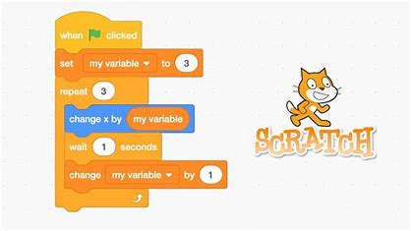***Year 6 computing Autumn 1***

***Exploring basic procedures***

Year 6 discussed the meaning of ‘procedure’ and some of examples of these.

* A set of instructions grouped together to carry out a task.
* Run a procedure by using its name.
* Procedures can be run/used lots of times.

Some examples that the children came up with were every day procedures that our brains know what to do. E.g. walking, getting dressed, eating, jumping.

They put this into steps as if it was code.

Next, the children explored a code on Scratch that had already been made. Using the sheet, they had to explore how different procedures were carried out.

After exploring the programme, they had a number of modifications that they needed to add to the programme.

