
Pupil Premium Strategy Statement – Springwood Junior School
2026-27 to 2028-29

It outlines our pupil premium strategy, how we intend to spend the funding in this academic year and the effect that last year’s spending of pupil premium had within our school.

School overview
Detail | Data
School name | Springwood Junior School
Number of pupils in school | 216
Proportion (%) of pupil premium eligible pupils | 50% (109/216)
Academic year/years that our current pupil premium strategy plan covers (3 year plans are recommended) | 2026-27 to 2028-29
Date this statement was published | September 2026
Date on which it will be reviewed | Annually (however actions are ongoing)  Updates to be provided at FGB.
Statement authorised by | FGB
Pupil premium lead | Jo Livingstone
Governor / Trustee lead | Andy Brown and Alison Syred-Paul
Funding overview
Detail | Amount
Pupil premium funding allocation this academic year | £157,060.00
Recovery premium funding allocation this academic year | £0
Pupil premium funding carried forward from previous years (enter £0 if not applicable) | £0
Total budget for this academic year  If your school is an academy in a trust that pools this funding, state the amount available to your school this academic year | £157,060.00

Part A: Pupil Premium Strategy Plan

Statement of intent
At Springwood, our core values are:
- Staying Safe
- Treating Each Other as you Wish to be Treated
- Trying Your Best and Being Proud
Therefore, we aim to develop responsible, self-regulated and self-motivated children.

Children in Springwood rapidly develop a love of learning and are aspirational. Therefore, our aim is to use the pupil premium funding to ensure that all disadvantaged children progressively acquire the broad range of knowledge and skills required to enable them to problem-solve and satisfy enquiries they have about the world in which they live. Thus sustaining positive outcomes.

Although Springwood’s strategy is focussed on the needs of disadvantaged children, it will benefit all pupils in our school where funding is spent on whole school approaches.

How we support Every Child's Learning Journey
We believe every pupil deserves the opportunity to thrive and reach their full potential. Our curriculum is designed to support all children, including those with special educational needs and disabilities (SEND) and those eligible for pupil premium (PP), ensuring they make strong progress from their individual starting points.

We personalise learning to meet the unique needs of each child. This includes a range of tailored approaches and resources, such as our enhanced mainstream offer, which helps us provide the right support for pupils with complex needs.

Our teachers carefully plan lessons to build on what pupils already know and can do, making sure learning is accessible, engaging, and challenging. We regularly assess pupils’ progress to identify any gaps in learning and intervene quickly to help children catch up.

We also provide additional opportunities beyond the classroom, including after-school clubs and enrichment activities, to support pupils’ wider development and enjoyment of learning.

We work closely with parents and carers to keep them informed about their child’s progress and how they can support their learning at home. Together, we create a positive and inclusive school community where every child feels valued, safe, and proud of their achievements.

Curriculum Outcomes and Progress
We believe that assessment is an integral part of the learning journey, helping us ensure that every pupil makes strong progress from their individual starting points.

Our teachers use ongoing, formative assessment to monitor pupils’ understanding and skills throughout each topic. This continuous assessment allows them to identify any gaps in learning early and adapt teaching to support all pupils effectively.

We also use information from previous assessments, including those from transition points and the prior year, to build a clear picture of each pupil’s needs. This comprehensive approach ensures that assessment is meaningful and supports smooth progression through the curriculum.

Outcomes are designed to give pupils opportunities to demonstrate their learning independently. These carefully planned outcomes shape our assessment practices, focusing not just on memorising facts but on applying knowledge and skills confidently and creatively.

By using assessment as a tool for learning, we ensure that pupils are well-prepared for the next stages of their education and develop the confidence and competence to succeed.

Some of the above approaches include:
- Ensuring that every child, including those with SEND and those eligible for Pupil Premium, makes strong progress from their individual starting points.
- Delivering a broad, balanced and ambitious curriculum that meets the National Curriculum standards and reflects our school values of staying safe, treating others as we wish to be treated, trying our best, and being proud.
- Fostering a love of learning and reading for pleasure through engaging, inclusive, and differentiated teaching approaches.
- Developing confident, reflective and skilled teachers who use evidence-based instructional practises to raise attainment in reading, writing, mathematics and the wider curriculum.
- Creating an environment where children feel safe, valued and motivated to learn, ensuring positive behaviour and attitudes.
- Supporting all children with personalised learning provision, particularly those with complex needs, through our enhanced mainstream offer

This strategy is integral to the School Improvement Plan.

Challenges

This details the key challenges to achievement that we have identified among our disadvantaged pupils.
Challenge number | Detail of challenge
1 | Outcomes  Many of our Pupil Premium Children have dual characteristics (e.g. are on the SEND register), so the wider context must be considered. The May 2026 census identified 52% and PP and 46% SEND.  The past three years has shown a marked increase in the numbers of pupils requiring significant additional support. We need to continue to build capacity in our school to meet the needs of disadvantaged children, ensuring all make good progress from their starting points.  Teachers need to consistently support pupils to develop independent skills and precision so that children make rapid progress.
2 | Attendance  Our attendance data over the last year indicates that attendance among disadvantaged pupils has been between 89.9-92.5%. However, this does include children with reduced timetables. The overall figure for disadvantaged pupils for 2024-25 was 91.4% with reduced timetables, 94.5% without reduced timetables. Unfortunately, we did not sustain the 95% which was achieved in 2024-25. Non disadvantaged attendance was 96.9%, 96.9% without reduced timetables.  Our assessments and observations indicate that absenteeism is negatively impacting on disadvantaged pupils’ progress, whether it is social and emotional and/or academic.
3 | Empowering parents and carers to support the child’s emotional wellbeing within the home and school  At Springwood, we recognise that parents looking after their family’s wellbeing is very important. Families all need some help from time to time due to life changes or events.
4 | Cultural Capital  Through observations and conversations with pupils and their families, we find that disadvantaged pupils generally have fewer opportunities to develop cultural capital outside of school.  Junior Summer 2025 pupil surveys evidenced that the children take part in school activities outside of lessons, like clubs, supports, music and art sometimes 24%, not very often 15% and never 23% (total – 62%)

Intended outcomes
This explains the outcomes we are aiming for by the end of our current strategy plan, and how we will measure whether they have been achieved.
Intended outcome | Success criteria
- Outcomes  Enhance the Quality of Teaching and Learning so the gap between the school’s results and the National Average continues to decrease | The school's Principles of Teaching and Learning will be embedded through consistent high-quality classroom practice, ensuring all pupils, including those with SEND, receive effective Ordinarily Available Provision and adaptive teaching that enables them to achieve their full potential.  Springwood’s mainstream offer will be refined and reviewed.  The second year of the maths curriculum will commence and impact will be checked  Oracy will be embedded across the curriculum, in the second year of implementation, so that there are improvements to pupil spoken language, reasoning, confidence, and talk is used as a lever for reading comprehension and final outcomes.
   | 2024 | 2025 | 2026 | National 2026
  Reading | 61.5% | 69.6% | 65% | 74.1%
  Writing | 65.4% | 71.4% | 70% | 73.2%
  GPS | 57.7% | 73.2% | 68.3% (73% with special consideration) | 72.8%
  Maths | 57.7% | 62.5% | 68.3% (73% with special consideration) | 74.2%
  Combined | 46.2% | 53.6% | 56.7% (57% with special consideration) | 62.5%
- Attendance  Attendance meets national expectations for PP pupils, particularly in light of current National challenges | Disadvantaged children’s attendance meets 95%+ for 2026-27.  Therefore steps to success:  At least 0.5% improvement for 2026-27  (note 2022-23's target was 93% which was achieved, 2023-24's was 94% which was achieved and 2024-25's was 95% which was achieved. Attendance for PP pupils dropped to 94.5% in 2025-26).  In cases where attendance is below the national average (or target for the academic year), the school can evidence gains for those children.  Note -The Attendance Action Plan details specific actions and further Success Criteria
- Empowering parents and carers to support the child’s emotional wellbeing within the home and school | Support children to recognise their emotions by using zones of regulation.  Behavioural incidents reduce for disadvantaged pupils  Events include:  - Weekly SEND Parent appointments  - INclude team who target six families, but also run parent workshops on neurodiversity, etc  - School Nursing Team  - Mental Health and -Wellbeing Workshops  - Student Social Worker  - Healthy Me Workshops  - Anxiety Workshops  - PSHE/RSE workshops
- Cultural Capital  Disadvantaged pupils are given more opportunities to attend school trips and residentials. | -Whole school curriculum identifies experiences for children  -PP funding supports families to access wider experiences  -Pupil conferencing evidences opportunities given  -Pupil Questionnaire in Summer 2027 evidences an improvement from responses from Summer 2025.

Activity in this academic year
This details how we intend to spend our pupil premium (and recovery premium funding) this academic year to address the challenges listed above.

Teaching (for example, CPD, recruitment and retention)
Budgeted cost: £70,000 (approx.)
Activity  (Area of Focus in line with the SIP) | Evidence that supports this approach  EEF Documentation consulted:  -Metacognition and self-regulated learning  -Pupil Premium Guide  Putting Evidence to Work – A School’s Guided to Implementation | Challenge number(s) addressed
Developing High Quality Teaching:  -English and Maths leaders attend termly core provision for their subjects and disseminate the training for all staff through PDMS, phase team meetings, INSET days as well as TA training  - Implement new EEF Maths Curriculum  - Implement Oracy into the classroom  - Two INSET Days delivered by HIAS on the writing journey. Additional support given to Years 4 and 5  - Raising Attainment in Year 4 delivered by HIAS and attended by EHT and Year 4 teachers  - Deputy Headteacher to use ongoing CPD to coach and monitor ECTs and teachers so that teacher’s use metacognitive strategies to enable children to plan, monitor and evaluate their learning  To deliver Professional Development Meetings throughout the year with specific focus on:  -No Lost Learning Time  -Is it Right for Everyone  -Progress for All  - Additional training for all staff across all roles to support ‘Meeting the Needs of our most Vulnerable Pupils) (Key Objectives Three and Four) | Education Endowment Foundation (EEF) recommends high quality CPD to ensure teachers are highly skilled so that teachers’ use AfL, formative assessment and knowledge of the pupils’ learning to shape planned learning opportunities and task design so that misconceptions are addressed in a timely manner and pupils make strong progress.  EEF - Metacognition and self-regulated learning  The Inclusive Classroom by Daniel Sobel and Sara Alston  Reaching the Unseen Children – Jean Gross | 1
 |  | 1
Termly pupil progress meetings focus on pupil premium children to enable teachers to review progress and provision and make adaptations to meet individual needs | Data analysis, including capturing of finer points of progress, will ensure that teaching is targeted to close gaps in learning | 1

Targeted academic support (for example, tutoring, one-to-one support structured interventions)
Budgeted cost: £70,000 (approx.)
Activity | Evidence that supports this approach  EEF Documentation consulted:  -Metacognition and self-regulated learning  -Pupil Premium Guide  Putting Evidence to Work – A School’s Guided to Implementation | Challenge number(s) addressed
Developing High Quality Teaching:  INSET Days x 2 – Writing Journeys  DHT attending Oracy Training  Maths Lead attending EEF Maths Training | EEF’s ‘Effective Professional Development’ | 1
PPRs identify ‘at risk children’. Quality First Teaching and Tutoring after school (Y6):  - 1:1 word reading  - Targeted reading, writing and maths support from pupil progress reviews. Extra support in children’s books is identified and marked as PPRs.  - Social skills (lunch time)  - Targeted Phonics  - Fine and gross motor control  - Handwriting and spelling  - Maths (areas specific to gaps)  - Oxford Reading Buddy/Owls  Cluster Moderation events at local schools to agree judgements | EEF states that “where TAs are working individually/or in small groups with low attaining pupils, the focus should be on retaining access to high quality teaching, for example by delivering brief, but intensive, structured interventions”. PPRs identify how the interventions are to be used and the frequency of the intervention in order for the children to make accelerated progress. | 1
Regular supplementary reading for children identified as the lowest 20% of readers | EEF identify reading and discussing books to support and improve literacy skills | 1
Personalised Speech and Language interventions for those children whose language skills are not on track | EEF research highlights the importance of good language skills in order to support learning. | 1

Wider strategies (for example, related to attendance, behaviour, wellbeing)
Budgeted cost: £15,000 (approx.)
Activity | Evidence that supports this approach  EEF Documentation consulted:  -Metacognition and self-regulated learning  -Pupil Premium Guide  Putting Evidence to Work – A School’s Guided to Implementation | Challenge number(s) addressed
Senior Admin Assistants to work with EHT to rigorously implement Attendance and Punctuality Action Plan and offer support to pupil premium pupils at risk of meeting targets, this includes EBSA:  95%+ for 2026-27  Interventions/Activities include:  - Attendance and Punctuality letters and emails detailing actions which will take place so that all parents are clear  - Termly meetings for EHT at Attendance Hubs  - Termly meetings for SAAs at Cluster attendance groups  - EBSA interventions  - Breakfast via Activ8  - Daily telephone calls for pupils not in attendance. Home visits to check on welfare if contact cannot be made for two days (in line with Attendance Policy)  - Cluster Attendance Leaflet  - Friendly phone call  - Challenging phone call  - Text Messages  - Meetings  - Letters  - Home collections  - Home Visits  - Support with routines at home and resources  - Child and parent agreements  - Reward Systems  - Referral Level 2 FSS  - School Nurse referral  - Children Services Referral  - Referral to Inclusion  - Reduced timetable/  alterations to school timings  - Assigned Family Key Worker  - Funding Taxis  Assemblies and Facebook also used to promote good attendance | The Department for Education (DfE) recommendations include “Recognise attendance as an important area of school improvement. Make sure it is resourced appropriately (including through the use of pupil premium funding) to create, build and maintain systems and performance”. | 2
Families and pupils supported through:  - Weekly SEND Parent appointments  - INclude team who target six families, but also run parent workshops on neurodiversity, etc  - School Nursing Team  - Mental Health and -Wellbeing Workshops  - Student Social Worker  - Healthy Me Workshops  - Anxiety Workshops  - PSHE/RSE workshops  - Preloved uniform  - Signposting food banks, local support re energy prices, etc  - Emotional Literacy Support Assistant (ELSA) programme to support well-being  - Nurture/Sharing and turn taking groups with targeted pupils  - Support with lunch times with lunch skills and social skills.  - Balanced diet promoted through PE, DT and lunchtime expectations | There is evidence from the EEF that supporting children’s social and emotional skills, will result in improved outcomes, e.g. progress and attainment, behaviour and friendships with peers. | 3
Children whose parents cannot afford to pay for school trips, afterschool clubs and residential will have their places paid for | All children including those from disadvantaged backgrounds, deserve a well-rounded and broad curriculum with plenty of opportunities. | 4
Total budgeted cost: £157,060.00

Part B: Review of outcomes in the previous academic year

Pupil premium strategy outcomes
This details the impact that our pupil premium activity had on pupils in the 2022-2023 academic year.
Outcomes:
Attainment in reading, writing, mathematics and the wider curriculum at least meet the National Average at ARE and Greater Depth.
All children make strong progress from their individual starting points.

2026 End of Year Results
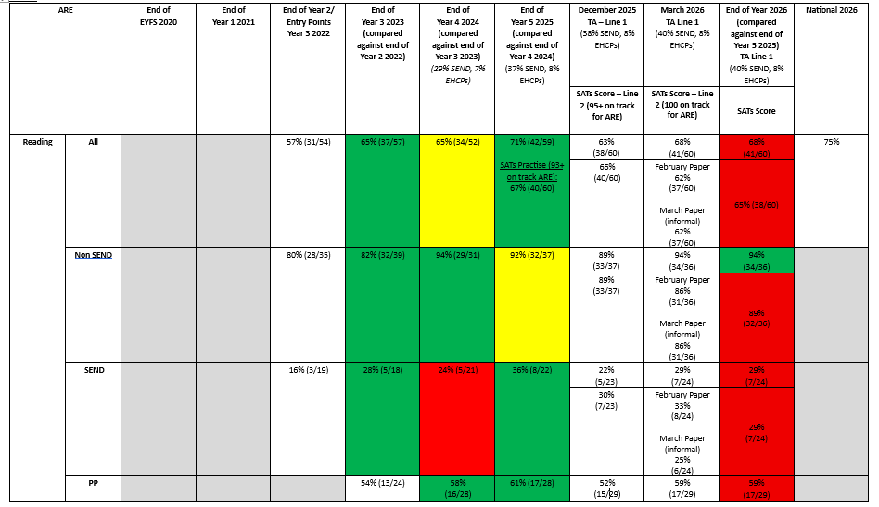
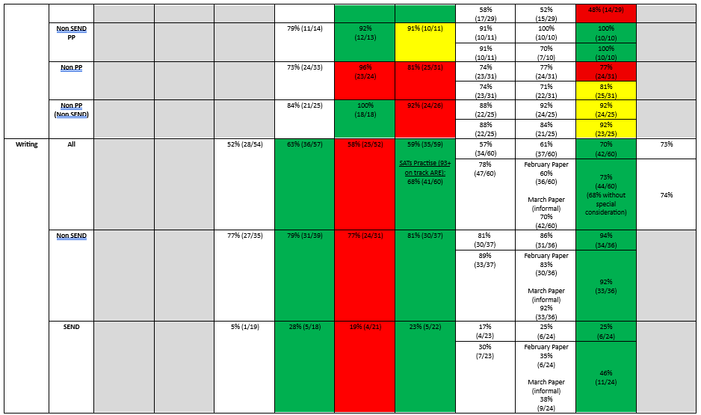
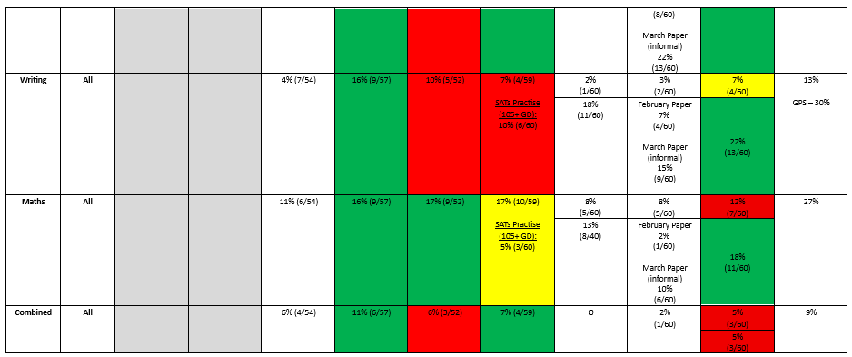
Attendance was 94.5% for PP pupils.
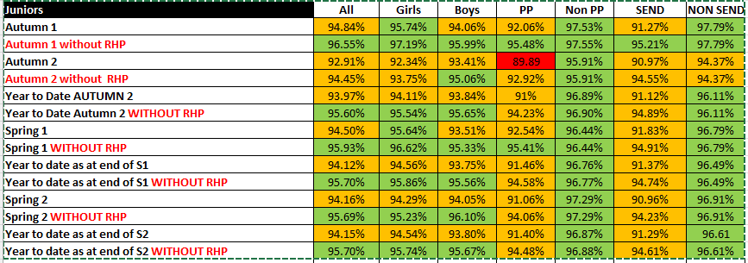

Behavioural incidents decrease for disadvantaged children
Weekly Assemblies for Oracy and Zones of Behaviour:
Zones of Behaviour:
- Help children to recognise and name the different zones. Introduce visuals and classroom display materials.
- Explain that Zones of Regulation represent different states our body can be in, not just specific emotions.
- Introduce the idea that our bodies send signals that tell us how we are feeling physically and emotionally. Highlight that all emotions are okay and it is natural to experience a wide range (sometimes even in a short space of time).
- Support children in identifying physical and emotional signs that indicate which zone they are currently in (e.g., fast heartbeat, feeling restless, feeling tired).
- Guide children to explore and discuss why they might find themselves in each zone, considering triggers or situations that affect their state.
- Encourage children to start thinking about strategies they can use to regulate their state and move back towards the Green Zone so they are happy, safe and ready to learn.
- Promote awareness that seeking help or using calming techniques is a positive step towards managing their feelings and behaviours effectively.
- Next to come - exploring and trialing specific strategies for each Zone and sharing experiences.

Disadvantaged pupils are given more opportunities to attend school trips, residential and after school clubs
Whole school curriculum identifies experiences for children
Springwood's Curriculum | Springwood Infant School (springwoodfederation.co.uk)
PP funding has supported families to access wider experiences, such as the historic dockyard, Mary Rose Museum.

The school offered afterschool provision weekly for all PP pupils for Spring 2026 and Summer 2026
Year 3 and 4 – Basketball
Year 5 and 6 - Football

Externally provided programmes
Please include the names of any non-DfE programmes that you purchased in the previous academic year. This will help the Department for Education identify which ones are popular in England
Programme | Provider
Oxford Reading Owls/Buddy
Essential Letters and Sounds

Service pupil premium funding (optional)
For schools that receive this funding, you may wish to provide the following information:
Measure | Details
How did you spend your service pupil premium allocation last academic year? | Pupils from service families are approximately 5%. They are captured in the above analysis. However needs are assessed on a case by case basis. Please book an appointment with Mrs Jo Livingstone if you wish to discuss this further.
What was the impact of that spending on service pupil premium eligible pupils?

Further information (optional)

