Science Team

October 2022

Final version

© Hampshire County Council

Disciplinary Knowledge and the National Curriculum Statutory requirements for Working Scientifically

HIAS MOODLE+ RESOURCE
Overview

This document contains…
A document which shows the working scientifically statements from the National Curriculum and how they have broken down into disciplinary skills.

Points to consider when using this resource
This resource could be used as document for subject leaders to show coverage of the Working Scientifically aspect of the National Curriculum for Science when using disciplinary knowledge rather than working scientifically statements when planning and teaching.

Please also refer to the new Disciplinary Skills Trackers resource which has taken the disciplinary knowledge and has grouped them into the following categories…
Knowledge of Scientific methods | Knowledge of apparatus and techniques | Knowledge of data analysis and presentation | Knowledge of how science uses evidence to develop explanations
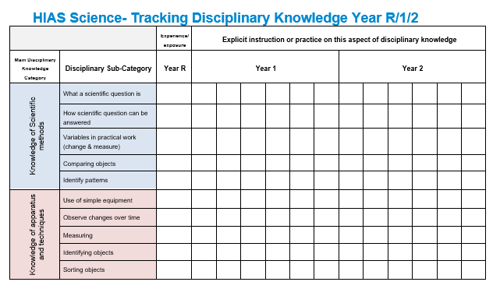
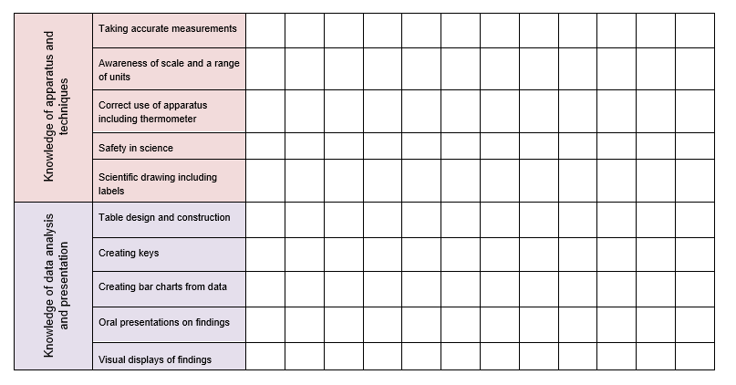
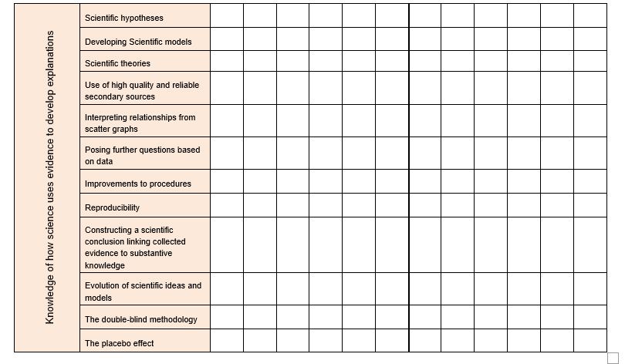

Year 1/2

Working Scientifically Statement | Disciplinary Knowledge |  | Working Scientifically Statement | Disciplinary Knowledge
Asking simple questions and recognising that they can be answered in different ways | What a scientific question is |  | Identifying and classifying cont. | Comparing objects
 | How scientific question can be answered |  | Identifying and classifying cont. | Identify patterns
 | Using simple secondary sources |  | Using their observations and ideas to suggest answers to questions | What scientific evidence is
 | Variables in practical work (change & measure) |  |  | What scientific evidence is not
Observing closely, using simple equipment | Use of simple equipment |  |  | What conclusions are used for
Observing closely, using simple equipment | Observe changes over time |  |  | What a scientific conclusion should include
Performing simple tests | Measuring |  | Gathering and recording data to help in answering questions. | What data is
Performing simple tests | Recording of data |  | Gathering and recording data to help in answering questions. | What a table is
Identifying and classifying | Identifying objects |  | Gathering and recording data to help in answering questions. | How to place data into a table
Identifying and classifying | Classifying |  | Gathering and recording data to help in answering questions. | That data in a table can be clearer when displayed as a graph
Identifying and classifying | Sorting objects |  | Gathering and recording data to help in answering questions.

Year 3/4

Working Scientifically Statement | Disciplinary Knowledge
Asking relevant questions and using different types of scientific enquiries to answer them | Scientific hypotheses
 | Scientific models
 | Scientific theories
Setting up simple practical enquiries, comparative and fair tests | Variables in science-change and measure
 | Control variables- (keep the same)
Making systematic and careful observations and, where appropriate, taking accurate measurements using standard units, using a range of equipment, including thermometers and data loggers | Observing
 | Taking accurate measurements
 | Awareness of scale and a range of units
 | Correct use of apparatus including thermometer
 | Safety in science

Working Scientifically Statement | Disciplinary Knowledge
Gathering, recording, classifying and presenting data in a variety of ways to help in answering questions | Table design and construction
 | Use of secondary sources
 | Classifying
 | Identify patterns and relationships
Recording findings using simple scientific language, drawings, labelled diagrams, keys, bar charts, and tables | Table design and construction
 | Creating keys
 | Scientific drawing including labels
 | Creating bar charts from data
Reporting on findings from enquiries, including oral and written explanations, displays or presentations of results and conclusions | Oral presentations on findings
 | Written explanations
 | Oral presentations on findings

Year 5/6

Working Scientifically Statement | Disciplinary Knowledge
Planning different types of scientific enquiries to answer questions including recognising and controlling variables where necessary | Scientific hypotheses
 | Developing Scientific models
 | Scientific theories
 | Distinguishing Pseudoscience from science
 | Variables in science-change (independent) and measure (dependent)
 | Control variables- (keep the same)
Taking measurements, using a range of scientific equipment, with increasing accuracy and precision, taking repat readings where appropriate | Making accurate observations
 | Taking accurate measurements
 | Awareness of scale and a range of units
 | Correct use of a range of apparatus
 | Safety in science
 | Repeatability
 | Awareness of sources of error in investigations

Working Scientifically Statement | Disciplinary Knowledge
Recording data and results of increasing complexity using scientific diagrams and labels, classification keys, tables, scatter graphs, bar and line graphs. | Complex table design and construction
 | Use of high quality and reliable secondary sources
 | Classifying
 | Create classification keys
 | Identifying patterns in nature
 | Scientific drawing including labels
 | Creating bar charts from data
 | Creating scatter graphs from data
 | Ascertain the level of uncertainty in collected results
Identify scientific evidence that has been used to support or refute ideas or arguments | Evolution of scientific ideas and models
 | The double-blind methodology
 | The placebo effect

Working Scientifically Statement | Disciplinary Knowledge
Using test results to make predictions to set up further comparative and fair tests | Interpreting relationships from scatter graphs
 | Validity of results
 | Posing further questions based on data
 | Improvements to procedures
 | Reproducibility
Reporting and presenting findings from enquiries, including conclusions, casual relationships and explanations of and degree of trust in results, in oral and written form such as displays and other presentations | Oral presentations on findings
 | Constructing a scientific conclusion linking collected evidence to substantive knowledge
 | Illustrated presentations of research, techniques/methods and findings

HIAS Science Team

Kevin Neil- County Inspector/Adviser for Science Kevin.neil@hants.gov.uk
Emma Cooper- General Inspector/Adviser for Science emma.cooper3@hants.gov.uk

For further details on the full range of services available please contact us using the following details:

Tel: 01962 874820 or email: hias.enquiries@hants.gov.uk

Upcoming Courses
Keep up-to-date with our learning opportunities for each subject through our Upcoming Course pages linked below. To browse the full catalogue of learning offers, visit our new Learning Zone. Full details of how to access the site to make a booking are provided here.

- English
- Maths
- Science
- Geography
- RE
- History
- Leadership
- Computing
- Art
- D&T
- Assessment
- Support Staff
- SEN

Terms and conditions

Terms of licence
Moodle+ subscribers are licenced to access and use this resource and have agreed to pay the annual subscription fee. This authority starts when the fee is paid and ends when the subscription period expired unless it is renewed. This file is for personal or classroom use only. By using it, you agree that you will not copy or reproduce this file except for your own personal, non-commercial use. HIAS have the right to modify the terms of this agreement at any time; the modification will be effective immediately and shall replace all prior agreements.

You are welcome to:
- download this resource
- save this resource on your computer
- print as many copies as you would like to use in your school
- amend this electronic resource so long as you acknowledge its source and do not share as your own work.

You may not:
- claim this resource as your own
- sell or in any way profit from this resource
- store or distribute this resource on any other website or another location where others are able to electronically retrieve it
- email this resource to anyone outside your school or transmit it in any other fashion.

