HIAS OPEN ACCESS RESOURCE

Hampshire Science Team

Progression of Substantive Knowledge in Physics- Forces

Year 1-6
HIAS Science Team

April 2022

© Hampshire County Council
Overview

This document contains…
A progressive list of the substantive knowledge within the Hampshire Science Learning Journeys with reference to the related National Curriculum statutory requirements.

Points to consider when using this resource
The Learning Journeys provide schools with clearly sequenced substantive knowledge across chemistry, biology and physics. Where possible, the links to the National Curriculum statutory and/or non- statutory requirements have been identified.
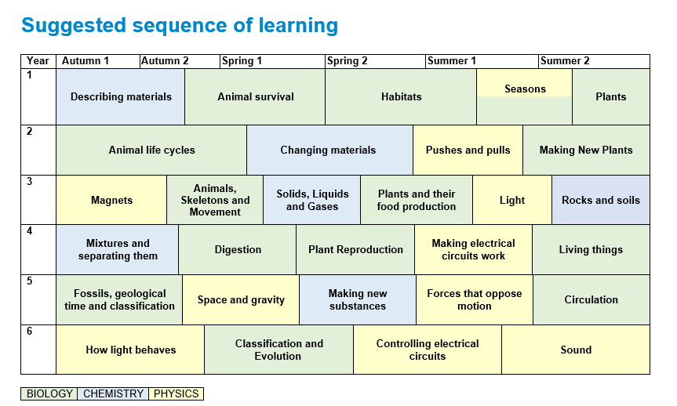
PHYSICS
Forces

Year 1 | Substantive Knowledge from Learning Journeys | National Curriculum Statutory Requirement
Year 2 | Year 2- Pushes and pulls  Knowledge Block 1  - Objects can move (be in Motion) in various ways-roll, slide and bounce  Knowledge Block 2  - The pushing or pulling of an object can affect its motion.  - Pushing or pulling can do three things, slow down, speed up or change the direction of an object.  Knowledge Block 3  - The larger the push/pull the bigger the effect on motion | Year 3 Forces and Magnets  Pupils should be taught to:  - compare how things move on different surfaces  - notice that some forces need contact between two objects  HIAS Science team guidance  The first-time forces are mentioned in the National Curriculum is in year 3 in the topic on magnets. Magnets are a non-contact force which may appear almost magical if children have not first had a firm grounding in the idea that objects can be made to move differently through the physical acts of pushing and pulling. For this reason, we have constructed a topic that we think should be taught in key stage one that teaches the idea of contact forces changing how things move.
Year 3 | Magnets  Knowledge Block 1- What magnets do  - Magnets exert attractive forces on some metals  Knowledge Block 2- Magnets don’t need to touch  - Magnetic forces work through other materials including air, so magnets don't need to be touching to exert their force. It is called a non-contact force  Knowledge Block 3- Magnets attract and repel  - Each end of a magnet is called a pole, opposite poles are called north and south.  - Magnets exert attractive forces on each other when the poles facing each other are north and south (opposites).  - Magnets exert repulsive forces on each other when the poles facing each other are the same.  Knowledge Block 4- what affects magnetic strength  The strength of magnetic forces is affected by:  - The strength of the magnet.  - The distance between the magnet and the object.  - The material the object is made from. | Year 3 Forces and Magnets  Pupils should be taught to:  - compare how things move on different surfaces  - notice that some forces need contact between two objects, but magnetic forces can act at a distance  - observe how magnets attract or repel each other and attract some materials and not others  - compare and group together a variety of everyday materials on the basis of whether they are attracted to a magnet, and identify some magnetic materials  - describe magnets as having two poles  - predict whether two magnets will attract or repel each other, depending on which poles are facing.

Year 4 | Substantive Knowledge from Learning Journeys | National Curriculum Statutory Requirement
Year 5 | Forces that oppose motion  Knowledge Block 1: Water and air resistance.  - When objects move through air and water, they have to push it out of the way. The water and air push back with forces called water resistance and air resistance. The harder it is to push the material out of the way the greater the resistance.  - Gases weigh less than liquids and so water resistance is greater than air resistance.  Knowledge Block 2: Friction  - Friction is a force against motion caused by two surfaces rubbing against each other. It occurs because no surfaces are perfectly smooth; they have bumps and undulations that can interlock when placed on top of each other.  - To move one interlocking surface over another, one of three things must happen:  - The surfaces must rise slightly  - The bumps on the surface must bend  - The bumps on the surface must break  - All of these actions require a force, this is what causes friction  Knowledge Block 3: Managing Forces  - Some objects require large forces to make them move; gears, pulley and levers can reduce the force needed to make things move.  - The use of levers can reduce the force needed to move things. The object you are lifting is called the load, and the force you apply to the arm to make the object move is called the effort.  - The use of pulleys can reduce the force needed to move things  (These are particularly complex ideas. It might be better to teach them through a design technology project where children make toys using cogs, pulleys and lever) | Year 5 Forces and Magnets  Pupils should be taught to:  - explain that unsupported objects fall towards the Earth because of the force of gravity acting between the Earth and the falling object  - identify the effects of air resistance, water resistance and friction, that act between moving surfaces  - recognise that some mechanisms, including levers, pulleys and gears, allow a smaller force to have a greater effect.
Year 6
HIAS Science Team

Kevin Neil- County Inspector/Adviser for Science Kevin.neil@hants.gov.uk
Emma Cooper- General Inspector/Adviser for Science emma.cooper3@hants.gov.uk
David Whittle- General Inspector/Adviser for Science david.whittle@hants.gov.uk

For further details on the full range of services available please contact us using the following details:

Tel: 01962 874820 or email: hias.enquiries@hants.gov.uk

Upcoming Courses
Keep up-to-date with our learning opportunities for each subject through our Upcoming Course pages linked below. To browse the full catalogue of learning offers, visit our new Learning Zone. Full details of how to access the site to make a booking are provided here.

- English
- Maths
- Science
- Geography
- RE
- History
- Leadership
- Computing
- Art
- D&T
- Assessment
- Support Staff
- SEN

Terms and conditions

You are welcome to:
- download this resource
- save this resource on your computer
- print as many copies as you would like to use in your school
- amend this electronic resource so long as you acknowledge its source and do not share as your own work.

You may not:
- claim this resource as your own
- sell or in any way profit from this resource
- store or distribute this resource on any other website or another location where others are able to electronically retrieve it
- email this resource to anyone outside your school or transmit it in any other fashion.

