HIAS OPEN ACCESS RESOURCE

Hampshire Science Team

Progression of Substantive Knowledge in Physics- Energy Pathways

Year 1-6
HIAS Science Team

April 2022

© Hampshire County Council
Overview

This document contains…
A progressive list of the substantive knowledge within the Hampshire Science Learning Journeys with reference to the related National Curriculum statutory requirements.

Points to consider when using this resource
The Learning Journeys provide schools with clearly sequenced substantive knowledge across chemistry, biology and physics. Where possible, the links to the National Curriculum statutory and/or non- statutory requirements have been identified.
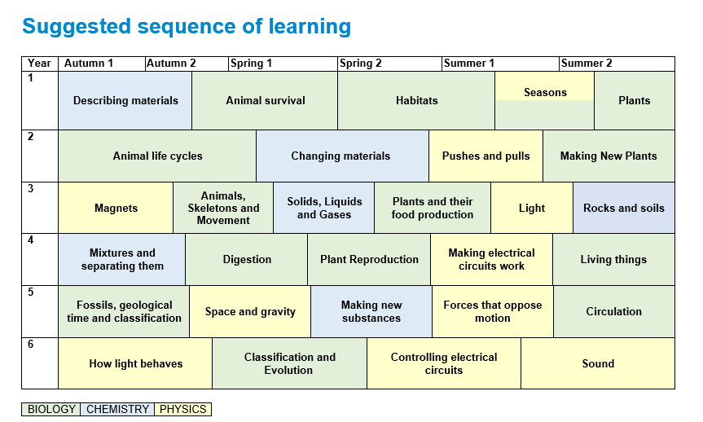

PHYSICS
Energy Pathways
Year 1 | Substantive Knowledge from Learning Journeys | National Curriculum Statutory Requirement
Year 2
Year 3 | Light  Knowledge Block 1- Light and sight  - There must be light for us to see.  - Light comes from a source.  - We need light to see things, even shiny things.  - Light from the sun can be dangerous and that there are ways to protect their eyes  Knowledge Block 2- What light does when it hits materials  - If an object is transparent light will go through it and we will be able to see through it.  - If an object is opaque, it will block the light and no light will get through. This is what forms shadows.  - The closer to the light source an object is, the bigger the shadow will be. This is because the object blocks more of the light.  - The further away from the light source an object is, the smaller the shadow will be. This is because the object blocks less of the light.  - If an object is perfectly reflective, light will bounce back off it and we will see reflections of objects.  - If the material is translucent, it will allow light through, but we won't be able to see through it. | Year 3 Light  Pupils should be taught to:  - recognise that they need light in order to see things and that dark is the absence of light  - notice that light is reflected from surfaces  - recognise that light from the sun can be dangerous and that there are ways to protect their eyes  - recognise that shadows are formed when the light from a light source is blocked by an opaque object  - find patterns in the way that the size of shadows change.
Year 4

Year 5 | Substantive Knowledge from Learning Journeys | National Curriculum Statutory Requirement
Year 6 | How light behaves  Knowledge Block 1: How light travels  - When light is emitted from a light source, it travels in straight lines until it hits an object. This can be represented by an arrow.  - Shadows form when light hits an opaque object. The area behind the object is in darkness because light can only travel in straight lines.  - Shadows have the same shape as the objects that cast them.  Knowledge Block 2: How light behaves when it hits objects  - When light hits a transparent object, it goes through it in a straight line so we can see a clear image through it.  - When light hits a translucent material, it goes through it but is scattered, this means light can pass through, but we can’t see an image through it.  - When light hits a mirrored surface, it reflects off it in straight lines, so we can see an image in the reflective material.  - Sometimes when light hits a material it reflects off it in many different directions (it is scattered). In this case light will be reflected but no image will be seen in the material.  - Shiny surfaces are better reflectors and rough surfaces scatter light more. Opaque objects don’t allow any light to pass through them  Knowledge Block 3: How we see  - Animals see objects when light is reflected off the object and enters the eye through the pupil.  - The pupil changes its size to allow enough, but not too much light into the eye.  - Too much light damages the eye and too little results in poor quality images. | Year 6 Light  Pupils should be taught to:  - recognise that light appears to travel in straight lines  - use the idea that light travels in straight lines to explain that objects are seen because they give out or reflect light into the eye  - explain that we see things because light travels from light sources to our eyes or from light sources to objects and then to our eyes  use the idea that light travels in straight lines to explain why shadows have the same shape as the objects that cast them.

Year 6 | Substantive Knowledge from Learning Journeys | National Curriculum Statutory Requirement
Year 6 | Sound  Knowledge Block 1: Describing Sound  - Sounds can be produced in a variety of ways.  - Sounds have the properties of pitch and volume.  - When a sound is produced it spreads out from its source in all directions  Knowledge Block 2: How sound is made and travels  - Sound is caused by vibration (objects move rapidly back and forth or up and down)  - When objects vibrate it makes the objects in contact with it also vibrate. This includes the air.  - The vibration travels through the air and makes other objects it is in contact with vibrate including your ear drum.  Knowledge Block 3: Pitch and Volume changes  - Pitch and volume are caused by how the material vibrates  - The pitch of a sound is caused by how fast an object vibrates. This is called the frequency of vibration. Higher the frequency, higher the pitch  - Smaller objects or tighter strings tend to vibrate with a higher frequency  - The volume of sound is caused by how big each vibration is. This is called the amplitude of vibration. The bigger the amplitude the higher the volume.  - Sounds get fainter as the distance from the sound source increases. | Year 4 Sound  Pupils should be taught to:  - identify how sounds are made, associating some of them with something vibrating  - recognise that vibrations from sounds travel through a medium to the ear  - find patterns between the pitch of a sound and features of the object that produced it  - find patterns between the volume of a sound and the strength of the vibrations that produced it  - recognise that sounds get fainter as the distance from the sound source increases.  HIAS Science team guidance  The learning journeys place this topic in year 6. The ideas that children have to grapple with about sound are very abstract and challenging. They need to learn that when objects vibrate, they produce sounds and sounds move through materials by making that material vibrate in turn. None of these vibrations can be seen by the naked eye and so they are abstract concepts. It gets even trickier because children also have to learn how changes in the way an object vibrates can lead to changes in pitch and volume. Dylan Williams says that some ideas are more troublesome than others; this is a very troublesome idea and so the more mature a child is when they have to understand and use it the better.

HIAS Science Team

Kevin Neil- County Inspector/Adviser for Science Kevin.neil@hants.gov.uk
Emma Cooper- General Inspector/Adviser for Science emma.cooper3@hants.gov.uk
David Whittle- General Inspector/Adviser for Science david.whittle@hants.gov.uk

For further details on the full range of services available please contact us using the following details:

Tel: 01962 874820 or email: hias.enquiries@hants.gov.uk

Upcoming Courses
Keep up-to-date with our learning opportunities for each subject through our Upcoming Course pages linked below. To browse the full catalogue of learning offers, visit our new Learning Zone. Full details of how to access the site to make a booking are provided here.

- English
- Maths
- Science
- Geography
- RE
- History
- Leadership
- Computing
- Art
- D&T
- Assessment
- Support Staff
- SEN
Terms and conditions

You are welcome to:
- download this resource
- save this resource on your computer
- print as many copies as you would like to use in your school
- amend this electronic resource so long as you acknowledge its source and do not share as your own work.

You may not:
- claim this resource as your own
- sell or in any way profit from this resource
- store or distribute this resource on any other website or another location where others are able to electronically retrieve it
- email this resource to anyone outside your school or transmit it in any other fashion.

