HIAS OPEN ACCESS RESOURCE

Hampshire Science Team

Progression of Substantive Knowledge in Physics- Electricity

Year 1-6
HIAS Science Team

April 2022

© Hampshire County Council
Overview

This document contains…
A progressive list of the substantive knowledge within the Hampshire Science Learning Journeys with reference to the related National Curriculum statutory requirements.

Points to consider when using this resource
The Learning Journeys provide schools with clearly sequenced substantive knowledge across chemistry, biology and physics. Where possible, the links to the National Curriculum statutory and/or non- statutory requirements have been identified.
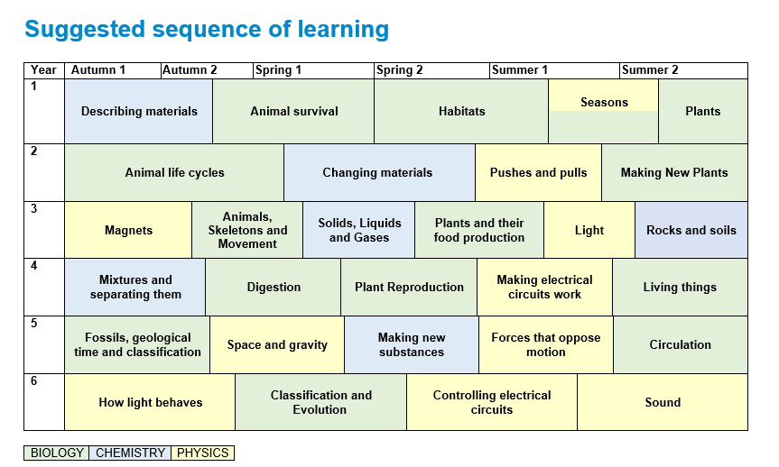
PHYSICS
Electricity
Year 1 | Substantive Knowledge from Learning Journeys | National Curriculum Statutory Requirement
Year 2
Year 3
Year 4 | Electricity  Knowledge Block 1- Electricity as a power source  - Lots of devices are powered by electricity  - Electricity comes from a source There are two main sources- batteries and mains  Knowledge Block 2- What batteries do  - A battery pushes electricity to the device.  - To be able to push electricity the battery must be connected to the device using wires  - This is called a circuit  Knowledge Block 3- Making devices work harder  - If there are more batteries added to a circuit this provides a bigger push on the electricity  - This will make the device work harder e.g., brighter bulbs, faster spinning motor, louder buzzer  Knowledge Block 3- Insulators and conductors  - Some materials will allow electricity to flow through them- Conductors  - Metals such as silver, gold and copper are good conductors. Water is also a conductor of electricity.  - Other materials will not allow electricity to flow through them- Insulators  - Plastic, wood, glass and rubber are good electrical insulators. That is why they are used to cover materials that carry electricity.  - A switch opens and closes a circuit | Year 4 Electricity  Pupils should be taught to:  - identify common appliances that run on electricity  - construct a simple series electrical circuit, identifying and naming its basic parts, including cells, wires, bulbs, switches and buzzers  - identify whether or not a lamp will light in a simple series circuit, based on whether or not the lamp is part of a complete loop with a battery  - recognise that a switch opens and closes a circuit and associate this with whether or not a lamp lights in a simple series circuit  - recognise some common conductors and insulators, and associate metals with being good conductors.

Year 5 | Substantive Knowledge from Learning Journeys | National Curriculum Statutory Requirement
Year 6 | Controlling electrical circuits  Knowledge Block 1: Pushing electrical current  - Current is the flow of electricity around a circuit.  - The power supply in a circuit pushes the current round the circuit  - The voltage of the power supply is a measure of this push  - Voltage is measure in volts  - Batteries have a limited store of energy and when this is gone, they can no longer push the current  Knowledge Block 2: Electrical current  - Current is the flow of electricity through a conductor  - When current passes through a device it makes it work  - Increasing the voltage (the number of cells in the battery) increases the current. The larger the flow of current, the harder the device works  Knowledge Block 3: Electrical resistance  - All parts of a circuit offer resistance to electrical current including the wires.  - Resistance is the slowing down of electrical current  - The more devices added into a circuit the greater the resistance  - This means less current flows around the circuit | Year 6 Electricity  Pupils should be taught to:  - associate the brightness of a lamp or the volume of a buzzer with the number and voltage of cells used in the circuit  - compare and give reasons for variations in how components function, including the brightness of bulbs, the loudness of buzzers and the on/off position of switches  - use recognised symbols when representing a simple circuit in a diagram.

HIAS Science Team

Kevin Neil- County Inspector/Adviser for Science Kevin.neil@hants.gov.uk
Emma Cooper- General Inspector/Adviser for Science emma.cooper3@hants.gov.uk
David Whittle- General Inspector/Adviser for Science david.whittle@hants.gov.uk

For further details on the full range of services available please contact us using the following details:

Tel: 01962 874820 or email: hias.enquiries@hants.gov.uk

Upcoming Courses
Keep up-to-date with our learning opportunities for each subject through our Upcoming Course pages linked below. To browse the full catalogue of learning offers, visit our new Learning Zone. Full details of how to access the site to make a booking are provided here.

- English
- Maths
- Science
- Geography
- RE
- History
- Leadership
- Computing
- Art
- D&T
- Assessment
- Support Staff
- SEN
Terms and conditions

You are welcome to:
- download this resource
- save this resource on your computer
- print as many copies as you would like to use in your school
- amend this electronic resource so long as you acknowledge its source and do not share as your own work.

You may not:
- claim this resource as your own
- sell or in any way profit from this resource
- store or distribute this resource on any other website or another location where others are able to electronically retrieve it
- email this resource to anyone outside your school or transmit it in any other fashion.

