HIAS OPEN ACCESS RESOURCE

Hampshire Science Team

Progression of Substantive Knowledge in Physics- Earth and Space

Year 1-6
HIAS Science Team

April 2022

© Hampshire County Council
Overview

This document contains…
A progressive list of the substantive knowledge within the Hampshire Science Learning Journeys with reference to the related National Curriculum statutory requirements.
Points to consider when using this resource
The Learning Journeys provide schools with clearly sequenced substantive knowledge across chemistry, biology and physics. Where possible, the links to the National Curriculum statutory and/or non- statutory requirements have been identified. The Learning Journey ‘Seasons’ in Year 1, covers knowledge across the sciences of both biology and physics.
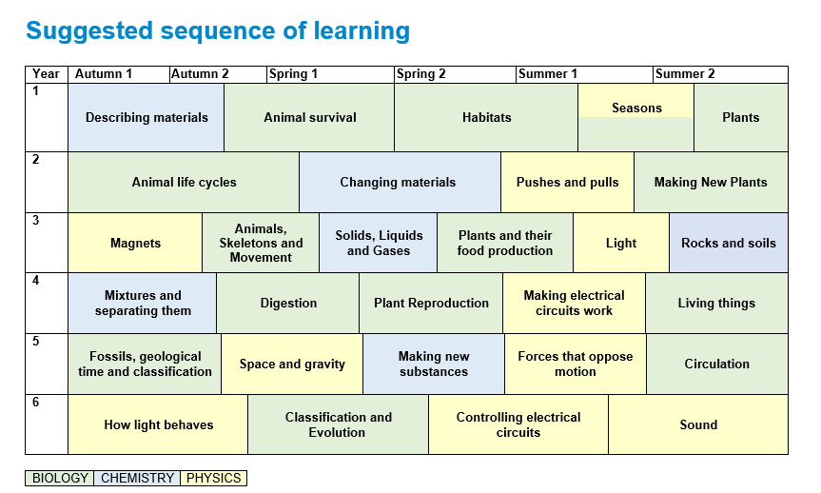

PHYSICS
Earth & Space
Year 1 | Substantive Knowledge from Learning Journeys | National Curriculum Statutory Requirement
Year 1 | Year 1- Seasons  Knowledge Block 1- Surviving the changing seasons  - There are four seasons, Spring, summer, autumn and winter  - Each season is about three months long  - In Spring, young animals like lambs and chicks are born, the flowers bloom and the weather starts to become warmer.  - In autumn, the leaves fall off the trees and the amount of time we have in the day becomes less.  - Winter has the shortest amount of time during the day and the weather is at its coldest.  - In summer the trees are full of green leaves and the weather is at its warmest.  - Animals and plants have adapted ways of surviving the changing seasons  - These include hibernating, storing food, fattening up, migration, loss of leaves  - Trees can be either evergreen or deciduous.  - Evergreen trees keep their green leaves all year round.  - Deciduous trees lose their leaves every autumn.  (THIS SUBSTANTIVE KNOWLEDGE APPEARS IN THE PROGRESSION WITHIN THE BIOLOGY- VARIATION AND EVOLUTION) | Year 1 Seasonal Changes  Pupils should be taught to:  - observe changes across the four seasons  - observe and describe weather associated with the seasons and how day length varies  Year 1 Plants  Pupils should be taught to:  - identify and name a variety of common wild and garden plants, including deciduous and evergreen trees
Year 2
Year 3
Year 4

Year 5 | Substantive Knowledge from Learning Journeys | National Curriculum Statutory Requirement
Year 5 | Space and Gravity  Knowledge Block 1: Our Solar system  - A Solar system is a collection of planets, which orbit (a curved path) a star.  - There are huge number of stars in space and therefore a huge number of solar systems  - Our solar system consists of 8 planets, many of those planets have moons which orbit around them.  - Earth’s moon is not a planet but is a satellite which orbits Earth. It is around a quarter of the size of Earth.  - As the Moon orbits the Earth, the Sun lights up different parts of it, making it seem as if the Moon is changing shape. We call these the phases of the moon.  - The Moon doesn’t emit (give off) light itself, the ‘moonlight’ we see is actually the Sun’s light reflected off the lunar surface.  - Our solar system can be represented with a model (see diagram), but it isn’t possible to draw it to scale.  - The planets and moons are rotating (spinning)  - The time it takes one planet to rotate is called a day. On Earth this is 24 hours  - The time it takes a planet to complete one orbit around its star is called a year. On Earth this is 356.25 days  - The solar system is with a massive collection of stars called the galaxy (called the Milky way)  - The Milky way is one of billions of galaxies in the Universe.  Knowledge Block 2: What else is in the solar system?  - Stars are huge balls of gas that produce vast amounts of light and heat.  - Asteroids are lumps of rock that orbit a star (there are millions in between Mars and Jupiter)  - Comets are objects that are made of Ice, which melts when they get closer to the sun leaving a tail.  Knowledge Block 3: Gravity and its effects  - Gravity is force of attraction between two objects with mass (a quantity of matter)  - The bigger the mass the bigger force it exerts  - Gravity works over distance but gets weaker as distance increases  - Stars, planets, moons have a very large amount of mass. They exert a gravitational attraction on each other  - Differences in gravity result in smaller mass objects orbiting around lager mass objects, e.g., planets around stars and moons around planets | Year 6 Earth and space  Pupils should be taught to:  - describe the movement of the Earth, and other planets, relative to the Sun in the solar system  - describe the movement of the Moon relative to the Earth  - describe the Sun, Earth and Moon as approximately spherical bodies  - use the idea of the Earth’s rotation to explain day and night and the apparent movement of the sun across the sky.
Year 6
HIAS Science Team

Kevin Neil- County Inspector/Adviser for Science Kevin.neil@hants.gov.uk
Emma Cooper- General Inspector/Adviser for Science emma.cooper3@hants.gov.uk
David Whittle- General Inspector/Adviser for Science david.whittle@hants.gov.uk

For further details on the full range of services available please contact us using the following details:

Tel: 01962 874820 or email: hias.enquiries@hants.gov.uk

Upcoming Courses
Keep up-to-date with our learning opportunities for each subject through our Upcoming Course pages linked below. To browse the full catalogue of learning offers, visit our new Learning Zone. Full details of how to access the site to make a booking are provided here.

- English
- Maths
- Science
- Geography
- RE
- History
- Leadership
- Computing
- Art
- D&T
- Assessment
- Support Staff
- SEN

Terms and conditions

You are welcome to:
- download this resource
- save this resource on your computer
- print as many copies as you would like to use in your school
- amend this electronic resource so long as you acknowledge its source and do not share as your own work.

You may not:
- claim this resource as your own
- sell or in any way profit from this resource
- store or distribute this resource on any other website or another location where others are able to electronically retrieve it
- email this resource to anyone outside your school or transmit it in any other fashion.

