HIAS OPEN ACCESS RESOURCE

Hampshire Science Team

Progression of Substantive Knowledge in Biology- Variation and Evolution

Year 1-6
HIAS Science Team

April 2022

© Hampshire County Council
Overview

This document contains…
A progressive list of the substantive knowledge within the Hampshire Science Learning Journeys with reference to the related National Curriculum statutory requirements.

Points to consider when using this resource
The Learning Journeys provide schools with clearly sequenced substantive knowledge across chemistry, biology and physics. Where possible, the links to the National Curriculum statutory and/or non- statutory requirements have been identified. The Learning Journey, Seasons-Year 1, covers knowledge across the sciences of both biology and physics.
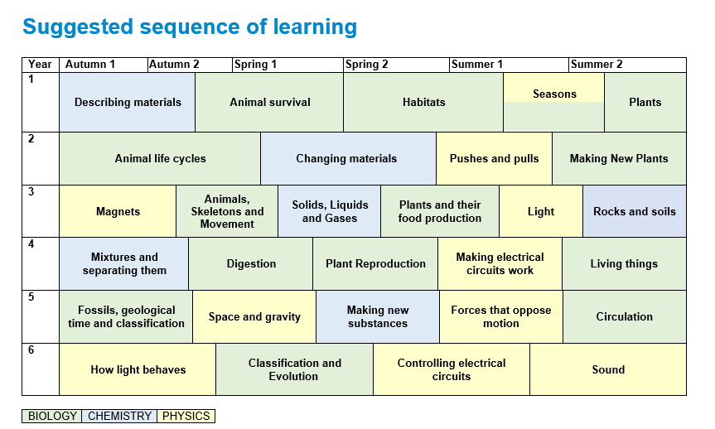
BIOLOGY
Variation and Evolution

Year 1 | Substantive Knowledge from Learning Journeys | National Curriculum Statutory Requirement
Year 1 | Habitats  Knowledge Block 1- Adapted to survive  - There is variation in all living things  - Animals and plants live in a variety of different places called habitats  - Animals and plants have adapted to survive in different habitats  - Wild plants such as ferns, daisies, nettles and dandelions grow randomly.  - Garden plants such as roses, tulips, poppies, daffodils are planted intentionally.  Knowledge Block 2- Plants adaptations for survival  - Plants have specific adaptations for survival  - To survive they need to get water, light, and avoid being eaten  Year 1- Seasons  Knowledge Block 1- Surviving the changing seasons  - There are four seasons, Spring, summer, autumn and winter  - Each season is about three months long  - In Spring, young animals like lambs and chicks are born, the flowers bloom and the weather starts to become warmer.  - In autumn, the leaves fall off the trees and the amount of time we have in the day becomes less.  - Winter has the shortest amount of time during the day and the weather is at its coldest.  - In summer the trees are full of green leaves and the weather is at its warmest.  (THIS SUBSTANTIVE KNOWLEDGE APPEARS IN THE PROGRESSION WITHIN THE PHYSICS- EARTH AND SPACE)  - Animals and plants have adapted ways of surviving the changing seasons  - These include hibernating, storing food, fattening up, migration, loss of leaves  - Trees can be either evergreen or deciduous.  - Evergreen trees keep their green leaves all year round.  - Deciduous trees lose their leaves every autumn. | Year 1 Plants  Pupils should be taught to:  - identify and describe the basic structure of a variety of common flowering plants, including trees.  Year 1 Seasonal Changes  Pupils should be taught to:  - observe changes across the four seasons  - observe and describe weather associated with the seasons and how day length varies  Year 1 Plants  Pupils should be taught to:  - identify and name a variety of common wild and garden plants, including deciduous and evergreen trees
Year 2

Year 3 | Substantive Knowledge from Learning Journeys | National Curriculum Statutory Requirement
Year 4 | Living things  Knowledge Block 1- Classifying living things  - Living things can be divided into groups based upon their characteristics  - Classification keys help group, identify and name living things  - Animals can be classified as vertebrates (having a spine) or invertebrates (lacking a spine)  - In any habitat there are food chains and webs where nutrients are passed from one organism to another when it is eaten  - If the population of one organism in the chain or web is affected, it has a knock-on effect to all the others  Knowledge Block 2- Life cycles  - Mammals, amphibians, insects and birds have different life cycles.  - Lifecycles vary in time depending on the species of animal- it can be as short as just a few weeks for insects, to up to 200 years for sea urchins. Larger animals often have longer life cycles but not always.  - All animal life cycles begin with growth and development followed by reproduction.  - Some animals undergo a complete metamorphosis as they grow. Metamorphosis is a process where animals undergo an abrupt and obvious change in the structure of their body and their behaviour.  - Some animals are eusocial. This means they live in colonies (groups) with one animal or group producing young and the others working to care for them.  Knowledge Block 2- Environmental change  - Environmental change affects different habitats differently  - Human activity significantly affects the environment  - Different organisms are affected differently by environmental change | Year 4 Living things and their habitats  Pupils should be taught to:  - recognise that living things can be grouped in a variety of ways  - explore and use classification keys to help group, identify and name a variety of living things in their local and wider environment  - recognise that environments can change and that this can sometimes pose dangers to living things.  Year 5 Living things and their habitats  Pupils should be taught to:  - describe the differences in the life cycles of a mammal, an amphibian, an insect and a bird  - describe the life process of reproduction in some plants and animals.

Year 5 | Substantive Knowledge from Learning Journeys | National Curriculum Statutory Requirement
Year 5 | Fossils, geological time and classification  Knowledge Block 1- What is evolution and how do we know it happened?  - The Earth is very old. Around 4.2 billion years. We know this from dating rocks  - Life first appeared on Earth around 3.8 billion years ago.  - Life was, at first, very simple but over millions and millions of years life became more complex through the process of evolution  Knowledge Block 2- Evidence for evolution  - There are many sources of evidence for evolution  - Fossils are one of the main sources of evidence for evolution. They show when new organisms appear and when they go extinct.  - Due to the nature of fossil formation and discovery, fossils only provide an incomplete record of evolution.  - Scientists use fossils along with other pieces of evidence (DNA, Embryology, comparative anatomy, artificial selection) to work out how organisms have evolved  - Fossils form when dead organisms are rapidly buried or leave an imprint and are turned to stone over a long period of time. If they survive in the Earth, they then have to be found by a palaeontologist who will study them.  Knowledge Block 3: Classification of life  - All living (and extinct) organisms are classified into groups based upon their physical features.  - This includes animals, plants, fungi, and microorganisms like bacteria.  - Within each of these broad groups, organisms are classified into small subgroups. Animals- invertebrates, mammals, birds, amphibians, reptiles and fish, Plants- flowering plants, ferns, conifers, moss.  - Bacteria are a group of organisms that are not visible to the naked eye but are very abundant and have distinct physical features we can only see under powerful microscopes. | Year 5 Evolution and inheritance  Pupils should be taught to:  - recognise that living things have changed over time and that fossils provide information about living things that inhabited the Earth millions of years ago  Year 6 Living things and their habitats  Pupils should be taught to:  - describe how living things are classified into broad groups according to common observable characteristics and based on similarities and differences, including micro-organisms, plants and animals  - give reasons for classifying plants and animals based on specific characteristics.

Year 6 | Substantive Knowledge from Learning Journeys | National Curriculum Statutory Requirement
Year 6 | Classification and Evolution  Knowledge Block 1: Natural selection  - Evolution is the change of physical form in a population over a long-time span  - Natural selection is the process which controls that change.  - In any population there is variation and competition for resources (food, water, mates).  - Within that variation, organisms that have features which make them better adapted at securing food, water, and mates, are more likely to survive and produce offspring which have inherited those same successful features. Those that are not well adapted will eventually go extinct.  - Over a long enough timeline all organisms in a population will have those successful features.  - This is known as the Theory of Evolution by Natural Selection and was developed by Charles Darwin in 1859  Knowledge Block 2: How Charles Darwin discovered the process of Evolution by Natural selection  - Before Darwin, Lamarck’s Idea of acquired characteristics was proposed. (Giraffes stretch their necks in life, which made their children have longer necks).  - Darwin as a young man travelled around the world on the HMS Beagle. On this 5-year voyage he saw lots of things and recorded down lots of evidence which allowed him to work out how organisms change over time by a different mechanism of Natural selection | Year 5 Evolution and inheritance  Pupils should be taught to:  - recognise that living things produce offspring of the same kind, but normally offspring vary and are not identical to their parents  - identify how animals and plants are adapted to suit their environment in different ways and that adaptation may lead to evolution

HIAS Science Team

Kevin Neil- County Inspector/Adviser for Science Kevin.neil@hants.gov.uk
Emma Cooper- General Inspector/Adviser for Science emma.cooper3@hants.gov.uk
David Whittle- General Inspector/Adviser for Science david.whittle@hants.gov.uk

For further details on the full range of services available please contact us using the following details:

Tel: 01962 874820 or email: hias.enquiries@hants.gov.uk

Upcoming Courses
Keep up-to-date with our learning opportunities for each subject through our Upcoming Course pages linked below. To browse the full catalogue of learning offers, visit our new Learning Zone. Full details of how to access the site to make a booking are provided here.

- English
- Maths
- Science
- Geography
- RE
- History
- Leadership
- Computing
- Art
- D&T
- Assessment
- Support Staff
- SEN

Terms and conditions

You are welcome to:
- download this resource
- save this resource on your computer
- print as many copies as you would like to use in your school
- amend this electronic resource so long as you acknowledge its source and do not share as your own work.

You may not:
- claim this resource as your own
- sell or in any way profit from this resource
- store or distribute this resource on any other website or another location where others are able to electronically retrieve it
- email this resource to anyone outside your school or transmit it in any other fashion.

