HIAS OPEN ACCESS RESOURCE

Hampshire Science Team

Progression of Substantive Knowledge in Chemistry- Materials

Year 1-6
HIAS Science Team

April 2022

© Hampshire County Council
Overview

This document contains…
A progressive list of the substantive knowledge within the Hampshire Science Learning Journeys with reference to the related National Curriculum statutory requirements.

Points to consider when using this resource
The Learning Journeys provide schools with clearly sequenced substantive knowledge across chemistry, biology and physics. Where possible, the links to the National Curriculum statutory and/or non- statutory requirements have been identified.
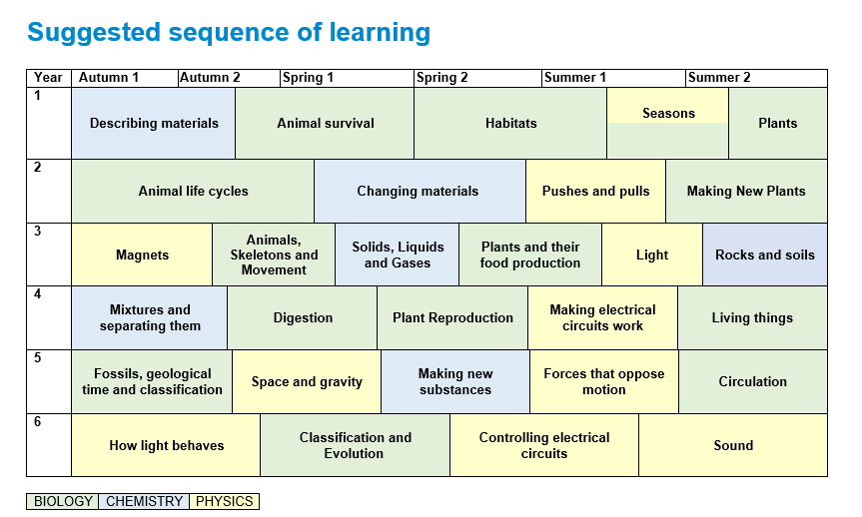

CHEMISTRY
Materials
Year 1 | Substantive Knowledge from Learning Journeys | National Curriculum Statutory Requirement
Year 1 | Describing Materials  Knowledge Block 1- The big idea about materials  - There are many different materials that have different observable properties  - Materials that have similar properties are grouped into metals, rocks, fabrics, wood, plastic and ceramics (including glass). | Year 1 Everyday Materials  Pupils should be taught to:  - distinguish between an object and the material from which it is made  - identify and name a variety of everyday materials, including wood, plastic, glass, metal, water, and rock  - describe the simple physical properties of a variety of everyday materials  - compare and group together a variety of everyday materials on the basis of their simple physical properties.
Year 2 | Changing Materials  Knowledge Block 1- How materials can change  - The properties of a material determine whether they are suitable for a purpose.  - Materials can be changed by physical force (twisting, bending, squashing and stretching).  (The purpose of the activities within this learning journey is for children to understand why we choose certain materials to do certain jobs. Children will plan how to test materials (wood, metal, plastic, glass, brick, paper, rock, cardboard) ) | Year 2 Uses of everyday materials  Pupils should be taught to:  - identify and compare the suitability of a variety of everyday materials, including wood, metal, plastic, glass, brick, rock, paper and cardboard for particular uses  - find out how the shapes of solid objects made from some materials can be changed by squashing, bending, twisting and stretching

Year 3 | Substantive Knowledge from Learning Journeys | National Curriculum Statutory Requirement
Year 3 | Solids, liquids and gases  Knowledge Block 1- Properties of solids, liquids and gases  - Materials can be divided into solids, liquids and gases.  - Solids hold their shape unless forced to change.  - Liquids flow easily but stay in their container because of gravity. The more viscous a liquid the less runny it is.  - Gases move everywhere and are not held in containers by gravity.  Knowledge Block 2- Changing state  - Heating causes solids to melt into liquids and liquids to evaporate to gases.  - Cooling causes gases to condense to liquids and liquids to freeze to solids.  Knowledge Block 3- Melting, freezing, boiling and condensation temperatures  - Different substances change state at different temperatures but the temperatures at which given substances changes state is always the same.  Knowledge Block 4- All about the water cycle  - The temperature at which a substance melts from a solid to a liquid is the same at which it freezes from a liquid to a solid.  - The temperature at which a substance boils from a liquid to a gas is the same at which it condenses from a gas to a liquid.  - Liquids evaporate slowly, even below their boiling temperatures.  - The water cycle is the process by which water is continuously transferred between the surface of the earth and the atmosphere.  - Liquid water evaporates into water vapor, condenses to form clouds, and precipitates back to earth in the form of rain and snow. | Year 4 States of matter  Pupils should be taught to:  - compare and group materials together, according to whether they are solids, liquids or gases  - observe that some materials change state when they are heated or cooled, and measure or research the temperature at which this happens in degrees Celsius (°C)  - identify the part played by evaporation and condensation in the water cycle and associate the rate of evaporation with temperature.

Year 3 | Substantive Knowledge from Learning Journeys | National Curriculum Statutory Requirement
Year 3 | Rocks and soils  Knowledge Block 1- The different types of rocks  - A rock is a solid material made up of minerals forming part of the surface of the Earth  - Rocks are exposed on the surface at cliffs, hills and mountains but are also under the surface.  - Some rocks, called ores contain metals  - Some rocks are made of grains squashed together and can contain the remains of long-dead organisms, called fossils. This type of rock is called sedimentary rock, an example would be limestone, sandstone or mudstone  - Some rocks are made of crystals that are locked tightly together. These are called igneous and metamorphic rocks; an example of igneous rock is granite, and an example of metamorphic rock is slate  Knowledge Block 2- The properties of rocks  - These three types of rocks all have different properties to each other, including porosity, hardness, reaction to chemicals  - The properties of the rock depend on how the rock was formed, e.g. Some igneous rocks form from lava from volcanoes and cool very quickly leading to very small crystals  Knowledge Block 3- The structure of soils  - Soil is made up of small broken-down pieces of rock.  - Soil contains a range of different size rock pieces, e.g., sand grains or stones.  - Soil also contains humus (rotted plant material)  - Soil made of very fine rock is called silt or clay. | Year 3 Rocks  Pupils should be taught to:  - compare and group together different kinds of rocks on the basis of their appearance and simple physical properties  - describe in simple terms how fossils are formed when things that have lived are trapped within rock  - recognise that soils are made from rocks and organic matter.

Year 4 | Substantive Knowledge from Learning Journeys | National Curriculum Statutory Requirement
Year 4 | Mixtures and separating them  Knowledge Block 1- What mixtures are  - A substance is an object with the same properties throughout.  - A mixture is when more than one substance is present in the same container  Knowledge Block 2- What dissolving is  - When a substance is added to a liquid the substance can disappear- this is called dissolving  - A mixture of a substance that has dissolved in a liquid is called a solution  - Not every substance can dissolve in water  Knowledge Block 3- Separating mixtures  - Mixtures can be separated if the substances have different properties  - This is because the substances in the mixture are still present and are unchanged  - There are different techniques for separating mixtures.  - Filtration requires the substances be one that does not dissolve in a liquid to work.  - Sieving requires the substances to be of different sizes to work  - Magnets requires the substances to be some magnetic materials and some non-magnet materials to work.  - Evaporation requires a solid substance dissolved in water and the solid has a higher boiling point in water to work.  - Floating requires some substances to float and some substances to sink to work. | Year 5 Properties and changes of materials  Pupils should be taught to:  - compare and group together everyday materials on the basis of their properties, including their hardness, solubility, transparency, conductivity (electrical and thermal), and response to magnets  - know that some materials will dissolve in liquid to form a solution, and describe how to recover a substance from a solution  - use knowledge of solids, liquids and gases to decide how mixtures might be separated, including through filtering, sieving and evaporating
Year 5 | Making new substances  Knowledge Block 1: Reversible and irreversible changes  - All matter, including gas, has mass.  - Sometimes, mixed substances react to make a new substance. These changes are usually irreversible.  - Heating can sometimes cause materials to change permanently. When this happens, a new substance is made. These changes are not reversible.  - Indicators that something new has been made are the properties of the material are different (colour, state, texture, hardness, smell, temperature)  - If it is not possible to get the material back easily it is likely that it is not there anymore and something new has been made (irreversible change) | Year 5 Properties and changes of materials  Pupils should be taught to:  - give reasons, based on evidence from comparative and fair tests, for the particular uses of everyday materials, including metals, wood and plastic  - demonstrate that dissolving, mixing and changes of state are reversible changes  - explain that some changes result in the formation of new materials, and that this kind of change is not usually reversible, including changes associated with burning and the action of acid on bicarbonate of soda.
Year 6

HIAS Science Team

Kevin Neil- County Inspector/Adviser for Science Kevin.neil@hants.gov.uk
Emma Cooper- General Inspector/Adviser for Science emma.cooper3@hants.gov.uk
David Whittle- General Inspector/Adviser for Science david.whittle@hants.gov.uk

For further details on the full range of services available please contact us using the following details:

Tel: 01962 874820 or email: hias.enquiries@hants.gov.uk

Upcoming Courses
Keep up-to-date with our learning opportunities for each subject through our Upcoming Course pages linked below. To browse the full catalogue of learning offers, visit our new Learning Zone. Full details of how to access the site to make a booking are provided here.

- English
- Maths
- Science
- Geography
- RE
- History
- Leadership
- Computing
- Art
- D&T
- Assessment
- Support Staff
- SEN

Terms and conditions

You are welcome to:
- download this resource
- save this resource on your computer
- print as many copies as you would like to use in your school
- amend this electronic resource so long as you acknowledge its source and do not share as your own work.

You may not:
- claim this resource as your own
- sell or in any way profit from this resource
- store or distribute this resource on any other website or another location where others are able to electronically retrieve it
- email this resource to anyone outside your school or transmit it in any other fashion.

