HIAS OPEN ACCESS RESOURCE

Hampshire Science Team

Progression of Substantive Knowledge in Biology- Plants

Year 1-6
HIAS Science Team

April 2022

© Hampshire County Council
Overview

This document contains…
A progressive list of the substantive knowledge within the Hampshire Science Learning Journeys with reference to the related National Curriculum statutory requirements.

Points to consider when using this resource
The Learning Journeys provide schools with clearly sequenced substantive knowledge across chemistry, biology and physics. Where possible, the links to the National Curriculum statutory and/or non- statutory requirements have been identified.
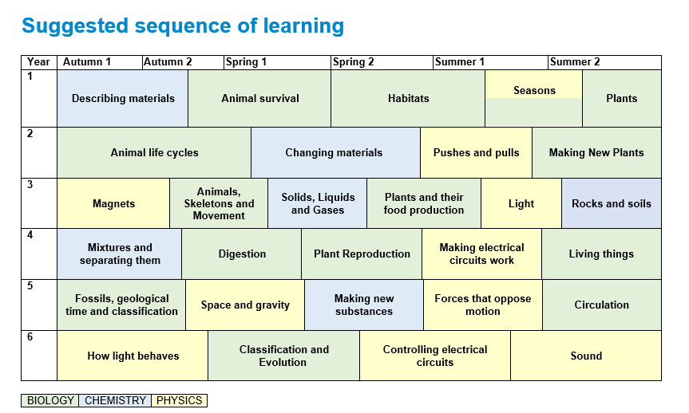
BIOLOGY
Plants
Year 1 | Substantive Knowledge from Learning Journeys | National Curriculum Statutory Requirement
Year 1 | Plants  Knowledge Block 1- Where do plants come from  - A seed contains a miniature plant that can develop into a fully grown plant.  - A bulb has underground vertical shoots which already has modified leaves  - Seeds and bulbs need water to grow but most do not need light (germination)  - Seeds and bulbs have food stores inside them to help the plant start to grow.  Knowledge Block 2- Plant survival  - To survive plants, need to get water, light, and avoid being eaten  Knowledge Block 3- How plants get what they need to survive  - A seed produces roots to allow water to get into the plant.  - A seed produces shoots to produce leaves to collect the sunlight.  - A basic plant structure can include leaves, flowers (blossom), petals, fruit, roots, bulb, seed, trunk, branches, stem | Year 1 Plants  Notes and guidance (non-statutory)  Pupils should use the local environment throughout the year to explore and answer questions about plants growing in their habitat. Where possible, they should observe the growth of flowers and vegetables that they have planted.  They should become familiar with common names of flowers, examples of deciduous and evergreen trees, and plant structures (including leaves, flowers (blossom), petals, fruit, roots, bulb, seed, trunk, branches, stem).  From Year 2  Note: Seeds and bulbs need water to grow but most do not need light; seeds and bulbs have a store of food inside them.
Year 2 | New Plants  Knowledge Block 1- What flowers are for  - All flowering plants make seeds (reproduction) that can grow (germinate) into new plants  - Plants need water, light and a suitable temperature to grow and stay healthy  Knowledge Block 2- What happens after a plant has produced seeds  - Some plants die after it has produced its seed and sometimes the plant lives for many generations producing seeds each year | Year 2 Plants  Pupils should be taught to:  - observe and describe how seeds and bulbs grow into mature plants  - find out and describe how plants need water, light and a suitable temperature to grow and stay healthy.  Notes and guidance (non-statutory)  Pupils should use the local environment throughout the year to observe how different plants grow. Pupils should be introduced to the requirements of plants for germination, growth and survival, as well as to the processes of reproduction and growth in plants.

Year 3 | Substantive Knowledge from Learning Journeys | National Curriculum Statutory Requirement
Year 3 | Plants and their food production  Knowledge Block 1- Plants don’t go to McDonalds  - Plants do not eat food so have to make their own.  - This food provides then with energy, and materials to grow  - To make the food (sugar) plants need water from the ground, carbon dioxide from the air and light from the sun.  - The water is taken up through the roots from the soil  - The carbon dioxide is taken in through the leaves  - As well as food, plants also make oxygen which is given out back into the air through the leaves | Year 3 Plants  Pupils should be taught to:  - identify and describe the functions of different parts of flowering plants: roots, stem/trunk, leaves and flowers  - explore the requirements of plants for life and growth (air, light, water, nutrients from soil, and room to grow) and how they vary from plant to plant  - investigate the way in which water is transported within plants
Year 4 | Plant reproduction  Knowledge Block 1- The reproductive parts of a flowering plant  - Flowering plants reproduce by the process of pollination  - Pollination leads to the formation of a seed which can grow into a new plant  - Flowering plants have evolved specific parts to carry out pollination and seed growth  - Those parts are stamen where pollen is produced, stigma where pollen is collected, and the ovaries which contains the eggs that become a seed when the pollen travels down the stigma and meets the egg  - Flowers have petals also are a range of colours, patterns, and smells to attract insects  Knowledge Block 2- All flowers are similar but different  - Plants and flowers look different because they pollinate in different ways.  - There are two types of pollination Insect and wind  - Insect pollinated flowers are usually bright coloured and strong scents  - Wind pollinated flowers have less colourful petals and much less scent  Knowledge Block 3- Seed dispersal  - Plants have evolved many different ways to disperse their seeds  - Seed dispersal increases the chances of seeds germinating and growing into a mature plant  Knowledge Block 4- What a seed does  - A seed contains a miniature, undeveloped version of the plant  - They contain a food store for the first stage of growth (until the plant can make its own food)  - They are surrounded with a protective coat. | Year 3 Plants  Pupils should be taught to:  - explore the part that flowers play in the life cycle of flowering plants, including pollination, seed formation and seed dispersal.
Year 5
Year 6

HIAS Science Team

Kevin Neil- County Inspector/Adviser for Science Kevin.neil@hants.gov.uk
Emma Cooper- General Inspector/Adviser for Science emma.cooper3@hants.gov.uk
David Whittle- General Inspector/Adviser for Science david.whittle@hants.gov.uk

For further details on the full range of services available please contact us using the following details:

Tel: 01962 874820 or email: hias.enquiries@hants.gov.uk

Upcoming Courses
Keep up-to-date with our learning opportunities for each subject through our Upcoming Course pages linked below. To browse the full catalogue of learning offers, visit our new Learning Zone. Full details of how to access the site to make a booking are provided here.

- English
- Maths
- Science
- Geography
- RE
- History
- Leadership
- Computing
- Art
- D&T
- Assessment
- Support Staff
- SEN

Terms and conditions

You are welcome to:
- download this resource
- save this resource on your computer
- print as many copies as you would like to use in your school
- amend this electronic resource so long as you acknowledge its source and do not share as your own work.

You may not:
- claim this resource as your own
- sell or in any way profit from this resource
- store or distribute this resource on any other website or another location where others are able to electronically retrieve it
- email this resource to anyone outside your school or transmit it in any other fashion.

