Task to term be completed over this half | Home Apps  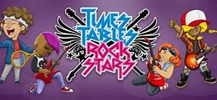  Timetable Rockstars  Even in Y6, timetables are vital to support in many areas. |  | Spelling  Practise daily spelling using the word sums that we will be focusing on in class.  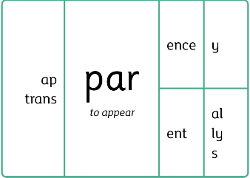  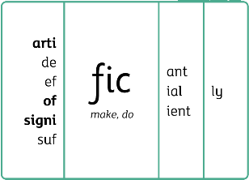  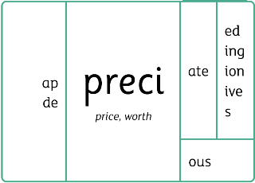 |  | Creative Family project:  Submission date: Week of 9th February  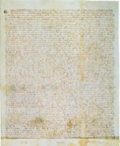  This term we are looking at the reign of King John and the signing of the Magna Carter.  Why was the signing of the Magna Carter so significant? What made King John one of the worst kings in history?  Research using the sites below:  https://www.youtube.com/watch?v=7xo4tUMdAMw  https://www.theschoolrun.com/homework-help/the-magna-carta  Consider why this event was significant for the time period for the monarchy. How did this impact the future?  You can present your learning in your own creative way: a drawing of King John, a fact file of why he was ‘the worst King’, a family tree of monarchs, a poster, a PowerPoint, a King John/Magna Carta commemorative coin.  Try and use recyclable materials where possible!
Task to term be completed over this half | Oxford Reading Buddy  Login to read books matches to your child’s level and complete online comprehensions.  Oxford Reading Buddy - Log in  At least four times a week.  Can year six be the year group that have completed the most quizzes?
Spellings to learn at home | Week 1 Spellings (Test 16.1.26)  sign  campaign  limbs  plumber  wriggle  answer  aisle  resign | Week 2 Spellings (Test 23.1.26)  foreign  debt  doubtful  honest  subtle  sword  debris  wrinkle |  | Week 3 Spellings (Test 30.1.26)  hymn  symptom  anchor  echo  chauffeur  mystery  syringe  chemist |  | Week 4 Spellings (Test 6.2.26)  stomach  brochure  crochet  cygnet  orchestra  moustache  chef  myth
In History, we are learning about:  - The changing power of the monarchs (British study that extends beyond 1066) | In Science, we are learning about:  - Classification and evolution | Curriculum Overview  Spring 1  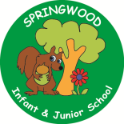  Year 6 | In PSHE, we are learning about:  Trying Your Best and Be Proud  - Keeping safe influences on their behaviour and resisting pressure  - Images in the media and reality; how this can affect how people feel  Healthy relationships by considering:  - Different types of relationships; positive and healthy relationships; maintaining relationships; recognising when a relationship is unhealthy (including forced marriage); committed; loving relationships; marriage.  - Acceptable and unacceptable physical touch; personal boundaries and the right to privacy  - Recognising challenging stereotypes  - Discrimination and bullying
In RE, we will be learning about:  - Theme/Unit: Ramadan and Eid-ul-Fitr  - Concept: Ritual | In MFL, we are developing our French skills through:  - Clothes  - Habitats
In PE, we are learning:  - Netball  - Dance - Samba | In Computing, we are learning about:  - QR codes
In English, we are using The Three Little Pigs (Guardian Advert):  - A police report  - A diary entry  - A persuasive letter  - A short narrative to include dialogue  In Reading we will be following a revision plan and looking at extracts from the following texts:  - Becoming (Michelle Obama)  - Earth Heroes (Lily Dyu)  - The tiger who sleeps under my chair (Hannah Foley)  - The worlds we leave behind (A F Harold)  Goddess (Janina Ramirez)  - A year of Nature Poems (Jospeh Coelho)  - Wolfbane (Michael Paver) |  |  | In Maths, we will continue to develop our Arithmetic skills.  We will also develop our skills and knowledge in:  - Fractions and decimals  - Percentages  - Measures

