
This sheet has been created to give you support in how to practise essential skills that your child needs in Year 1.
Revise these previously taught sounds.
Practise reading and writing them with the correct letter formation.
Pre-teach poster
Year 1
Autumn 2

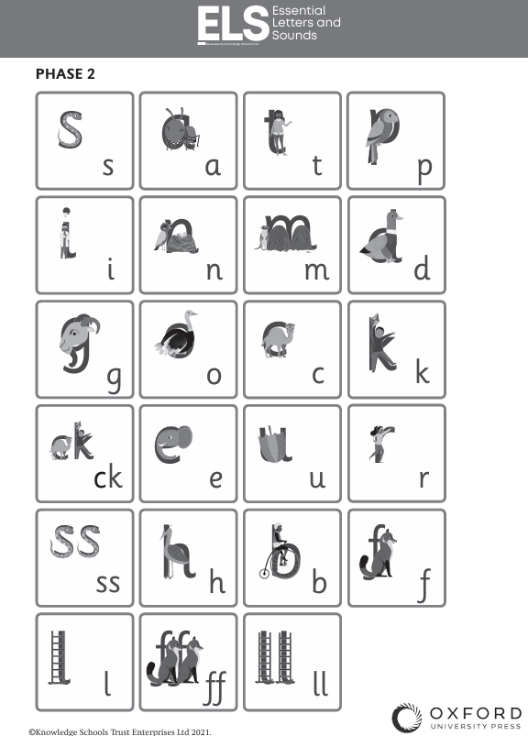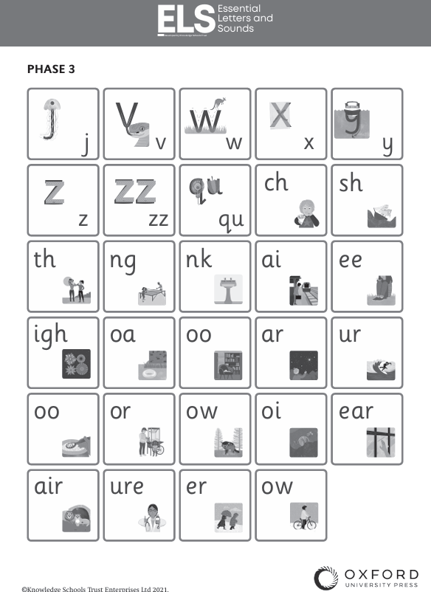

Reading  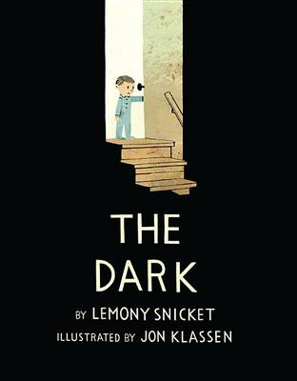 | Hard to read words to learn by sight:  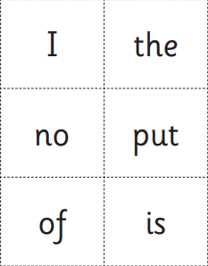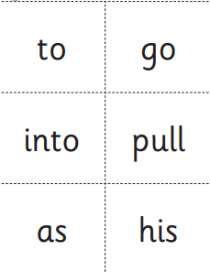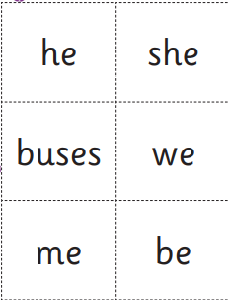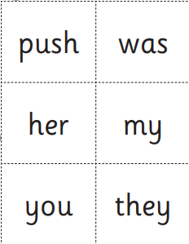 |   YouTube Song to practise reading Harder to Read and Spell Words.
Writing  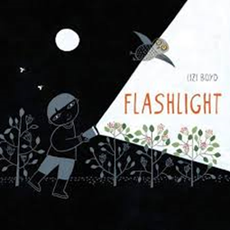 | Skill: Practise writing very simple sentences.  For example:  He looked at the bat. |   ELS Phase 2 Soundmat to support spelling at home .
Maths | Core Skill: Practise counting and ordering numbers to 20.  - Counting on and back (0-20)  - Ordering and sequencing numbers  - 1 more and 1 less  - Addition and subtraction within 10 using drawings to support. |   Ordering numbers up to 20 Maths Game,

