Task to be completed over this half term | Phonics  Continue to practise your sounds that you find tricky at home.  Practise reading and spelling these hard to read and spell words:  please  once  any  many  again  who  whole  where  two |  |  | Maths  *How many ways can you find to make 5/6/7/8/9/10 with addition?  *Can you subtract two numbers within 20 using the draw and cross out method?  E.g.  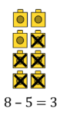  *Practise writing your numbers from 10-20, making sure they are the right way around.  Challenge: Write the 10s numbers (10-20-30-40-50-60-70-80-90-100), again making sure the digits are the right way around.  *Can you use a number line or objects at home (e.g. pasta) to find one more and one less than a number between 10-20. |  | Reading  There are decodable books on our Oxford Old site for children to read 3x a week  Try to:  - segment and blend using your phonics  - read tricky words on sight  *Can you re-read the sentence once you have sounded it out?  Look at the stories we’ve studied so far.  -What do these stories have in common?  -What is your favourite part?  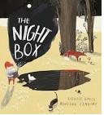  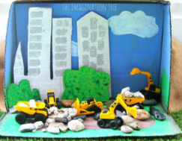  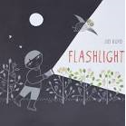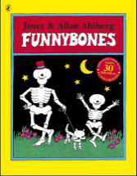  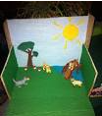  Flashlight- Lizi Boyd  Funnybones – Janet and Allen Ahlberg  The Night Box- Louise Grieg and Ashling Lindsay |  | Creative Family project:  Submission date:  Handed in week beginning 15th December  Geography: human and physical features in and around our school.  Think about your favourite place near our school. Could you draw or paint it, or create a model of it in a shoebox?  Physical features: Things that happen naturally, such as trees, ponds and flowers.  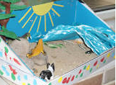  Human features: Things that are built by humans.
Spellings |  | Week 2 (Testing on 14.11)  cell  daisy  talk  walk  my  you  they  all | Week 3 (Testing on 21.11)  hair  pure  ladder  dinner  I  no  of  to |  | Week 4 (Testing on 28.11)  tower  chair  cure  grow  into  as  the  put |  | Week 5 (Testing on 05.12)  snow  pair  picture  crow  is  go  pull  his |  | Week 6 (Testing on 12.12)  low  toast  point  cook  he  she  we  me
In Geography, we are learning about:  - My school and local area. | In Science, we are learning about:  - How animals survive. | Curriculum Overview  Autumn 2  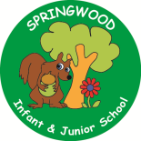  Year 1 | In PSHE, we are learning about:  Relationships  Having safe relationships by:  - Recognising privacy  - Staying safe  - Seeking permission  Respecting ourselves and others by:  - Understanding how behaviour affects others  - Being polite and respectful | In RE, we will be learning about:  - Theme/Unit: The Nativity Journey  - Concept: Journey’s end
In PE, we are learning about:  - Ball skills (hands)  - Gymnastics (body parts) | In Computing, we are learning:  - Algorithms unplugged |  | In Music, we are learning about:  - Dimensions Focus: timbre & dynamics | In Art, we are:  - Exploring drawing portraits of a teddy linked to illustrator and author Shirley Hughes (Dogger)
In English, we will be writing a sequence of captions linked to our key text, Flashlight by Lizi Boyd. We will be writing an informative poster about light and dark. We will be writing a letter to the owner of the house linked to our key text, Funny Bones by Janet and Alan Ahlberg.  In Reading we will be Reading complimentary texts including:  The Dark – Jon Klassen, Float – Daniel Miyares, Flotsam – David Wiesner |  |  | In Maths, we are learning about:  - Numbers to 20  - Addition and subtraction within 20

