Task to be completed over this half term | Early Reading / Phonics    Help your child to login to their Essential Letters and Sounds E Library Account using the password you have been provided with separately.  To best support your child learning how to read we ask that you read the online decodable text shared by the school 3+ times across the week. Your child will be praised and rewarded in school for their reading practise. |  | Maths  *Practise writing your numbers from 1-20, making sure they are round the right way and formed the correct way.  Challenge: Can you write the teen numbers 11-19 making sure the digits are in the correct place?  *Tell someone what is the same and what is different about 14 and 41.  Number Bonds to 20  *Pick two numbers that make 20. e.g. 6 + 14 = 20. What happens when you reverse the numbers? Does it still make 20? e.g. 14 + 6 = 20  *Use this sentence to talk about your number bonds.  20 is the whole, …… is a part and …. is a part.  e.g. 20 is the whole, 15 is a part and 5 is a part.  20 is the whole, 18 is a part and 2 is a part.  Challenge: Can you find 3 numbers that make 10? e.g. 2 + 2 + 6 =10 |  |  | Reading for pleasure  This half term we are learning about Traditional Tales, starting with Cinderella!  - What traditional tales do you know?  - What do all traditional tales have in common?  - What can you find out about Aesop’s Fables?  You could discuss these stories and listen to them from YouTube as part of your home learning!  Or perhaps you could visit the local library and find tales there… |  | Creative Family project:  Submission date: week of 9.2.26  History - Florence Nightingale and Mary Seacole  Florence Nightingale was known as the “Lady of the Lamp.”  - Can you make an old fashioned lantern at home?  Here are some ideas on how you could do this.  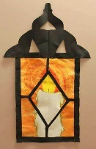  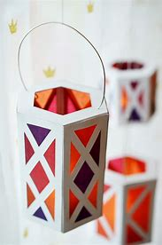  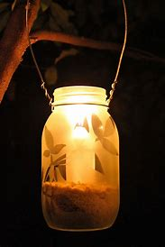
Spelling Quizzes |  | Week 2 Days of the Week  Quiz on 16.01.26  Monday  Tuesday  Wednesday  Thursday  Friday  Saturday  Sunday |  | Week 3 Review  Quiz on 23.01.26  Toy  Enjoy  Twirl  Shirt  Ball  Tall  Push  pull | Week 4 Review  Quiz on 30.01.26  Blue  Clue  Lawn  Drawn  When  What  Me  be |  | Week 5 Review  Quiz on 06.02.26  Whisk  Wheat  Dolphin  Graph  Said  So  He  she |  | Week 6 Review  Quiz on 13.02p.26  Launch  Haunt  Cake  Date  Out  Little  My  Put
In History, we are learning about:  - The life and contributions to healthcare of Florence Nightingale and Mary Seacole | In Science, we are continuing to learn about:  - Animals and their habitats. | Curriculum Overview  Spring 1  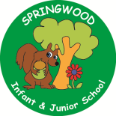  Year 1 | In PSHE, we are learning about:  -Belonging to a Community  -Media Literacy and Digital Resilience  -Money and Work | In RE, we will be learning about:  - Followers of Jesus (through the concept precious)
In PE, we are learning about:  - Ball skills: Feet  -Dance: Growing | In Computing, we are learning:  - Rocket to the moon |  | In Music, we are learning about:  - Dragons | In Art, we are:  - Creating a collaborative Giant Beanstalk made from painted and printed leaves.  - Designer: Orla Kiely
In English, we are starting our learning journey using ‘Cinderella’ as our stimulus to write:  - an invitation  In Reading we will be Reading complimentary texts including:  -Jack and the Baked Beanstalk  -Fairy Tales for Mr Barker  -Jim and the Beanstalk |  |  | In Maths, we will continue to develop our Arithmetic skills.  We will also develop our skills and knowledge in:  -Time  -Exploring Calculation  -Numbers to 50  -

