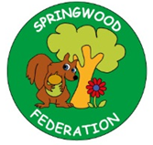
Revise these previously taught sounds.
Practise reading and writing them with the correct letter formation.
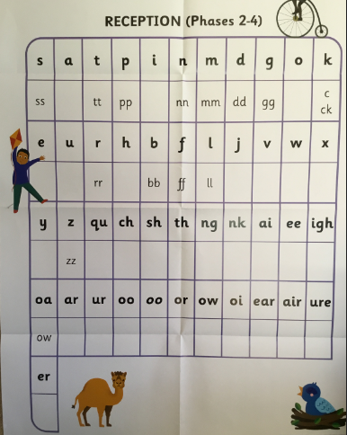
Pre-teach poster
Year 1
Spring 1

Reading  How many traditional tales do you know? Can you find some in the library? | Learn sounds and hard to read words by sight:  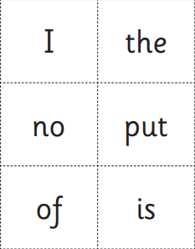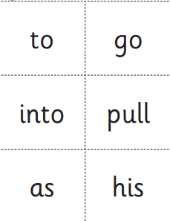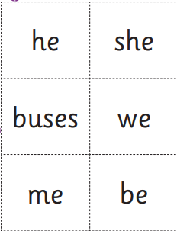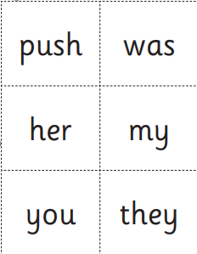  Skill: To read common words fluently. | 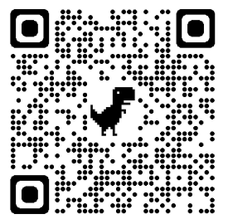  Watch the traditional version of the tale and discuss each part of the story.  What happens first, next, then, after that and finally?
Writing  Practise writing simple sentences e.g. He has a cow. | Words to understand the meaning of: traditional tale, character, setting, plot, problem, resolution, beginning, middle and end.  Skill: How to write a sentence. | 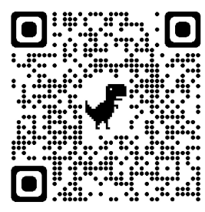  How to write a sentence.
Maths  Can you say all of the pairs of numbers that make ten off by heart? | Words to use: add, plus, total, sum, number bond, calculation, subtract, take away, leaves, minus, all together, is equal to, equation  Skill: To learn number bonds to 10 and the corresponding subtraction facts.: eg…  1 + 9 = 10 10 = 9 + 1 10 – 1 = 9  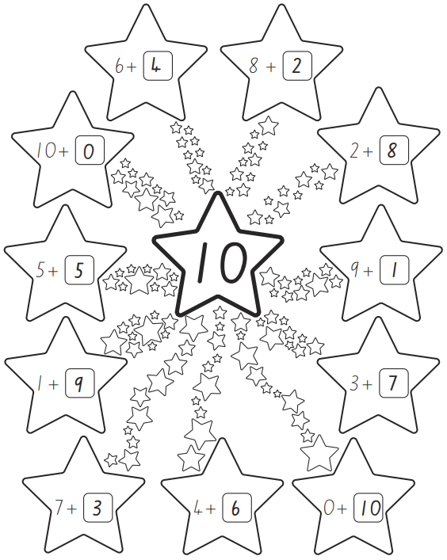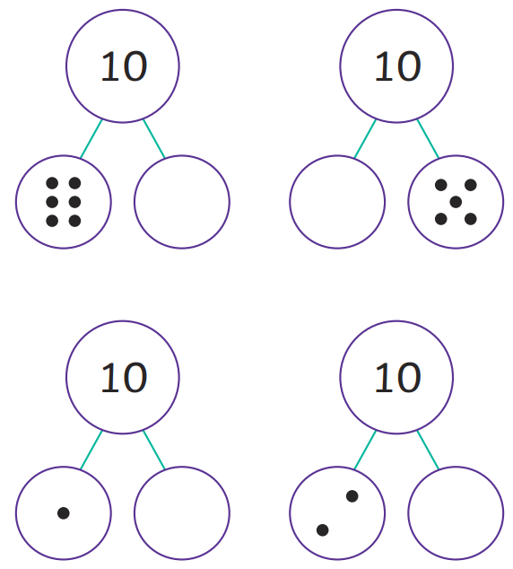 |   Use pasta pieces, buttons, crayons or whatever you have at home to practice making totals to 10, Then use this to work out the corresponding subtraction facts.  Practice this often to help your child to remember the facts to 10 off by heart.

