Task to be completed over this half term | Early Reading / Phonics    Help your child to login to their Essential Letters and Sounds E Library Account using the password you have been provided with separately.  To best support your child learning how to read we ask that you read the online decodable text shared by the school 3+ times across the week. Your child will be praised and rewarded in school for their reading practise.  Well done, to those children who have been receiving certificates for reading books in multiples of 10.  Keep looking on Oxford Owl for books set to your child’s reading book band.  -Please ask if you have any problems with books or logging on. |  | Maths  *Practise counting to 50.  Challenge: Can you write the numbers 0-50 making sure the digits are in the correct place?  *Practise using a number line to add two numbers within 20.  E.g. 2 + 15 = ?  *Practise your number bonds to 10 and 20.  Challenge: Can you find all your number bonds to 10 and 20? |  | Reading for pleasure  Don’t forget to return your library book on a Friday so it can be exchanged for a new one, the library computer will not issue a new book until the outstanding book is returned.  To start with this half term, we are going to be writing a recount of events in the story Hom by Jeannie Willis  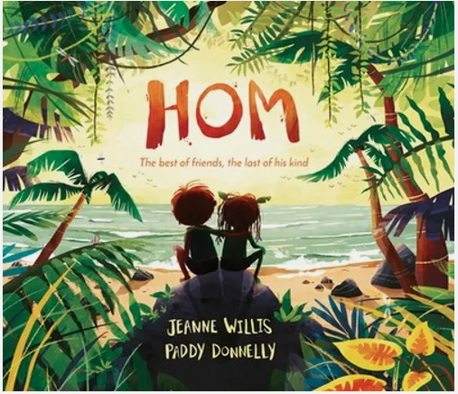 |  | Submission date: W/C 23rd March 2026, projects to be in school no later than the 27.3.26  Get creative this Easter! Design and make your very own “eggcellent” scene or drawing. This can be created in 2D or 3D, and we encourage the children to use their own interests and imagination to go wild with their ideas, using materials from around your home. We’ve teamed up with FOSS (Friends of Springwood Schools) and there will be prizes for 1st, 2nd and 3rd place in each class. Please ensure entries are appropriate for your child’s age.  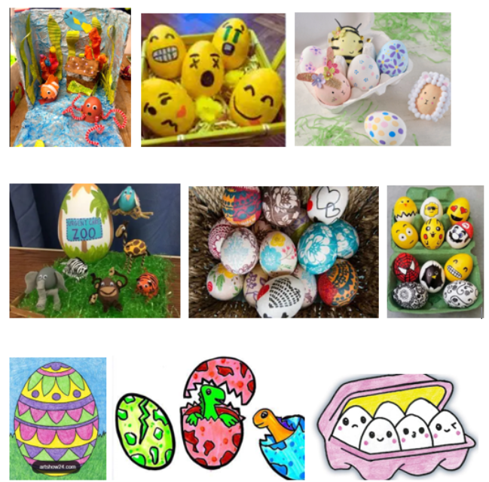
  Creative family project:
Spelling Quizzes | Week 2 Quiz on 06.03.26  crew  seat  birds  drawing  all  are  when  what | Week 3 Quiz on 13.03.26  ties  enjoy  true  growing  said  so  have  were |  | Week 4 Quiz on 20.03.26  smile  flute  happy  toes  little  one  do  children |  | Week 5 Quiz on 27.03.26  launch  whisking  played  looking  your  their (it is their house)  oh  love
In Geography, we are learning about:  - Our local area | In Science, we are continuing to learn about:  - Animals and their habitats.  - Seasons | Curriculum Overview  Spring 2  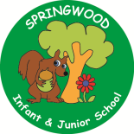  Year 1 | In PSHE, we are learning about:  - Media literacy and digital resilience: Using the internet and digital devices; communicating online  - Money and work: Strengths and interests; jobs in the community | In RE, we will be learning about:  - The Easter story though the concept of love, happiness and sadness.
In PE, we are learning about:  -Ball skills: Hands 2  -Dance: The Zoo | In Computing, we are learning:  - Bee Bots  Exploring commands, instructions and errors through the use of a Bee-Bot |  | In Music, we are continuing to learn about:  - Dimensions Focus: Dynamics- respond to, recognise and identify getting louder and quieter.  Tempo- respond to, recognise and recognise getting faster and slower.  Through the context of carnival of the animals. | In DT, we are:  - Creating a fruit salad by learning how to prepare fruits and vegetables.
In English, we are starting our learning journey using ‘Hom” as our stimulus to write: a simple recount of events, Follow Me Little Fox – Camilla Correa  to write a descriptive poem, Where The Wild Things Are – Maurice Sendak to write a character description and The Storm Whale - Benji Davis  To write a letter to an important person.  Reading linked texts:  In Reading we will be reading the final two books of the Hampshire Picture Book Competition ready to vote for our favourite: Basil Dreams Big by Lu Fraser and Everywhere with You by Carlie Sorosiak. Then we will read texts linked to our English learning: The Best, Worst Day Ever by Sophy Henn and Wanted: The Perfect Pet by Fiona Roberton. |  |  | In Maths, we will continue to develop our Arithmetic skills.  We will also develop our skills and knowledge in:  - Numbers to 50  - Addition and subtraction within 20  - Fractions  - Measures: Length and mass

