Task to be completed over this half term | Suggested Timetable: |  | Maths:  Please continue practising telling the time to the 5 minutes.  e.g. 5 past 3  10 to 4  quarter past 6  quarter to 8  We will continue focusing on multiples of x2, x5, x10 and x3. Remember, you need to be able to recall facts without hesitation!   |  | Reading  Continue to read at least 3 times a week. This can be on Oxford Reading Buddy and/or a library book.  Challenge yourself to read a narrative and a non-fiction book this half term.  Your teacher recommends and will be reading with you:  - George’s Marvellous Medicine  - The Barnabus Project  - The Boy Whose Wishes Came True  Use non-fiction books to learn about:  - The Ivory Coast  - Fair Trade  - Skeletons and the human body |  | A creative family project:  Submission date: Monday 15th December  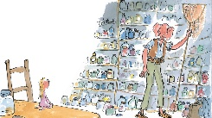  In English, we will be reading the BFG. Our learning will be all about the dreams that he catches, bottles up and delivers.  Dream Jars & Descriptions  We would like you to design and decorate your own “dream jars” (real or paper ones).  Inside, we would like you to write a description of a dream using adjectives, similes and imaginative language.  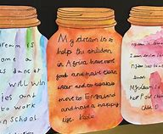  How to make a BFG Dream Jar  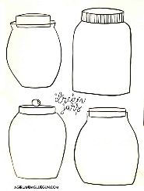  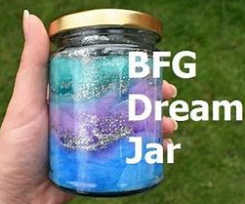
  Week 1 | Spellings  Oxford Reading Buddy  Maths focus – TTRS
  Week 2 | Spellings  Oxford Reading Buddy  Maths focus – Telling the time
  Week 3 | Spellings  Oxford Reading Buddy  Maths focus – TTRS
  Week 4 | Spellings  Oxford Reading Buddy  Maths focus – Telling the time
  Week 5 | Spellings  Oxford Reading Buddy  Maths focus – TTRS
Spelling words to practise | Week 1 (Testing on 14.11) | Week 2 (Testing on 21.11) |  | Week 3 (Testing on 28.11) |  | Week 4 (Testing on 05.12) |  | Week 5 (Testing on 12.12)
Spelling words to practise | jumped  remove  actually  angrily  busiest  forwards  awkwardly  dispossess  possessive  families | jumps  moving  gently  happily  busily  mysterious  famous  dangerous  courageous  humorous |  | slowly  strangely  business  backwards  afterwards  admiration  inspiration  location  sensation  rotation |  | towards  possessed  possession  stitches  ladies  medical  medicate  medicine  medication  medically |  | flies  babies  glasses  wishes  movement  prehistory  historian  historic  prehistoric  historical

In Geography, we are learning about:  - The Ivory Coast  - Understanding of economic activity linked to chocolate and how the UK is connected to the Ivory Coast through trade. | In Science, we are learning about:  - Animals, skeletons and movement | Curriculum Overview  Autumn 2  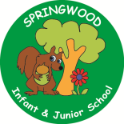  Year 3 | In PSHE, we will continue to focus on:  - Families and friendships  - Respecting ourselves and others  - Safe relationships | In RE, we will be learning about:  - Theme/Unit: Angels
In PE, we are learning:  - Gymnastics  - Handball | In Computing, we are learning how to use:  - Scratch (coding) |  | In Music, our learning links to:  - Stone Age  - Ivory Coast | In DT, we are looking at:  - Healthy and Varied Diet  - Protein flapjacks
In English, we are using the following text drivers:  - The Dreamgiver (Literacy Shed Video) - writing a narrative.  - The BFG (Roald Dahl) - writing a recipe for our own dream.  In Reading, we will be looking at a variety of different texts linked to the themes visited within the Writing quality text drivers. These themes focus on dreams and stepping into the unknown. |  | In MFL, we are beginning to learn French through the topics of:  - Animals | In Maths, we will continue to develop our Arithmetic skills.  We will also develop our skills and knowledge.  - Graphs  - Addition & Subtraction  - Length & Perimeter

