Task to be completed over this half term | Suggested Timetable: |  | Maths:  We are securing our understanding of our times tables knowledge.  This includes multiples of 2x, 5x, 10x and 3x.  We need to ensure that we are confident and can recall our times tables facts confidently by heart.  These can be practised on TTRS.    Addition and Subtraction of numbers up to 1000  When practising, we need to ensure that we have a secure knowledge of place value including knowing how many hundreds, tens, and ones a number has. |  | Reading  Continue to read at least 3 times a week. This can be on Oxford Reading Buddy and/or a library book.  Challenge yourself to read a narrative and a non-fiction book this half term.  Your teacher recommends and will be reading with you:  - Who’s afraid of the big bad book?  - Beware of the Storybook Wolves  - Orion and the Dark  - Revolting Rhymes  Use non-fiction books to learn about:  - The Romans  - Solids, Liquids and Gases |  | A creative family project:  Submission date: 9th February  Roman shield  In History this term, we will be learning about the Romans and the Roman Empire.  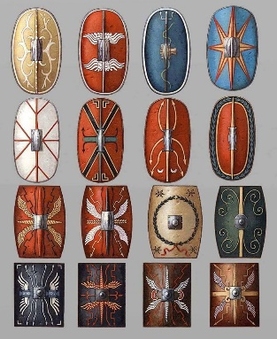  We would like you to research Roman Shields and create your own.  Look at their design, shape and uses. Design and make your own.  Don’t forget to add a handle on the back!  Possible construction materials include: cereal boxes, papier-mâché, tin foil, waste materials etc.  We will be using these shields in our History lesson to reconstruct battle techniques.
  Week 1 | Spellings  Oxford Reading Buddy  Maths focus – TTRS
  Week 2 | Spellings  Oxford Reading Buddy  Maths focus – Addition of numbers up to 1000
  Week 3 | Spellings  Oxford Reading Buddy  Maths focus – TTRS
  Week 4 | Spellings  Oxford Reading Buddy  Maths focus – Subtraction of numbers up to 1000
  Week 5 | Spellings  Oxford Reading Buddy  Maths focus – Telling the time
Spelling words to practise | Week 1 (Testing on 16.01) | Week 2 (Testing on 23.01) |  | Week 3 (Testing on 30.01) |  | Week 4 (Testing on 06.02) |  | Week 5 (Testing on 13.02)
Spelling words to practise | wrap  wriggle  wrestle  write  writing  wrist  written  wrong  wrote  wreck | answer  heart  busy  build  early  enough  fruit  grammar  February  height |  | arrive  century  decide  different  experiment  famous  group  guard  imagine  important |  | believe  guide  increase  island  learn  length  minute  natural  notice  often |  | caught  possible  pressure  promise  question  remember  sentence  special  straight  surprise

In History, we are learning about:  - The Roman Empire & its impact on Britain | In Science, we are learning about:  - Animals, skeletons, and movement  - Solids, Liquids and Gases | Curriculum Overview  Spring 1  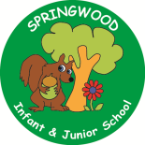  Year 3 | In PSHE, we are focusing our learning on the themes of:  - Belonging to a community  - Media literacy and digital resilience  - Money and work | In RE, we will be learning about:  Theme/Unit: Torah  Concept: Authority
In PE, we are learning:  - Basketball  - Dance | In Computing, we are learning about:  - Computing systems and networks: Emailing |  | In Music, our learning links to:  - Romans  - Our Local Area | In Art, we are looking at:  - Roman ‘pinch’ pots
In English, we are using the following text drivers:  - The Wolf Story - writing a narrative.  - The Three Billy Goats Gruff – writing a character description.  - The King who banned the dark – writing a persuasive speech.  In Reading, we will be looking at a variety of different texts linked to Traditional Tales. |  | In MFL, we are beginning to learn French through the topics of:  - Instruments | In Maths, we will continue to develop our Arithmetic skills.  We will also develop our skills and knowledge.  - Length and Perimeter  - Multiplication and Division

