Task to be completed over this half term | Suggested Timetable: | Maths:  It is vital that children at the end of Year 3 can recall the 2x, 3x, 4x, 5x, 10x tables fluently without using their fingers.  e.g. If you ask them 5x2, they should be able to answer 10 within 3-5 seconds.  TTRS and ‘Hit The Button’ are great games to help practise these skills.  www.topmarks.co.uk/maths-games/hit-the-button  Children in Year 3 must also be able to tell the time in 5-minute intervals (using an analogue and digital clock). This is something that lots of children find tricky, therefore would be beneficial to practise at home. |  | Reading  Continue to read at least 3 times a week. This can be on Oxford Reading Buddy and/or a library book.  Challenge yourself to read a narrative and a non-fiction book this half term.  Your teacher recommends and will be reading with you:  - The Rainforest Book  - The Great Kapok Tree  - What a Waste  - The Last Tree  Use non-fiction books to learn about:  - Our Local Area (Geography)  - Solids, Liquids and Gases (Science)  - Rocks and soils (Science)  - The Rainforest and saving our planet |  | Creative family project:  Submission date: W/C 23rd March 2026, projects to be in school no later than the 27.3.26  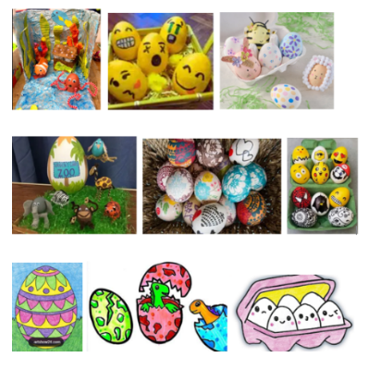  Get creative this Easter! Design and make your very own “eggcellent” scene or drawing. This can be created in 2D or 3D, and we encourage the children to use their own interests and imagination to go wild with their ideas, using materials from around your home. We’ve teamed up with FOSS (Friends of Springwood Schools) and there will be prizes for 1st, 2nd and 3rd place in each class. Please ensure entries are appropriate for your child’s age.
  Week 1 | Spellings  Oxford Reading Buddy  Maths focus – Times tables
  Week 2 | Spellings  Oxford Reading Buddy  Maths focus – Telling the time
  Week 3 | Spellings  Oxford Reading Buddy  Maths focus – Times tables
  Week 4 | Spellings  Oxford Reading Buddy  Maths focus – Telling the time
Spelling words to practise | Week 1 (Testing on 6.03) |  | Week 2 (Testing on 13.03) |  | Week 3 (Testing on 20.03) |  | Week 4 (Testing on 27.03)
Spelling words to practise | earth  early  circle  guide  heart  breath  library  decide  answer  promise |  | often  possible  grammar  February  question  woman  history  eight  breathe  extreme |  | accident  bicycle  purpose  thought  notice  naughty  island  material  strange  although |  | possess  calendar  experience  experiment  centre  complete  consider  knowledge  natural  fruit

In Geography, we are learning about:  - Our Local Area | In Science, we are learning about:  - Solids, Liquids and Gases  - Rocks and soils | Curriculum Overview  Spring 2  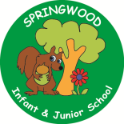  Year 3 | In PSHE, we are focusing our learning on the themes of:  - Belonging to a community  - Media literacy and digital resilience  - Money and work | In RE, we will be learning about:  Theme/Unit: Changing emotions  Concept: Love
In PE, we are learning:  - Tag Rugby  - Dance | In Computing, we are learning about:  - The journey inside a computer |  | In Music, our learning links to:  - Our Local Area | In DT, we are looking at:  - Roman coin purses
In English, we are using the following text drivers:  - The Great Kapok Tree – writing an additional entry to the book convincing the man to not cut down the tree.  - What a Waste – writing an information page about deforestation or pollution.  In Reading, we will be looking at a variety of different texts linked to saving the planet, the rainforest and people within the world who are trying to impact and change our views e.g. David Attenborough and Greta Thunberg. |  | In MFL, we are beginning to learn French through the topic of:  - Je peux…  I am able… | In Maths, we will continue to develop our Arithmetic skills.  We will also develop our skills and knowledge.  - Multiplication and division  - Time  - Fractions

Other important information
World Book Day – Thursday 5th of March

