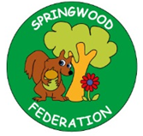
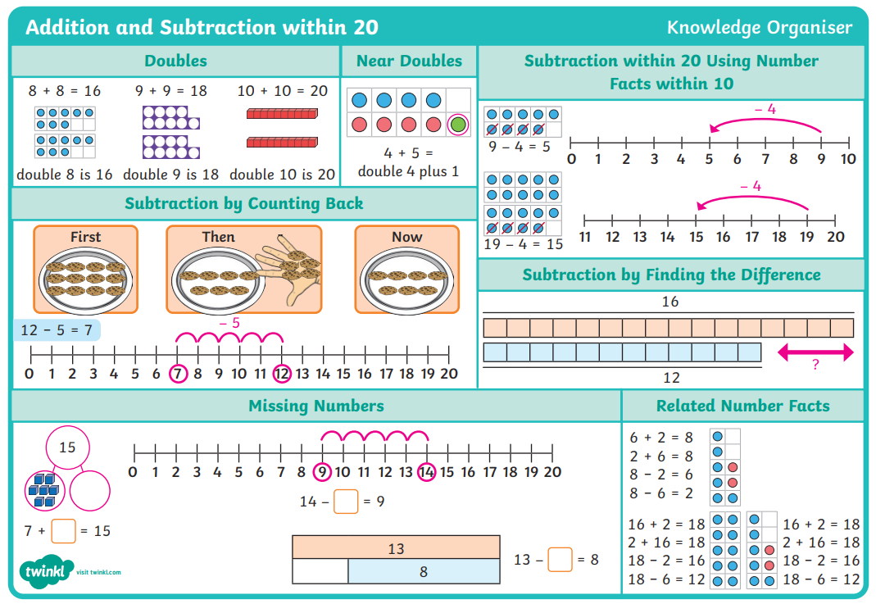
Pre-teach poster
Year 2
Spring 2

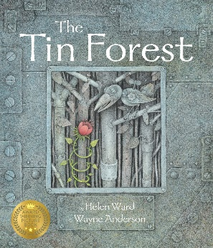  Writing |   Text: The Tin Forest  Key vocabulary: tin, close to forgotten, windswept, jungle, perched, toucan, tree frogs, exotic, seeds, old, dreamed, moonlight  Scan me  Skill: To use noun phrases to describe.
Phonics    Scan me for phase 3    Scan me for phase 5 | Skill: To secure our understanding of phase 3 and phase 5 sounds for reading and writing  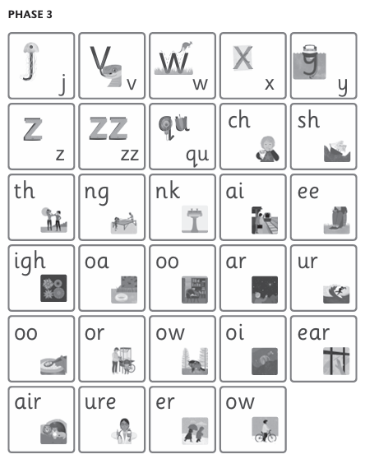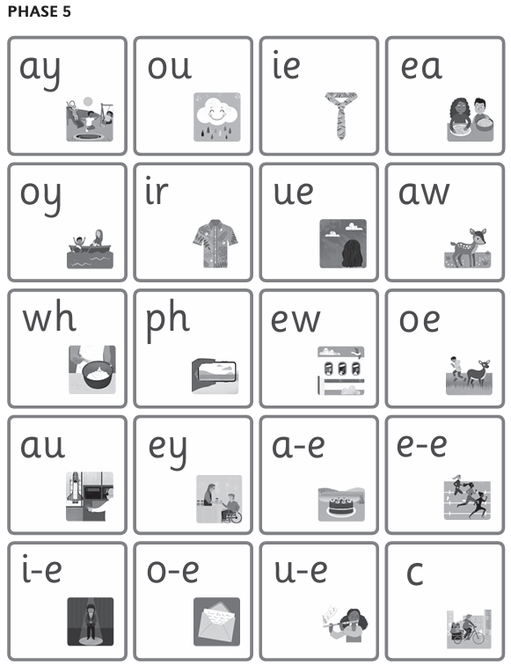

Words to read and spell by sight:
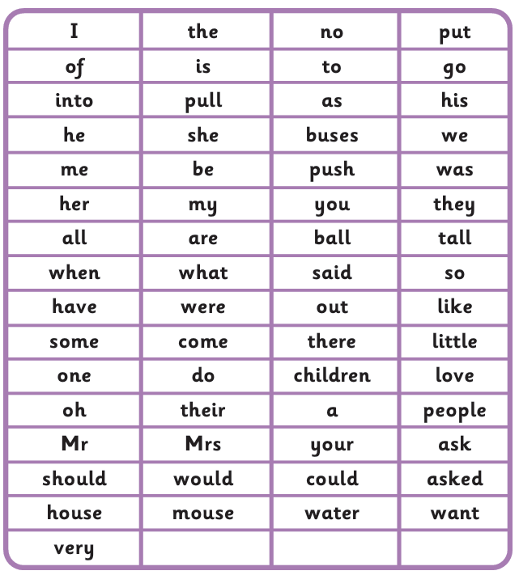
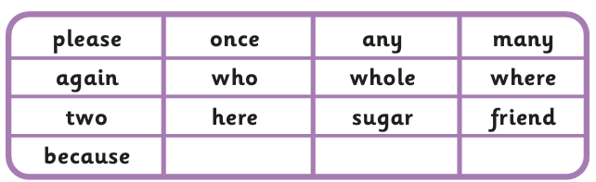
Remember…

log on to reading buddy and read 3 x a week.
TT rockstars will help with learning 2s 5s and 10s times tables.

