Task to be completed over this half term | Suggested Timetable: |  | Maths  It is very important that we secure and practise our understanding of the 5 times table. Please practise counting in fives and answering x5 fluently up to 12x5.  Counting fluently forwards and backwards in ones and tens is very useful to secure:  e.g.  12, 13, 14, 15 49, 48, 47, 46  12, 21, 31, 41 49, 39, 29, 19  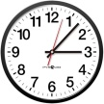  Practise telling the time. Focus on o’clock, half past, quarter past and quarter to. By the end of Year 2, your child should be telling the time to the five minutes. |  | Reading  *Continue to read at least 3 times a week on Oxford Reading Buddy.  Try to learn and remember all the phase 2 – phase 5 sounds. Phonic mats can be viewed here:  https://home.oxfordowl.co.uk/reading/reading-schemes-oxford-levels/essential-letters-and-sounds/  Tuesday is library day!  Bring a bag EVERY Tuesday so that your library book can be changed and safely transported. Keep your library book in this bag so it remains safe and undamaged. |  | Creative family project:  Submission date: W/C 23rd March 2026, projects to be in school no later than the 27.3.26  Get creative this Easter! Design and make your very own “eggcellent” scene or drawing. This can be created in 2D or 3D, and we encourage the children to use their own interests and imagination to go wild with their ideas, using materials from around your home.  We’ve teamed up with FOSS (Friends of Springwood Schools) and there will be prizes for 1st, 2nd and 3rd place in each class. Please ensure entries are appropriate for your child’s age.  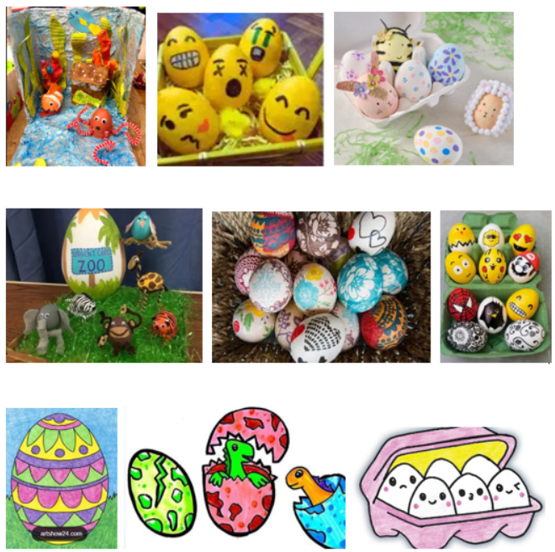
  Week 1 | Spellings  Oxford Reading Buddy  5x table
  Week 2 | Spellings  Oxford Reading Buddy  Maths focus – Counting forwards and backwards
  Week 3 | Spellings  Oxford Reading Buddy  Maths focus – Time
  Week 4 | Spellings  Oxford Reading Buddy  5x table
  Week 5  (after Easter) | Spellings  Oxford Reading Buddy  Counting forwards and backwards
Weekly Spellings | Week 1 (Testing on 6.3)  ‘ai’ focus  rain  pain  train  mail  paid  nail | Week 2 (Testing on 13.3)  ‘ee’ focus  tree  see  keep  meet  leek  peep |  | Week 3 (Testing on 20.3)  ‘igh’ focus  light  might  fight  sight  bright  fright |  | Week 4 (Testing on 27.3)  ‘oa’ focus  boat  coat  load  road  Soap  float |  | Week 5 (Testing on 17.4)  ‘oo’ focus  zoom  food  mood  loop  broom  spoon
In History, we are learning:  - The first Man on the Moon | In Science, we are continuing to learn about:  - Plants | Curriculum Overview  Spring 2  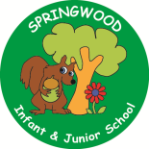  Year 2 | In PSHE, we will continue learning about:  - The internet in everyday life  - Online content and information – safe searching “for kids”  - Money - needs and wants  - Looking after money | In RE, we will be learning about:  - Palm Sunday - focusing on Welcoming.
In PE, we are learning about:  - Ball skills: Hands 2  - Dance: Explorers | In Computing, we are learning:  - Introduction to block  Coding |  | In Music, we are continuing to learn:  - Samba | In DT, we are learning about:  - Mechanisms with a focus on Sliders and Levers.
In English, we are using ‘The Tin Forrest’ to write:  - A Setting Description  - An Information Page  In Reading we will be looking at complimentary texts including examples of stories relating to Into The Wild:  The Flower – John Light  The Promise – Nicole Davies  The Enchanted wood Enid Blyton  The Big Book of Blue – Yuval Zommer  Tree Full of Wonder – Anna Smithers |  |  | In Maths, we will continue to develop our Arithmetic skills.  We will also develop our skills and knowledge in:  - Numbers to 50  - Addition and subtraction with 20  - Fractions ½ ¼ ¾  - Length and mass  - Multiplication (2s, 5s and 10s)

