Tasks to be completed over this half term | Suggested Timetable: |  | Maths  It is very important that we master solving arithmetic style questions using the operations:  Addition, subtraction, multiplication and division.  + - x ÷  You can find examples of these types of questions here: www.satspapers.org.uk  Use our guidance on the website that demonstrates workings that we use in school.  You can also use TTRS to rehearse the timetables (2x, 5x and 10x) that we should know fluently by the end of this term.   |  | Reading  *Continue to read at least 3 times a week on Oxford Reading Buddy  Try to read both fiction and non-fiction texts for pleasure too.  *Focus on your fluency – how many words can you read without having to sound them out?  *Use the question and answer section to practise.  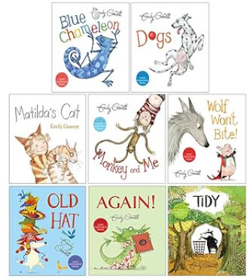  Your teacher recommends and will be reading a range of stories focusing on the author Emily Gravett.  e.g. |  |  | Creative Project  Submission date: Monday 18th May  Create a Coat of Arms  Design your own family coat of arms – a special shield with symbols that represent you.  🛡️ Think about:  - Animals, shapes, colours, and pictures that show who you are  - A motto (a short sentence that shows what your family stands for)  🖍️ Add bright colours and explain what each part means.  
  Week 1 | Spellings  Oxford Reading Buddy  Times tables
  Week 2 | Spellings  Oxford Reading Buddy  Arithmetic
  Week 3 | Spellings  Oxford Reading Buddy  Times tables
  Week 4 | Spellings  Oxford Reading Buddy  Arithmetic
  Week 5 | Spellings  Oxford Reading Buddy  Arithmetic
  Week 6 | Spellings  Oxford Reading Buddy  Arithmetic
Weekly Spellings | Week 1 (Testing on 24.4)  bravest  nicest  happiest  calmest  slowest  scariest | Week 2 (Testing on 1.5)  fiction  reaction  education  agreement  enchantment  pavement |  | Week 3 (Testing on 8.5)  sadness  weakness  helpfulness  lateness  carelessness  fitness |  | Week 4 (Testing on 15.5)  carefully  painfully  joyfully  tearfully  playfully  peacefully | Week 5 (Testing on 22.5)  biggest  hottest  friendliest  prettiest  noisiest  earliest |  | Week 6 (Testing on 5.6)  nicer  earlier  later  faster  earlier  ruder

In History, we are learning about:  - Castles with a Local Study about Portchester, Southsea and Arundel castles. | In Science, we are learning about:  - Growing and plants | Curriculum Overview  Summer 1  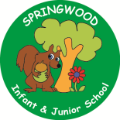  Year 2 | In PSHE, we are learning about:  - Money / finance  - Physical health and  - Mental wellbeing  - Growing and changing  - Keeping safe | In RE, we will be learning about:  - The concept Special by looking at Special Food.
In PE, we are learning about:  - Locomotion: Jumping  - Games for Understanding | In Computing, we are learning:  - Online safety  - Stop motion  Using tablets |  | In Music, we are going to learn:  - Listen2Me:  Tuned percussion | In DT, we are learning about joining techniques:  - Textiles to create a Simple bag.
In English, we are conducting an author study of Emily Gravett and her books as stimulus to write:  - A Persuasive Letter  - A Non-Chronological Report |  |  | In Maths, we will continue to develop our Arithmetic skills.  We will also develop our skills and knowledge in:  - Money  - Times tables: 2, 10, 5, 3  - Data handling and graphs  - Number and place value (numbers to 1000)  - Fractions  - Addition and subtraction  - Numbers within 100 / 1000  - Measures: Capacity and volume  - Measures: Mass

