Task to be completed over this half term | Early Reading / Phonics    Help your child to login to their Essential Letters and Sounds E Library Account using the password you have been provided with separately.  To best support your child learning how to read we ask that you read the online decodable text shared by the school 3+ times across the week. Your child will be praised and rewarded in school for their reading practise. |  |  | Maths  *Can you read all the door numbers in your road?  *Practise writing your numbers from 1-20, making sure they are round the right way and formed the correct way.  Challenge: Can you write the numbers 20-30 making sure the digits are in the correct place?  *Tell someone what is the same and what is different about  14 and 41.  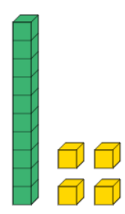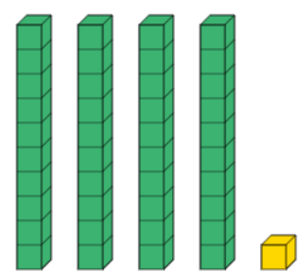 |  | Reading for Pleasure  Challenge yourself to read a mix of story books and an information book this half term.  Your teacher recommends these authors and will be reading some of their books with you:  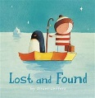  Lost and Found – Oliver Jeffers  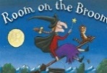  Room on the Broom – Julia Donaldson  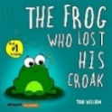  The Frog who lost his croak – Toni William |  | Creative family project:  Submission date: week beginning 20th October 2025  This term we would like you to design a board game based on one of the books we have read.  It could involve a racing track, snakes and ladders or your own ideas.  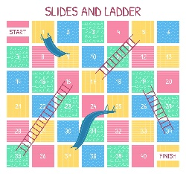  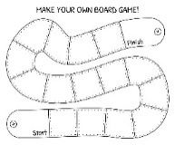
Task to be completed over this half term | Spelling  We will also be having spelling quizzes once a week on a Friday. These quizzes will include Harder to Read and Spell Words (typically cannot be sounded out to read or spell) and words with sounds that we have been learning this week (you can find them below to practise, but we’ll include a mystery word from previous quizzes each week). Every word will have been taught in school, but as we know, practise makes perfect! We will keep these quizzes as enjoyable as possible, praising progress and achievement. We have also given you focus sounds that you could practise, which will have been taught in the previous week.
Spelling Quiz words | Week 1 (Testing on 19.09)  Focus sounds: ay, ou, ie, ea  I the put no  play cloud pie sea | Week 2 (Testing on 26.09)  Focus sounds: oy, ir, ue, aw  of is to go  boy bird blue dawn | Week 3 (Testing on 03.10)  Focus: Review Week  we me be push  proud quirk fawn glue |  | Week 4 (Testing on 10.10)  Focus sounds: wh, ph, ew, oe  into pull as his  whip dolphin chew toe |  | Week 5 (Testing on 17.10)  Focus sounds: au, ey, a-e, e-e  he she buses we  corn key came theme |  | Week 6 (Testing on 24.10)  Focus: Review Week  buses he put pull  horn tame dolphin these

In History, we are learning about:  - The history of toys. | In Science, we are learning about:  - Describing materials, sorting them and exploring what objects are made of. | Curriculum Overview  Autumn 1  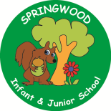  Year 1 | In PSHE, we are learning about:  - Families and friendships; the roles of different people, families and feeling cared for.  - Safe relationships; recognising privacy, staying safe and asking permission. | In RE, we will be learning about:  - Harvest through the concept of being thankful.
In PE, we are learning about:  - Locomotion, practising the skill of running.  - Gymnastics shapes (wide, narrow and curled) | In Computing, we are learning:  - How to use a mouse on a laptop. |  | In Music, we are learning about:  - Discovering dimensions  through singing and by playing percussion instruments | In DT, we are:  - Planning  - Making  - Evaluating  how to make a free-standing penguin enclosure .
In English, we are writing using Room on the Broom – Julia Donaldson and The Frog Who Lost his Croak – Toni Williams to write labels and captions, and as an introduction to sentence building.  Once upon a Jungle – Laura Knowles will be used as a basis for a diary entry, whilst Little Lost Dragon – Wayne Anderson, will be used to annotate a map. Dogger – Shirley Hughes will introduce your children to questions and predictions.  In Reading we are focusing on the skills of reading, but we will be reading stories related to the above books during our daily story time, and discussing our thoughts, feelings and opinions. |  |  | In Maths, we will continue to develop our Arithmetic skills.  We will also develop our skills and knowledge in:  - Number and Place Value  Learning to count to 30, order numbers, say the value of each digit in a 2-digit number, say what is 1 more and 1 less than a given number  - Addition and Subtraction  Using objects, mathematical resources, and using known number facts.

