Tasks to be completed over this half term | Suggested Timetable: |  | Maths  Now that we are in our final term, it is the perfect opportunity to master our times table knowledge.  You should know your 2x 5x and 10x tables up to 12x fluently, with no hesitation.  If you know these, move onto your 3x table.  Other skills that are beneficial to master include:  Telling the time to the hour, half past, quarter to and quarter past.  - Knowing your doubles and halves. |  | Reading  *Continue to read at least 3 times a week. Try to read both fiction and non-fiction texts.  * Use Oxford Reading Buddy to access books at your level and answer comprehension style questions.  Your teacher recommends and will be reading a range of stories focusing on the theme ‘The Classics’  e.g.  - The Wind in the Willows – Kenneth Grahame  - Winnie the Pooh – A A Milne  - The Sheep-Pig – Dick King Smith  - The Legend of Podkin One-Ear - Keiron Larwood  - Cicada- Shaun Tan |  | Creative Family project Submission date: Monday 13th July  Reading with a purpose...  Can you follow a recipe, instructions for building a model eg. Lego, or for playing a board game.  Then ask an adult to take a photograph of your finished creation, game or model and send it in via email to:  adminoffice@springwood.hants.sch.uk  (put year two home learning as the subject)  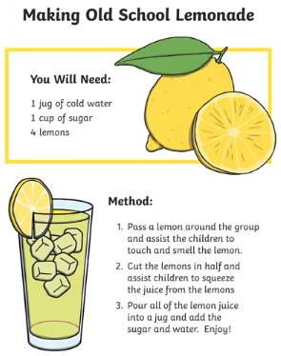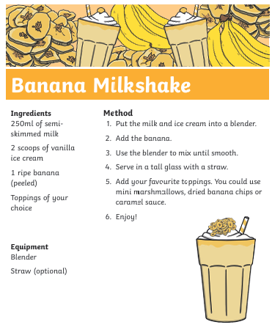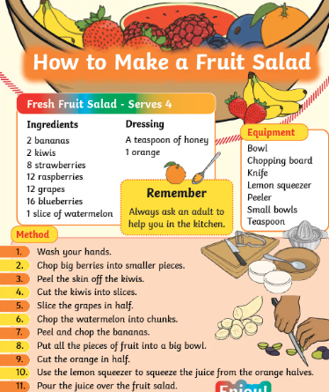
  Week 1 | Spellings  Read 3x  x table focus
  Week 2 | Spellings  Read 3x  Telling the time focus
  Week 3 | Spellings  Read 3x  Doubles & halves focus
  Week 4 | Spellings  Read 3x  x tables focus
  Week 5 | Spellings  Read 3x  Telling the time focus
  Week 6 | Spellings  Read 3x  Doubles & halves focus
Weekly Spellings | Week 1 (Testing on 12.06)  Pull  Put  Push  Was | Week 2 (Testing on 19.06)  You  They  My  Are |  | Week 3 (Testing on 26.06)  All  Ball  Tall  So |  | Week 4 (Testing on 03.07)  When  What  Said  Have |  | Week 5 (Testing on 10.07)  Were  Like  Some  Come | Week 6 (Testing on 17.07)  There  Their  Your  Want
In Geography, we are learning about:  - UK Weather & Seasons | In Science, we are continuing to learn about:  - Plants and growing | Curriculum Overview  Summer 2  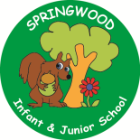  Year 2 | In PSHE we will be learning about being  - Healthy and safe  -diet  -cleaning teeth  -Railways  -Sun safety  -road safety  -changes and transition | In RE, we will be learning about:  - God by thinking about different ideas.
In PE, we are learning about:  - Rackets, bats and balls  - Health and wellbeing | In Computing, we are learning:  - Data Handling |  | In Music, we are going to continue learning:  - Ukulele | In Art, we are learning about:  - Sea-themed weaving using textiles and materials.
In English, we are using ‘The Hodgeheg’ as our stimulus and will be writing:  - A setting description from the point of view of Max the Hedgehog  - A guide to road safety for Hedgehogs (leaflet)  - A letter to parents about road safety outside our school  In Reading we will be looking at the theme anthropomorphism (animals taking on human characteristics. We will be using the following texts in our reading journeys:  - The Sheep pig by Dick King Smith  - Tiger Who Came to Tea by Judith Kerr  - Giraffes Can’t Dance by Giles Andreae  - Fantastic Mr Fox by Roald Dahl |  |  | In Maths, we will continue to develop our Arithmetic skills.  We will also develop our skills and knowledge in:  - Capacity  - measurement  - Multiplication and Division  - Addition and Subtraction

