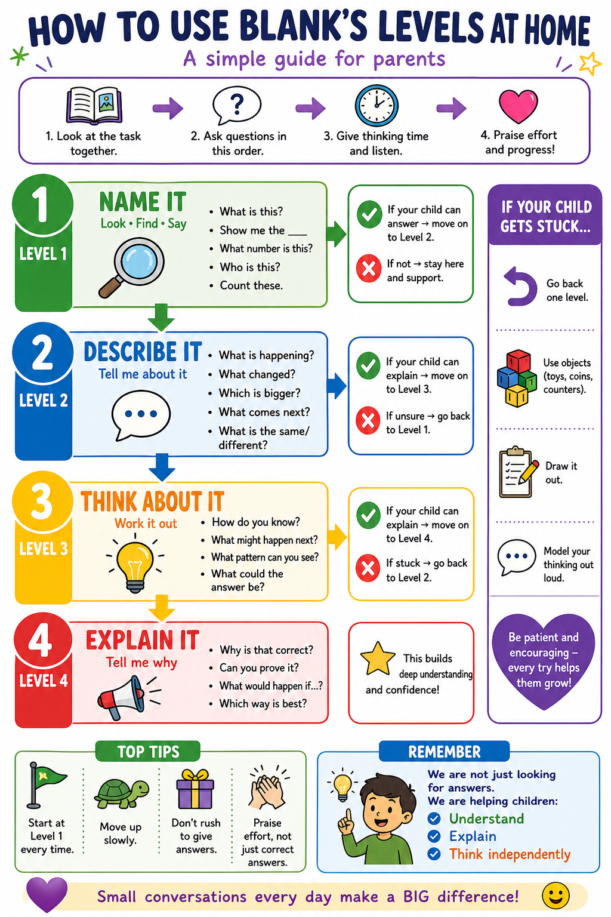

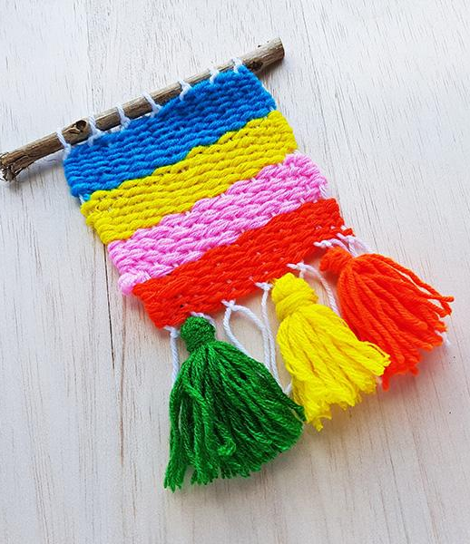
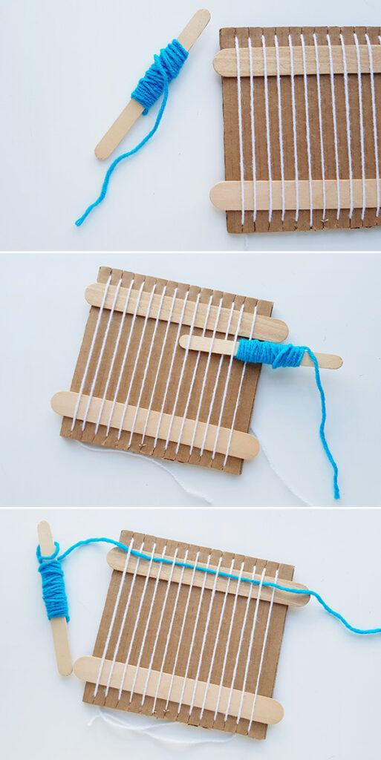
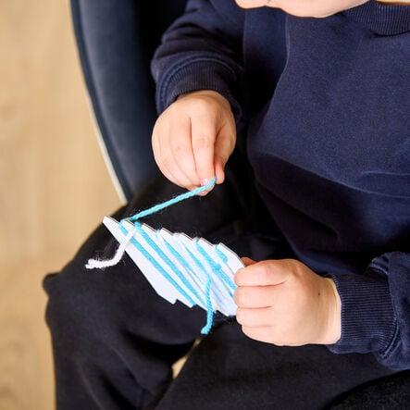
Year 2 – Summer Term Art Unit: Sea Themed Weaving

Key vocabulary: Weaving, pattern, over, under, wool, fabric, craft, seaside, landscape
Level 1
What can you see?
What colours can you see?
What materials are used? (string, wool)
Where are the lines going?
What is this type of art called?
Level 2
How has this been made?
What is the pattern like?
What happens when the wool goes over and under?
What does it remind you of? (sea, waves)
How does it feel? (soft, rough)
Level 4
Why is weaving a good way to make patterns?
How does the weaving show the sea?
Why do artists repeat patterns?
What makes a weaving interesting to look at?
Why is this a good way to create art?
Level 3
Why do we weave over and under?
How does this make a pattern?
Why do artists use different colours?
How could you make it look like the sea?
What happens if you change the pattern?

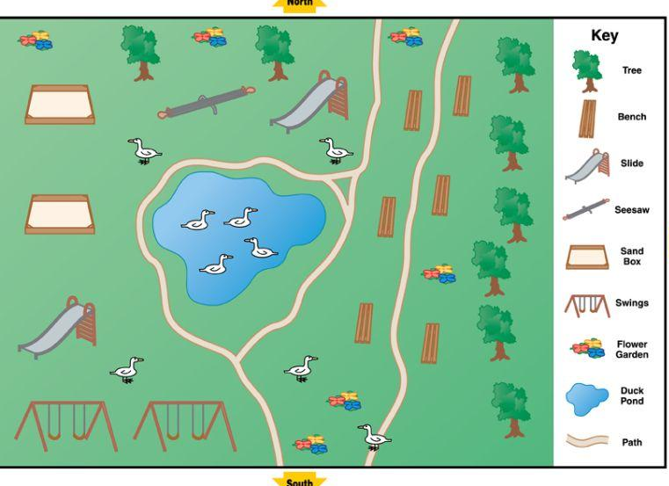
Year 2 – Summer Term Geography Unit: Weather and Seasons
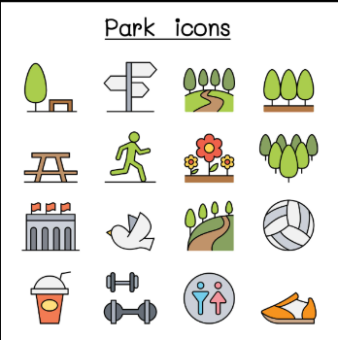
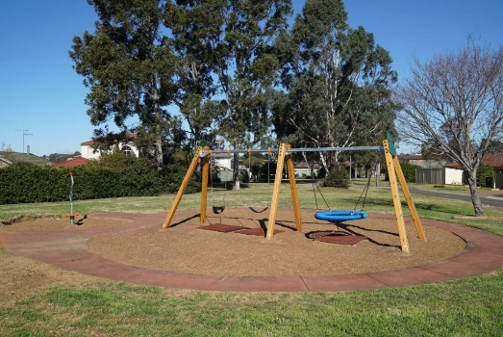

Key vocabulary: Peru, rainforest, desert, climate, hot, wet, dry, plants, arid, tropical
Level 4
Which season is the local park best suited to? Why?
How could we improve the park for winter / summer / rainy weather?
Why are maps useful when visiting a park?
How do human and physical features make the park useful?
How is your local park similar or different to a park in another country?
Level 3
Why do people use the park differently in different seasons?
Why might the park be better in summer than winter?
How does the weather change what people can do?
Why do we need symbols on a map?
How could you get from school to the park?
• What would make the park easier to use in bad weather?
Level 1
What can you see in the park?
Show me a tree / path / playground / pond.
What is the weather like?
What season is it?
Point to something made by people.
Point to something natural.
Level 2
What is happening in the park?
How is the park different in each season?
What do people do in the park?
What do people wear in this weather?
Which features are human features?
Which features are physical features?
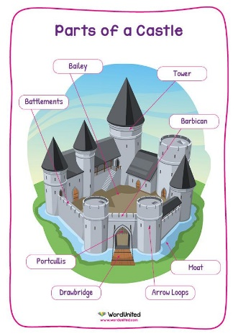
Year 2 – Summer Term History Unit: Castles
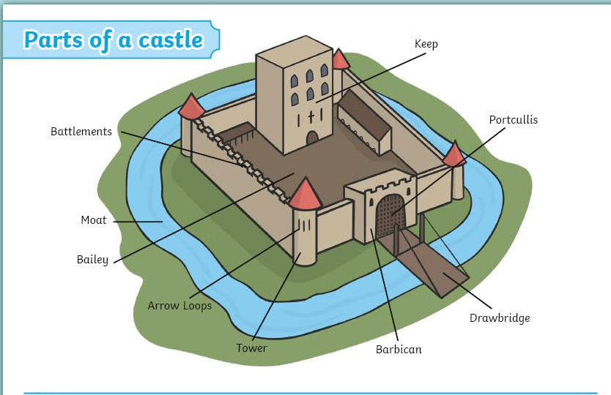
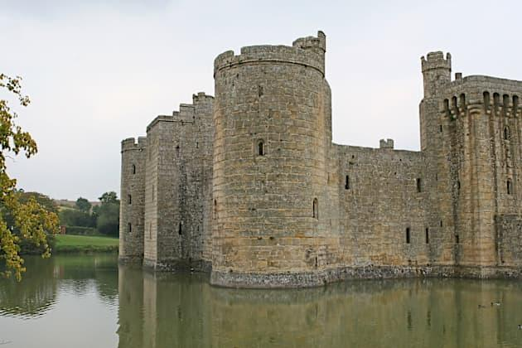

Key vocabulary: castle, tower, moat, drawbridge, keep, wall, battlements, gate, knight, past, defend, protect
Level 1
What can you see?
Point to the tower.
Point to the door or gate.
Show me the moat.
Who might live in a castle?
Level 4
Why were castles important in the past?
How do castles show us what life was like long ago?
Why do we not build castles like this now?
What was good about living in a castle?
What might have been difficult about living in a castle?
• How are castles different from buildings today?
Level 3
Why were castles built?
Why did castles need strong walls?
Why was the gate important?
Why might a castle be built on a hill?
What would happen if enemies came?
How did castles help keep people safe?
Level 2
What does the castle look like?
What is the castle made from?
What are the towers for?
What is the moat for?
What might people do inside the castle?
How is a castle different from your home?

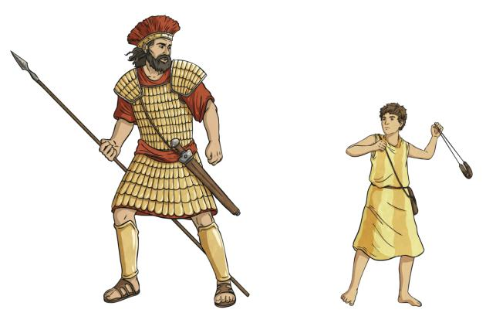
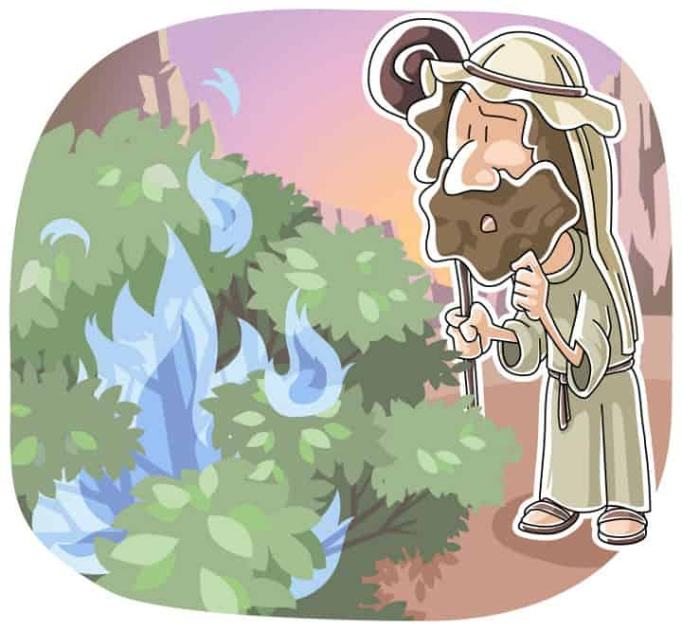
Year 2 – Summer Term RE Unit: Ideas about God
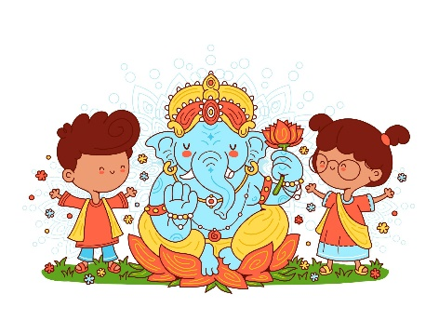

Key vocabulary: God, believe, Christian, Hindu, story, important, different, describe
Level 2
What is happening in each story?
What is God doing?
What do people think about God?
What words could you use to describe God?
How do people show they believe in God?
Level 1
What can you see?
Who is in the picture?
What is happening?
Which picture looks special?
What do you notice?
Level 3
What is God like in these stories?
Why do Christians think God is important?
Why do people describe God in different ways?
What do Hindu stories show about gods?
Why might people believe different things?
Level 4
Why is God important to Christians?
Why do different religions describe God differently?
What can we learn from these stories about God?
Why do people believe in God?
What do you think God is like? Why?
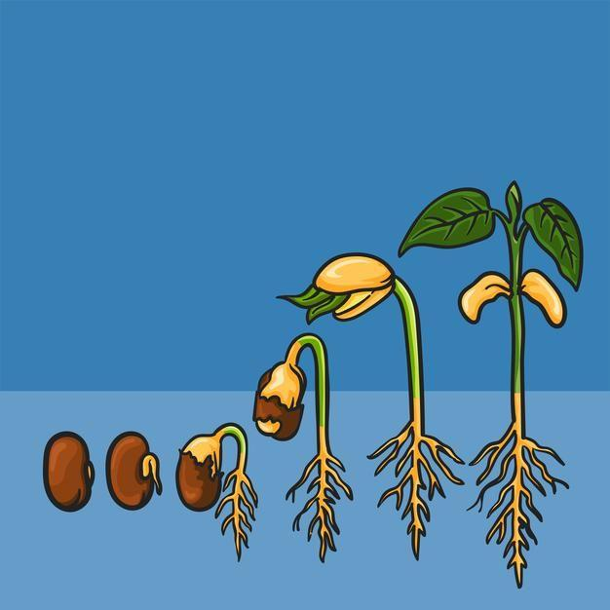
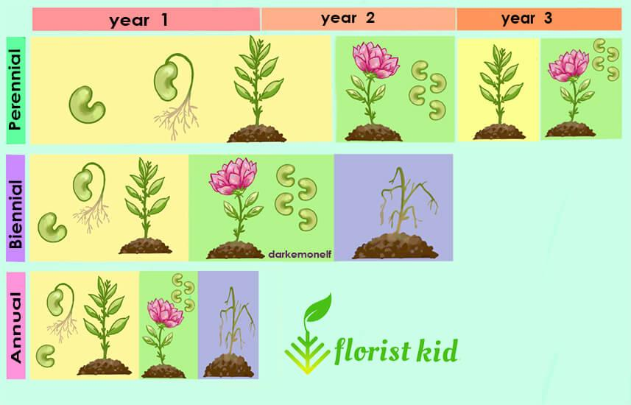
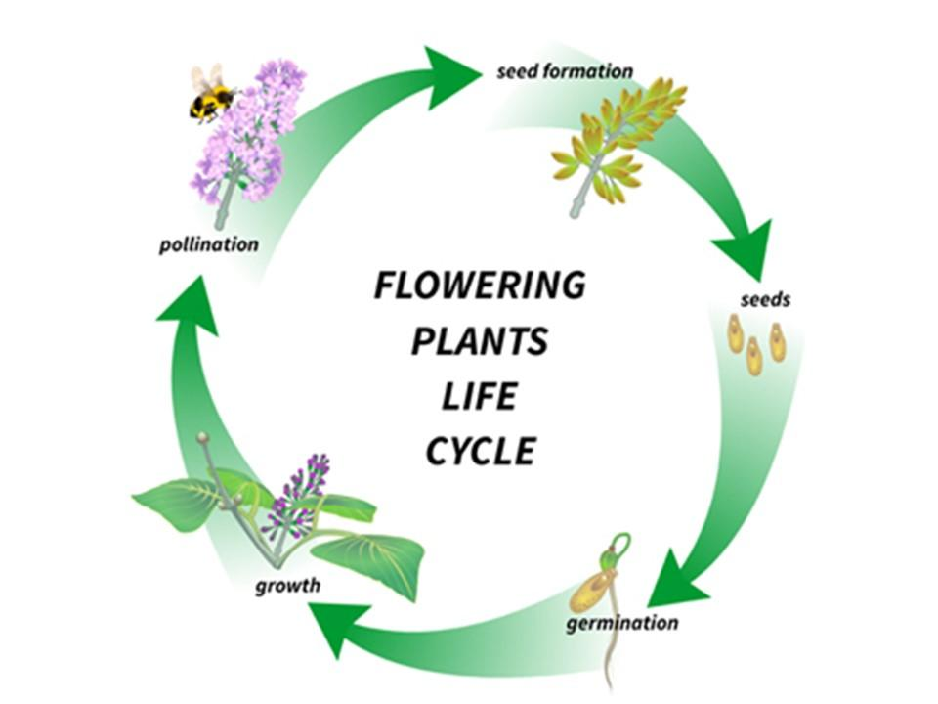
Year 2 – Summer Term Science Unit: How do plants grow?

Key vocabulary: Flowering, seed, germinate, reproduction, annual, perennial, generations
Level 4
Why are flowers important to plants?
How do seeds help plants continue?
What is the difference between a plant that dies after making seeds and one that grows again each year?
Why do some plants produce seeds every year?
How does a seed become a new plant?
Level 3
Why do plants make seeds?
Why do seeds need water?
Why do plants need light?
What might happen if a seed is too cold?
How can one plant make new plants?
Level 2
What is happening to the seed?
What does the seed grow into?
What does the plant need to grow?
What happens after the plant has flowers?
What do flowers help plants make?
Level 1
What can you see?
Show me the flower.
Show me the seed.
Point to the roots.
Point to the shoot.
Which picture shows a new plant growing?

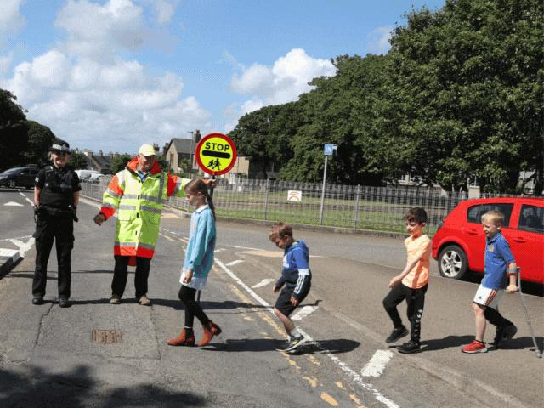
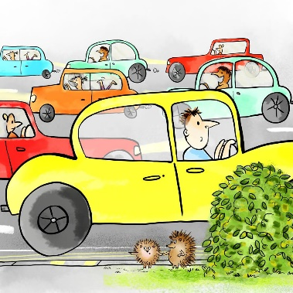
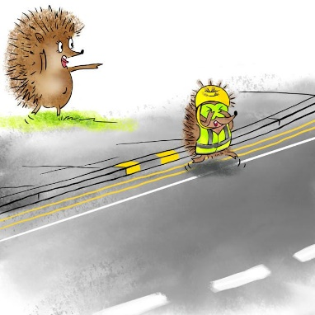
Year 2 – Summer Term Writing Unit: The Hodgeheg

Key vocabulary: farmer, pig, save, kill, kind, fair, important, persuade, stable, friendship
Level 3
Why is the road dangerous for Max?
Why should Max stop, look and listen?
What might happen if Max crosses without looking?
What advice could Max give other hedgehogs?
Where is the safest place to cross near school?
What would you tell parents about safe crossing places?
Level 4
Why is road safety important?
How can Max keep himself safe?
Why is a crossing safer than running across the road?
Why might the road feel different to a small hedgehog?
What makes a good road safety guide?
Why should parents know the safest places to cross near school?
Level 1
What can you see?
Who is crossing the road?
Show me the cars.
Show me the safe place to cross.
Who helps people cross the road?
What is dangerous?
Level 2
What is happening in the picture?
What does the road look like?
What can Max see?
What can Max hear?
How might Max feel?
Where should Max cross safely?

