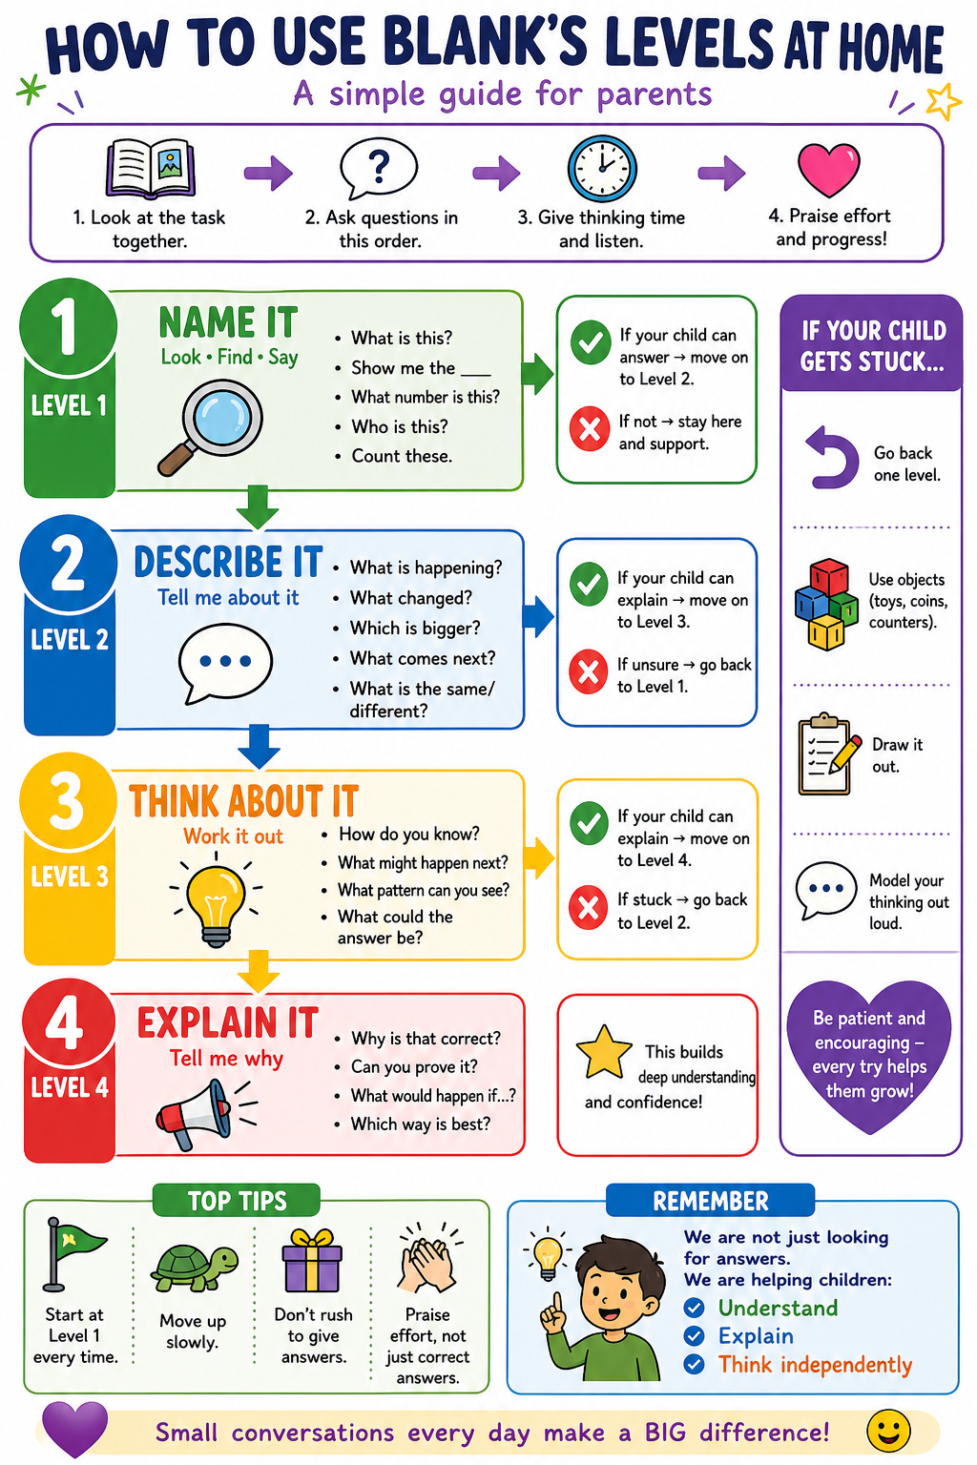

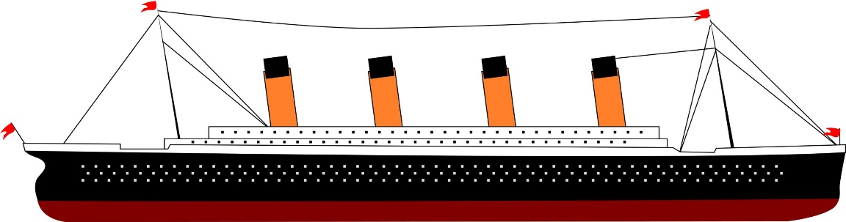
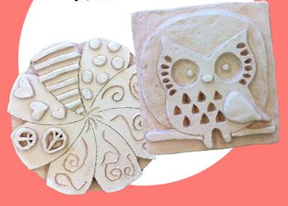
Year 1 – Summer Term Art Unit: Titanic Clay slabs

Key vocabulary: Slab, relief, 3D form, craftsperson, slip and score, join, architectural, composition, clay, Titanic
Level 4
How does adding raised details make it look 3D?
Why is slip and score useful when joining clay?
How can your composition show the Titanic clearly?
What would you add to make your slab more detailed?
What steps have been taken to make this?
Level 2
What shape is the slab?
What details can you see on the Titanic?
What parts are raised up?
What parts are pressed into the clay?
How has the clay been joined?
Level 1
What can you see?
Show me the clay slab.
Point to the ship.
Show me the windows.
Show me the funnels.
What material is being used?
Level 3
Why do we need to plan before using clay?
Why do we use careful lines for windows and railings?
Why do we score the clay before joining?
What happens if the clay pieces are not joined properly?
How can we make the ship stand out from the slab?

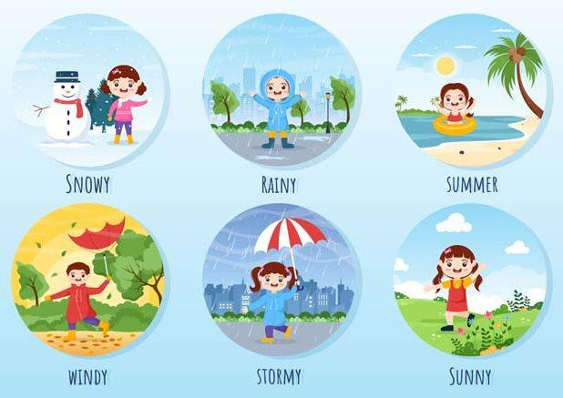
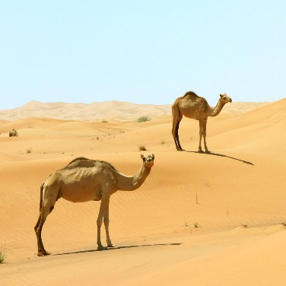
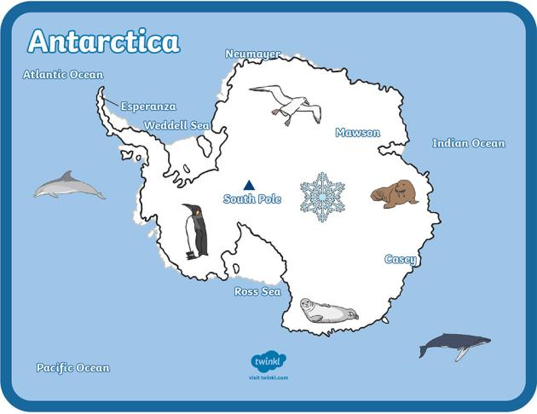
Year 1 – Summer Term Geography Unit: Antarctica vs Europe (hot and cold)

Key vocabulary: Antarctica, Europe, Sahara, hot, cold, weather, snow, ice, desert, sand, Equator, North Pole, South Pole
Level 1
What can you see?
Show me the snow.
Show me the sand.
Point to the cold/ hot place.
Which place is Antarctica?
Which place is the Sahara?
Level 4
Why are some places in the world hot and some places cold?
Why is the Sahara different from Antarctica?
Why might Europe have different weather at different times?
How does the weather affect people, animals and plants?
Which place would you like to visit? Why?
Level 3
Why would you need warm clothes in Antarctica?
Why would you need water in the Sahara?
Why do you think Antarctica is cold?
Why do you think the Sahara is hot?
Which place would be harder to live in? Why?
What animals might live in each place?

Level 2
What is the weather like in Antarctica?
What is the weather like in the Sahara?
What can you see on the ground?
Which place has snow and ice?
Which place has sand?
What might people wear in each place?

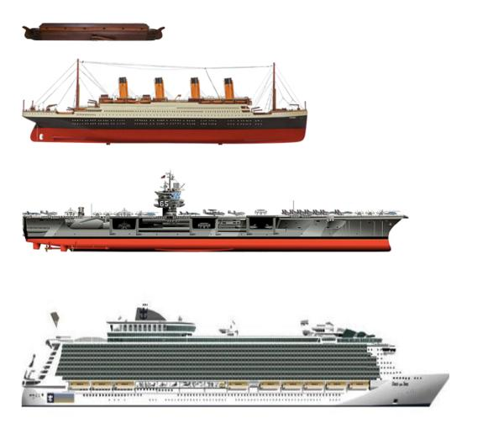
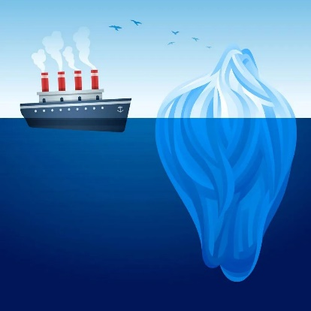
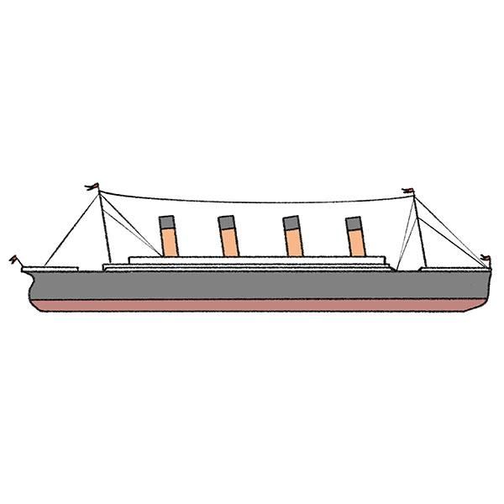
Year 1 – Summer Term History Unit: Titanic

Key vocabulary: Titanic, ship, iceberg, past, present, before, after, crew, voyage, safety, lesson
Level 4
Why do we remember the Titanic?
What lessons did people learn?
Why do ships have more safety rules now?
How has transport changed since the Titanic?
Why is this a significant event?
How are castles different from buildings today?
Level 3
Why was the Titanic important?
Why did people think the Titanic was special?
What happened after it hit the iceberg?
How do we know this happened a long time ago?
How are ships now different from the Titanic?
Level 2
What did the Titanic look like?
What happened to the Titanic?
What did the Titanic hit?
Did this happen before or after we were born?
Was the Titanic old or modern?
Level 1
What can you see?
Show me the ship.
Point to the iceberg.
What is this ship called?
Is this from the past or now?
• Who worked on the ship?
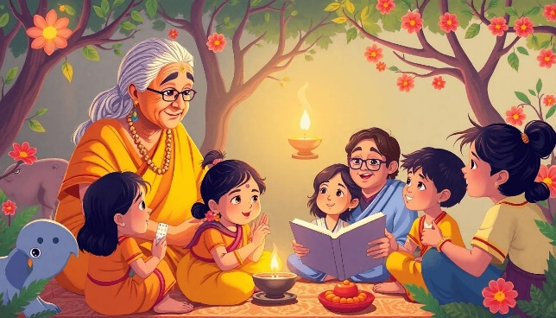
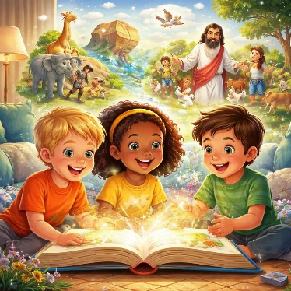
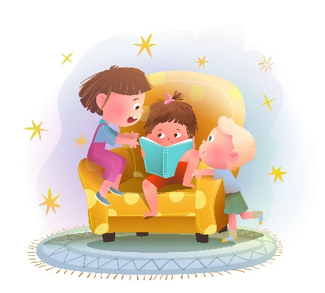
Year 1 – Summer Term RE Unit: Stories

Key vocabulary: story, book, Bible, Hindu story, Christian story, lesson, idea, community, tradition, remember, share
Level 1
What can you see?
Who is reading?
What are they holding?
Show me the book.
Is this a story?
Where might people hear stories?
Level 2
What is happening in the picture?
How are people sharing the story?
What stories do you know?
How do stories make people feel?
What do people do when they listen to stories?
Level 3
Why do people tell stories?
Why do people remember special stories?
What can stories teach us?
Why might families share stories?
Why might Christians and Hindus tell stories?
Level 4
Why are stories important?
How can stories help people learn?
Why do different communities have different stories?
How can a story change over time?
What story is important to you? Why?

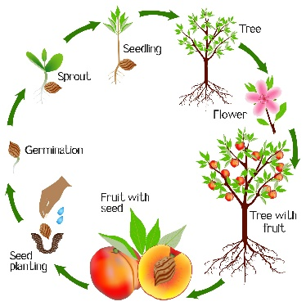
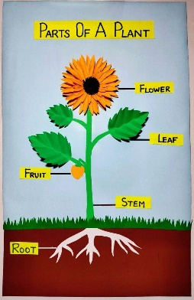
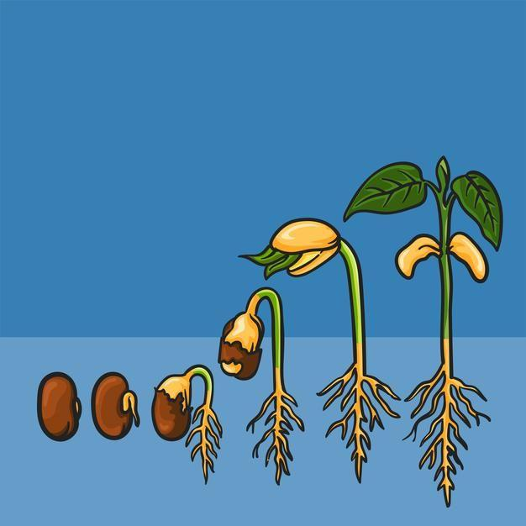
Year 1 – Summer Term Science Unit: How do plants grow?

Key vocabulary: seed, bulb, roots, shoot, leaves, flower, stem, fruit, water, light, grow, survive
Level 3
Why does a seed need water?
Why does a plant need roots?
Why does a plant need leaves?
Why does the shoot grow upwards?
What might happen if the plant gets no water?

Level 2
What is happening to the seed?
What is happening to the bulb?
What grows first?
What grows under the soil?
What does the plant need to grow?
Level 4
How does a seed grow into a plant?
How does a bulb grow into a plant?
Why do plants need to grow to survive?
Why do plants need water and light?
How do roots, shoots and leaves help the plant?
Level 1
What can you see?
Show me the seed.
Show me the bulb.
Point to the roots.
Point to the shoot.
Show me the leaves.
• Show me the flower.

