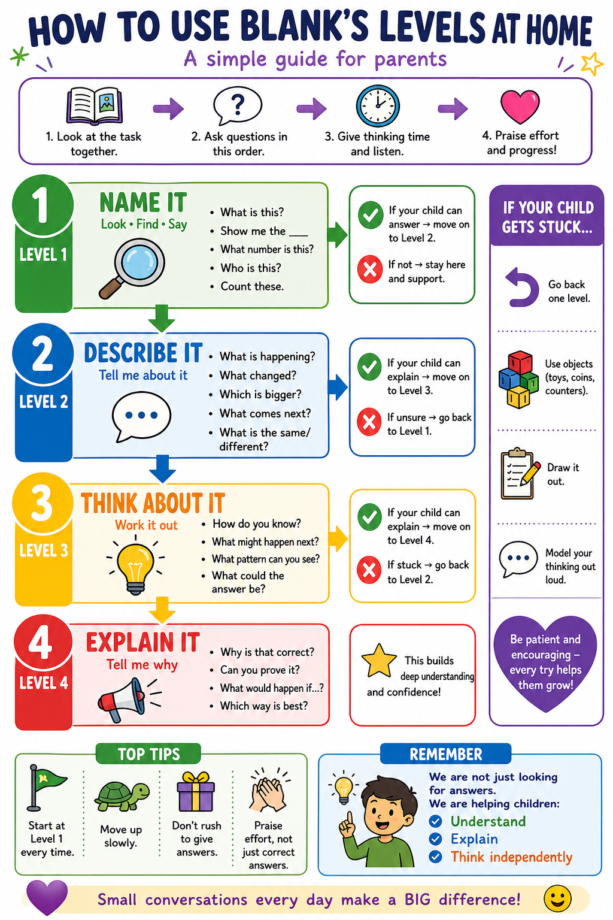

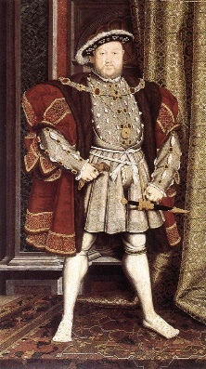
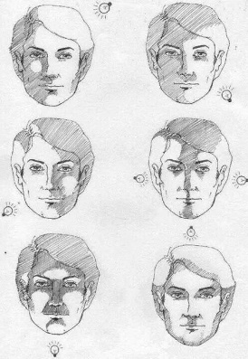
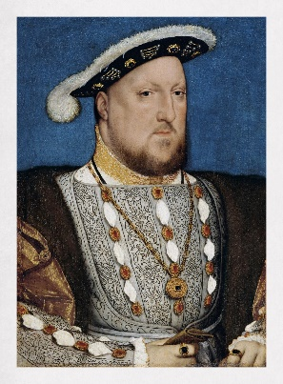
Year 3 – Summer Term Art Unit: Portrait of Henry VIII

Key vocabulary: Collage, deconstruct, implied texture, placement, composition, adhesive, horizon line, aerial perspective, mountainous
Level 1
Who is this person?
What can you see? (clothes, face, colours)
What shapes can you see?
Where is the light?
Where is the dark?
Point to the patterns you can see
Level 4
Why does this portrait show Henry VIII as powerful?
What do the clothes and objects tell us about his status?
Why did artists paint important people like this?
How does the artist make him look important?
What does this portrait tell us about the past?
Level 2
What does the person look like?
What is he wearing?
How has the artist used light and dark?
What do you notice about the face?
How has the artist shown detail?
Level 3
Why has the artist used light and dark?
How does shading make the face look real?
Why are some parts darker than others?
What do the clothes tell us about the person?
How could you use blending in your drawing?

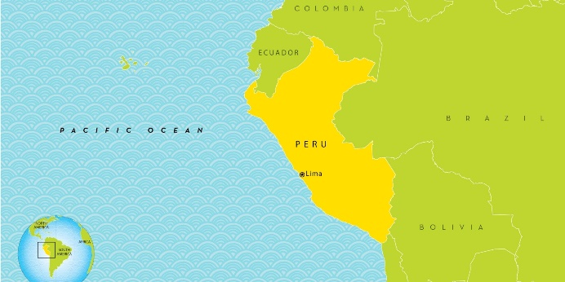
Year 3 – Summer Term Geography Unit: Peru – Biomes and Climate
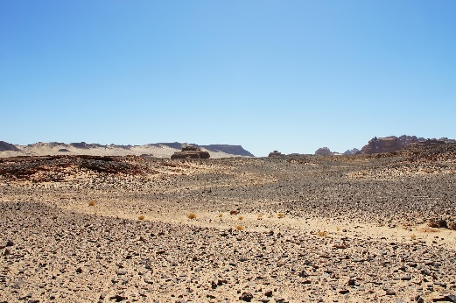
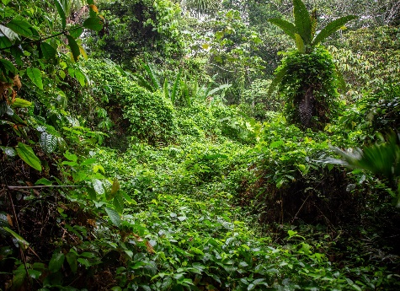

Key vocabulary: Peru, rainforest, desert, climate, hot, wet, dry, plants, arid, tropical
Level 1
Where is this place?
What can you see? (trees, sand, animals)
What is the weather like?
Which place looks hot?
Which place looks wet?
Level 2
What is the rainforest like?
What is the desert like?
What animals might live there?
What is the weather like in each place?
What do you notice about the plants?
Level 3
Why do different places have different climates?
Why do some places have lots of plants?
Why do some places have very few plants?
How does the climate affect animals?
How might people live differently in these places?
Level 4
Why is the rainforest good for plants and animals?
Why is it hard to live in the desert?
How does climate affect how people live?
Which place would be easiest to live in? Why?
How is Peru different from where you live?

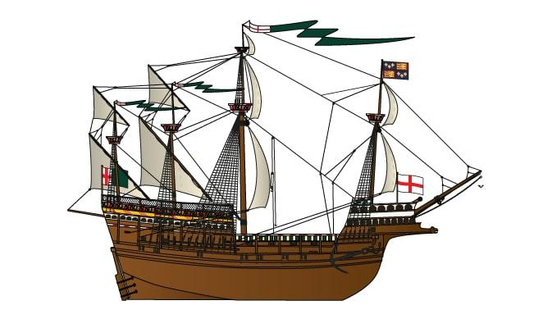
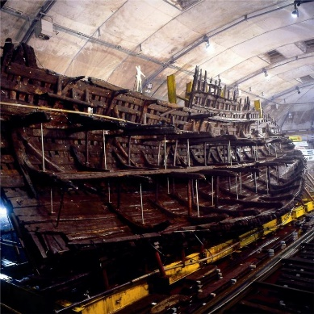

Year 3 – Summer Term History Unit: Mary Rose

Key vocabulary: Ship, past, Tudor, artefact, wreck, history, Navy, Portsmouth
Level 4
How do historians know about the Mary Rose?
Why are artefacts important?
What does the Mary Rose tell us about Tudor life?
Why is the Mary Rose important today?
How is life now different from then?
Level 3
Why are these objects important?
How do they help us learn about the past?
What can we learn about people on the ship?
Why was the Mary Rose important to England?
What was different about life then?
Level 2
What was the Mary Rose used for?
What do the objects tell us?
Who might have used these objects?
What was life like on the ship?
What happened to the ship?
Level 1
What can you see?
What is this object?
What type of transport is this?
What objects can you see?
What are they made from?

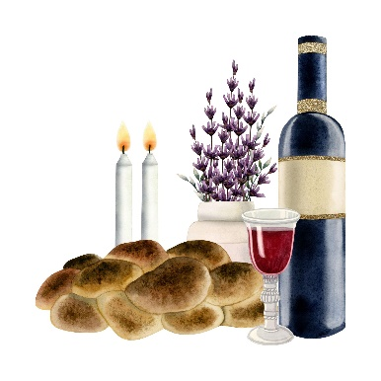

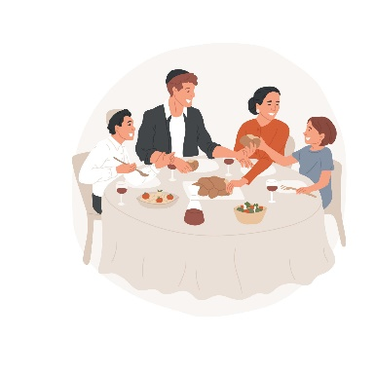
Year 3 – Summer Term RE Unit: Belonging in Judaism

Key vocabulary: Belonging, group, Shabbat, synagogue, family, community
Level 2
What is happening in each picture?
How are people together?
What makes this group special?
What do people do when they belong?
How do people show they belong?
Level 1
What can you see?
Who is in the picture?
What are they doing?
Where are they?
Point to the Synagogue
Level 3
Why do people like to belong to groups?
How does belonging make people feel?
Why is Shabbat important for Jewish families?
Why do people go to a synagogue?
What happens if someone feels they don’t belong?
Level 4
Why is belonging important to Jewish people?
How does Shabbat help people feel they belong?
Why is the synagogue important?
Why is belonging important for everyone?
Where do you feel you belong? Why?

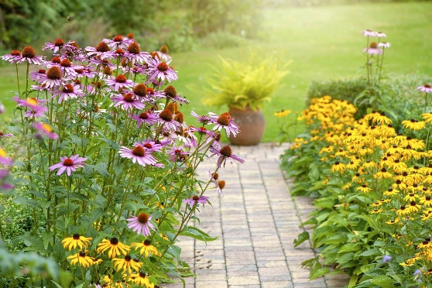
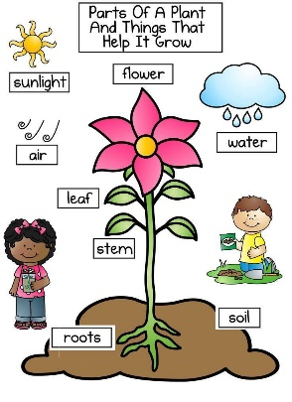
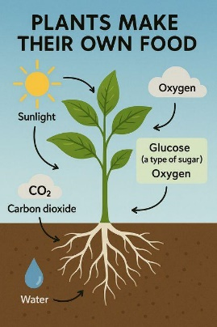
Year 3– Summer Term Science Unit: Plants and their food production

Key vocabulary: Roots, leaves, soil, water, sunlight, carbon dioxide, oxygen
Level 2
What is the plant taking in?
Where does water come from?
Where does air come from?
What does the sun give the plant?
What does the plant make?
Level 3
Why do plants need sunlight?
Why do plants need water?
Why do plants need air (carbon dioxide)?
How do roots help the plant?
What happens if a plant does not get these things?
Level 1
What can you see?
Show me the roots
Show me the leaves
Where is the soil?
Where is the sun?
Level 4
How do plants make their own food?
Why are plants important for animals and people?
What gas do plants give out? Why is this important?
How do leaves help the plant?
Why do plants need all three (water, air, sunlight)?

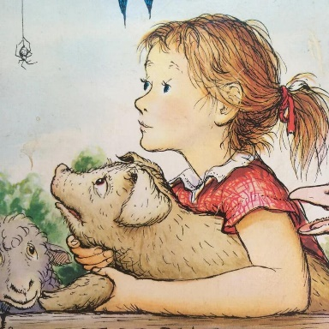
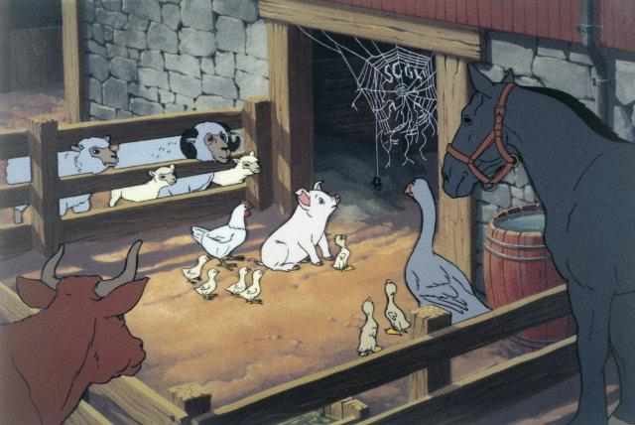
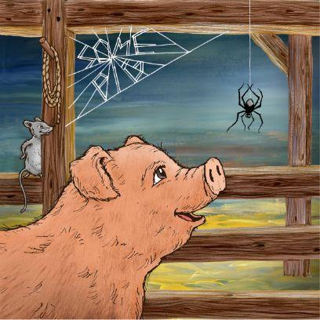
Year 3 – Summer Term Writing Unit: Charlotte’s Web

Key vocabulary: farmer, pig, save, kill, kind, fair, important, persuade, stable, friendship
Level 3
Why does Fern want to save Wilbur?
Why does the farmer want to kill Wilbur?
What might the animals say to Fern?
Who do you agree with? Why?
What could Fern say to persuade the farmer?
Level 4
Should Wilbur be kept or killed? Why?
What is a good reason for keeping Wilbur?
What is a good reason for the farmer’s decision?
What is fair in this situation?
Which argument is stronger? Why?
Level 1
Who can you see?
What animal is this?
Where are they?
What is Fern doing?
Point to the stable
Level 2
What is happening to Wilbur?
How does Fern feel?
What does the farmer want?
What are the animals doing?
What is the problem?

