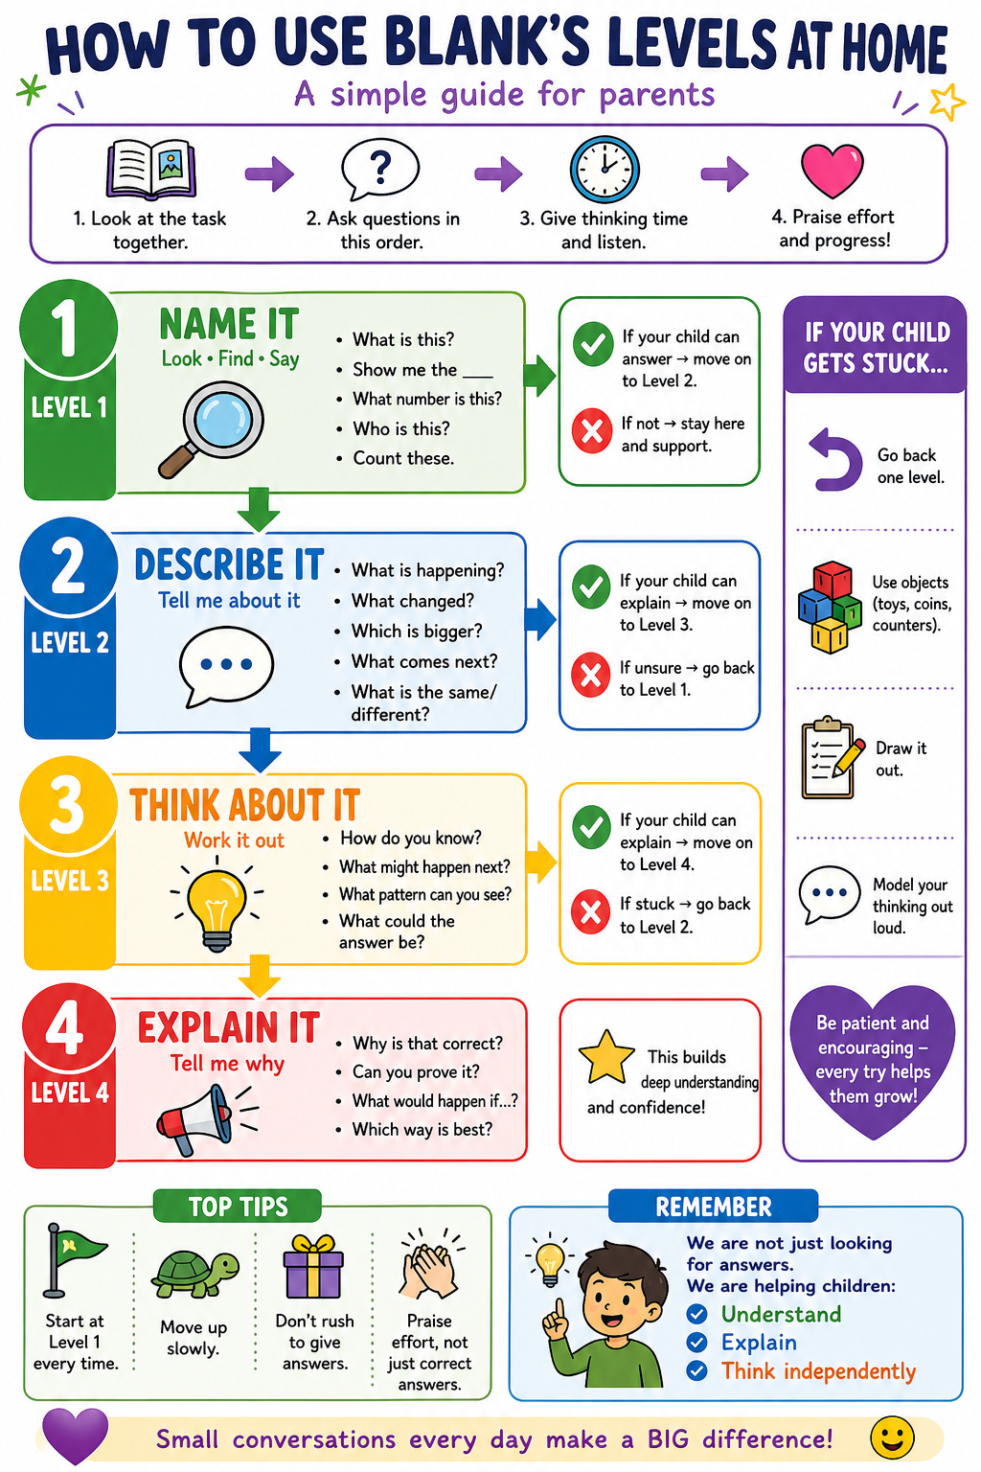

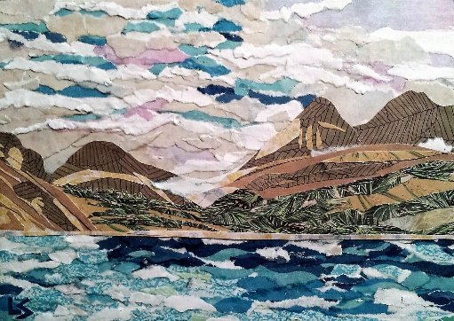
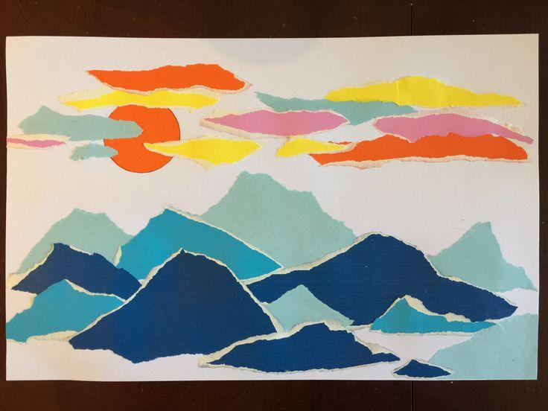
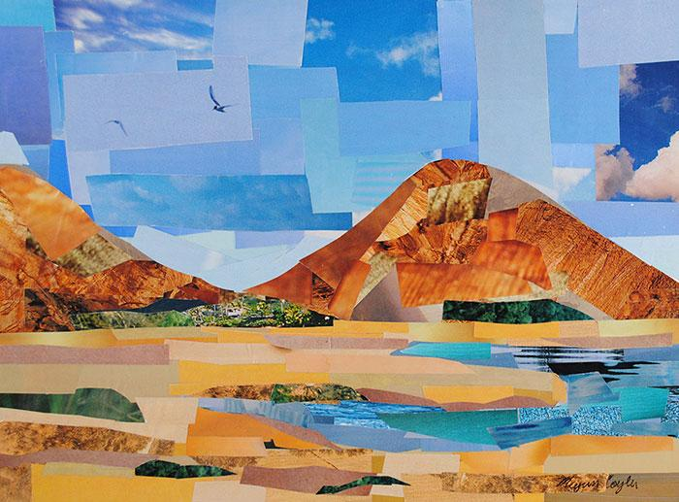
Year 4 – Summer Term Art Unit: Collage

Level 1
What can you see? (mountains, sky)
What is this artwork made from?
What shapes can you see?
Point to the horizon line?
What is this type of art called?
Key vocabulary: Collage, deconstruct, implied texture, placement, composition, adhesive, horizon line, aerial perspective, mountainous
Level 4
Why does the collage look realistic or not?
How does the composition help the picture?
Why is the horizon line important?
What makes the mountains look far away?
What makes this artwork interesting to look at?
Level 2
How has the picture been made?
What do you notice about the paper pieces?
How are the pieces placed?
What textures can you see?
Which mountains look closer or further away?
Level 3
Why has the artist torn the paper (deconstruct)?
How does placement change the picture?
How do we know which mountains are far away?
Why are some pieces bigger or smaller?
How could you arrange your collage?

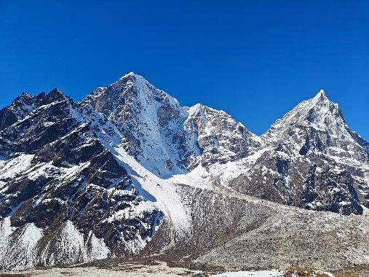
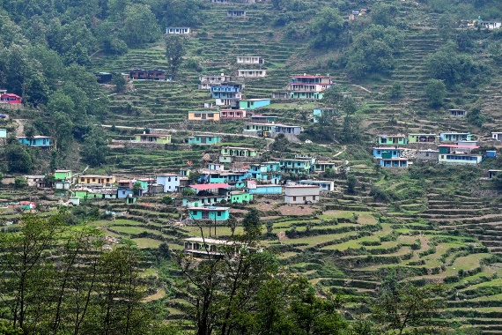
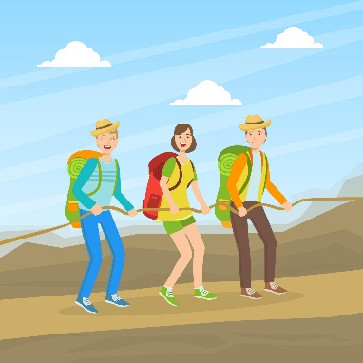
Year 4 – Summer Term Geography Unit: Himalayas and Nepal

Key vocabulary: Mountain, village, steep, high, cold, tourist, local, farming
Level 3
Why might it be hard to live in the mountains?
Why do people still live there?
Why do tourists visit mountains?
What jobs might people have?
What are the benefits of mountains?
Level 1
What can you see? (mountains, snow, houses)
Where are the mountains?
Who can you see?
What are people doing?
What is the weather like?
Point to the mountain peak
Level 4
Are mountains better for tourists or local people? Why?
How do mountains affect how people live?
Why is farming different in mountains?
What problems do mountains create for people?
How are mountains useful?
Level 2
What is it like in the mountains?
How do people live there?
What are people using the mountains for?
What do you notice about the land?
What is different from where you live?

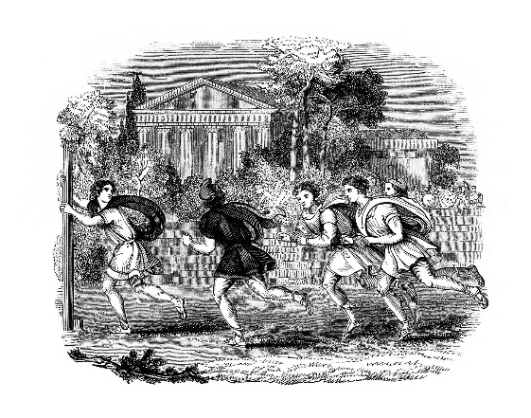
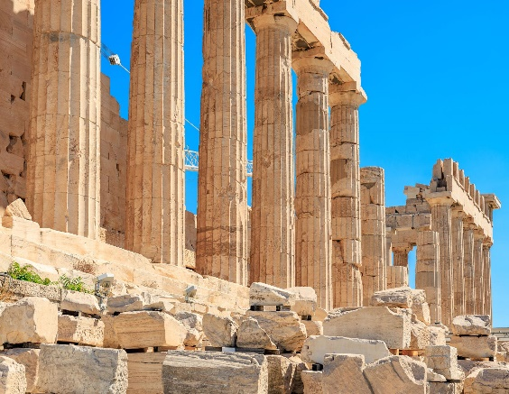
Year 4 – Summer Term History Unit: Greek Legacy
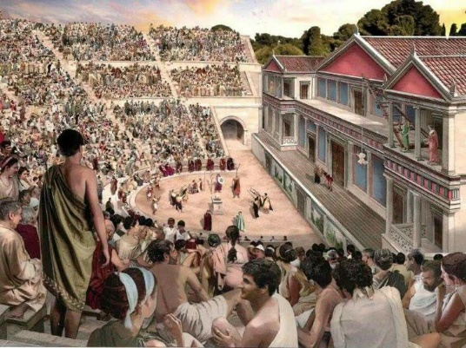

Key vocabulary: Ancient Greece, past, present, Olympics, theatre, temple, columns, building, sport, audience, actors, ideas, influence, legacy
Level 4
Why are Greek ideas still used today?
Why were the Olympics important then and now?
Why do buildings still use Greek styles?
How did Greek ideas spread over time?
Why is Ancient Greece important to learn about?
Level 3
Where might we see something like this today?
Why do we still have things like this?
How are these similar to modern life?
Why were these important to the Greeks?
What has stayed the same or changed?
Level 2
What is happening in each picture?
What are the people doing?
What are these places used for?
What do you notice about the buildings?
What looks similar or different to today?
Level 1
What can you see?
What type of building is this?
What are the people doing?
Where are they sitting or watching?
What shapes or features can you spot?

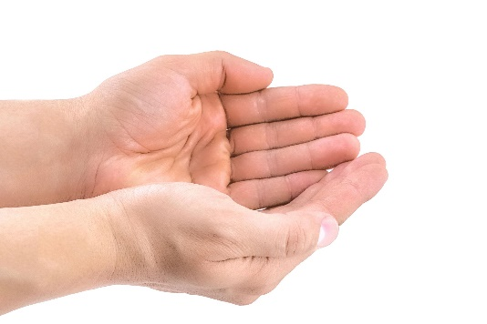

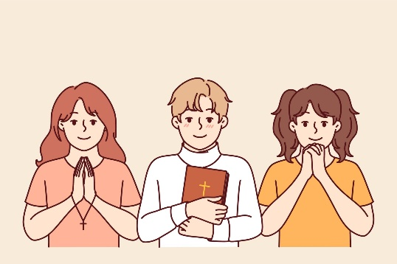
Year 4 – Summer Term RE Unit: Hajj, Zakat & Umma

Key vocabulary: God, belief, prayer, Christian, faith, important, different, respect
Level 2
How are people showing their beliefs?
What do these pictures tell us about God?
What feelings do the pictures show?
What do people do when they believe in God?
Level 1
What can you see in each picture?
What are the people doing?
Point to a crucifix
What actions can you see?
What looks important?
Level 3
Why do people describe God in different ways?
Why is God important to some people?
How might believing in God change how someone lives?
Why might people feel differently about God?
What do these pictures show about belief?
Level 4
Why do different people have different beliefs about God?
Why is it important to respect different beliefs?
How does belief in God affect people’s lives?
Why might some people not believe in God?
What do you think about God? Why?

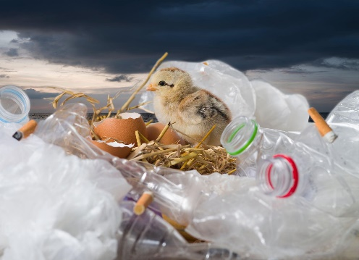
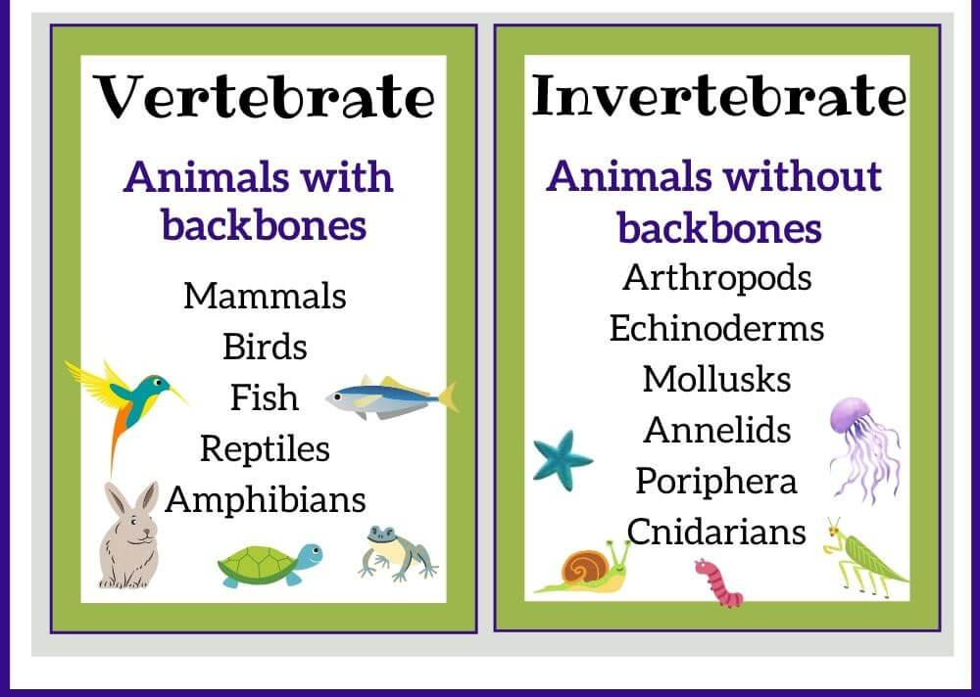
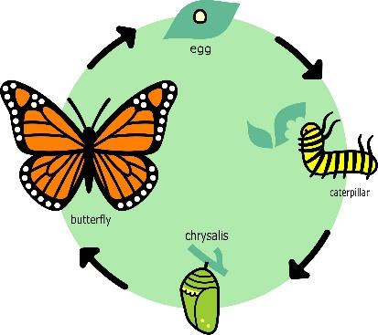
Year 4 – Summer Term Science Unit: Living Things

Key vocabulary: Classification, vertebrate, invertebrate, life cycle, habitat, food chain, change
Level 2
How are the animals grouped?
What happens in the life cycle?
How does the animal change?
What is happening to the habitat?
What looks healthy or unhealthy?
Level 3
Why do we group animals into categories?
How does a classification key help us?
Why do animals have different life cycles?
What happens if one animal is removed from a food chain?
Why are some habitats changing?
We can keep it healthy by _______________________

❤️ Key Vocabulary
Heart, lungs, blood, oxygen, blood vessels, pump, muscles, circulation

💡 Why these images are better
✔ Clear arrows = easier to follow the journey
✔ Simple shapes = less cognitive overload
✔ Focus on process, not detail
✔ Perfect for Blank’s Level 1 pointing

If you want to make this even stronger, I can:
- Create a step-by-step flow strip (lungs → heart → body → back)
- Or a cut-and-sequence activity (very effective for this unit)
- Or simplify further for SEN/EAL
Just tell me 👍

Level 1
What animals can you see?
Point to a vertebrate?
Point to an invertebrate?
What stages can you see in the life cycle?
What can you see in the habitat?
Level 4
Why is classification important for scientists?
How does a change in one animal affect others?
Why do some animals go through metamorphosis?
How do humans affect habitats?
Why are some animals more affected than others?

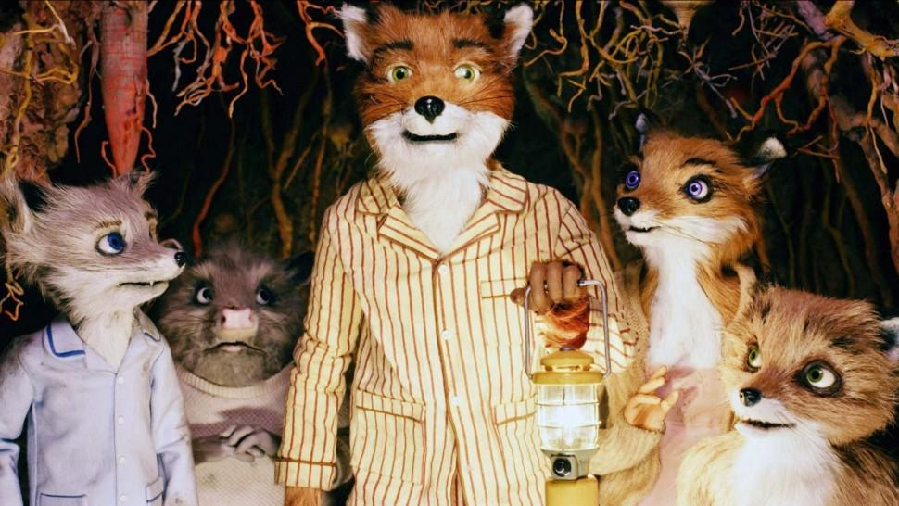
Year 4 – Summer Term Writing Unit: Fantastic Mr Fox
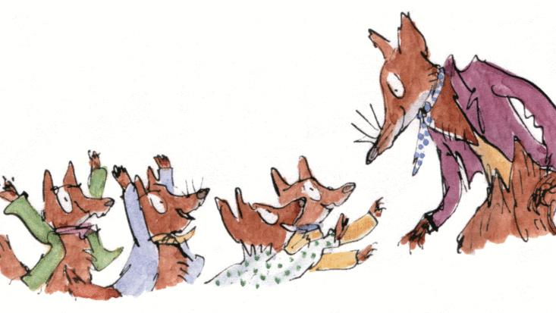
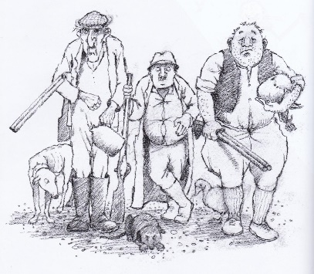

Key vocabulary: farmer, fox, steal, hunt, trap, clever, greedy, selfish, determined, danger, protect, survive, fair, unfair, persuade, argument, viewpoint, decision, responsibility, consequence
Level 1
Who can you see?
What are the farmers doing?
What is Mr Fox doing?
What do the farmers have?
Where are the foxes?
Level 2
What is happening in this scene?
How are the farmers feeling?
How do the foxes feel?
What is the problem?
What might happen next?
Level 3
Why do the farmers want to catch or shoot the fox?
Why is Mr Fox stealing food?
Who do you think is right? Why?
What could the farmers do instead?
What might the farmers say to each other?
Level 4
Should the farmers shoot the fox? Why or why not?
Is Mr Fox doing the right thing? Why?
Who is more responsible for the problem?
What is fair in this situation?
What would you do if you were the farmers?

