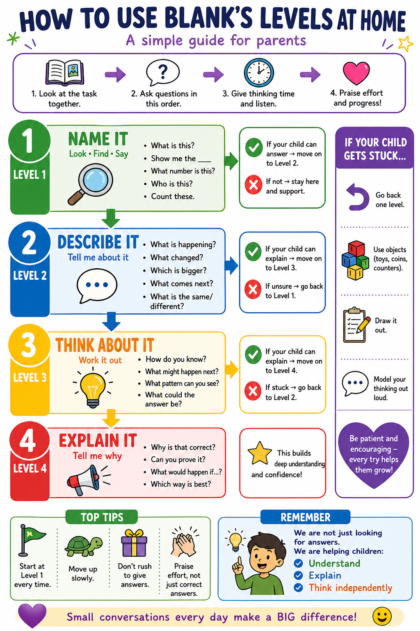

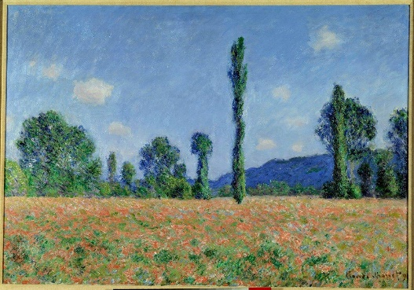
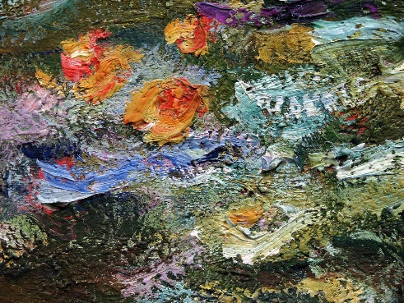
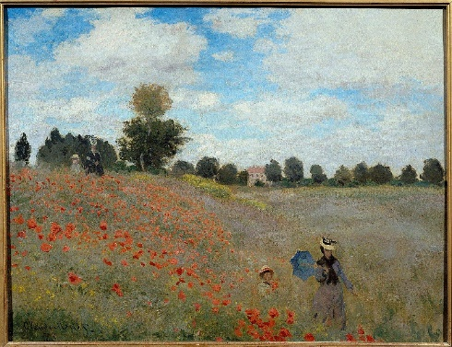
Year 6 – Summer Term Art Unit: Claude Monet – Poppies in the Field

Level 1
What is the name of the artist?
Find the poppies in the picture
What can you see in the foreground, middle ground and background?
Point to the horizon line?
Can you see a light source?
What colours can you see?
Key vocabulary: Painting: Impressionism, broken colour, atmospheric perspective, light source, reflection. Drawing: Perspective, vanishing point, orthogonal lines, horizon line, landscape, movement.
Level 2
What is happening in the painting?
How has the artist used colour?
What do you notice about the brushstrokes?
What is in the foreground and background?
What could be moving in the picture?
Level 3
How do you know which parts are close and which are far away?
What happens to colours in the distance?
How does the painting show movement?
Where do you think the light is coming from?
What helps your eye move around the picture?
How would you draw this scene?
Level 4
Why did Monet use this style of painting?
Why are the colours not all blended smoothly?
How does the painting make you feel? Why?
What makes this look like a real place?
Which part of the painting is most effective? Why?
What would you use in your own painting?
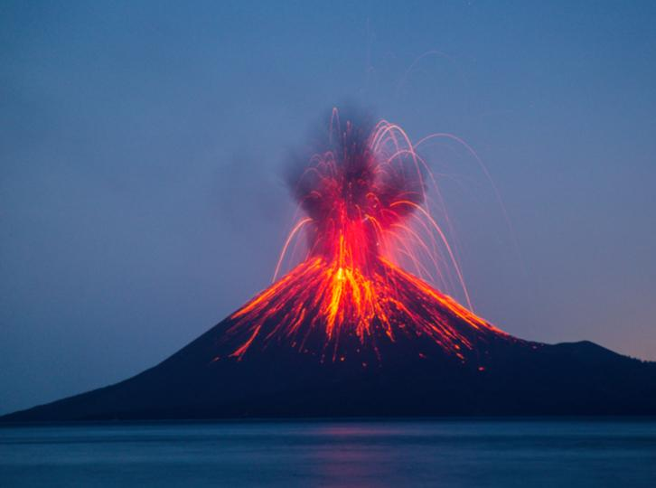
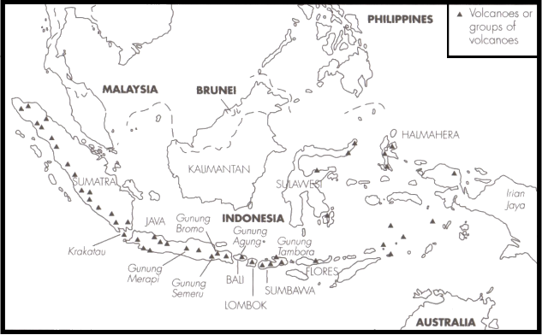
Year 6 – Summer Term Geography Unit: Indonesia Volcanoes

Key vocabulary: Indonesia, volcano, eruption, lava, ash, tsunami, risk, aid, cause, tectonic plates, Anak Krakatoa, Kilauea, Eyjafjallajökull
Level 4
Why is Indonesia at high risk of volcanoes?
Which is more dangerous: lava or fast hot ash clouds? Why?
Why do governments send aid after eruptions?
What are the positives and negatives of living near a volcano?
How could people reduce the risks?
Why do volcanoes form in different places around the world?
Level 3
Why do volcanoes erupt?
What happens after a volcano erupts?
How can lava affect people and buildings?
Why might people still live near volcanoes?
What could happen if a volcano erupts near the sea?
How can people stay safe?
Level 2
What is happening during the eruption?
What happens to lava when it leaves the volcano?
What can you see in the image of the eruption?
What dangers can you spot?
Where are the volcanoes located on the map?
Level 1
What countries can you see?
Show me Indonesia on the map
What is coming out of the volcano?
Point to where you might see a Tsunami
What is ash?
Point to the eruption

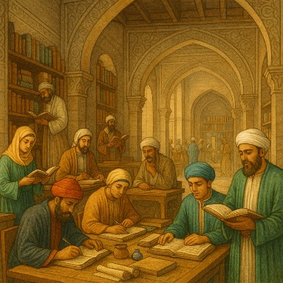
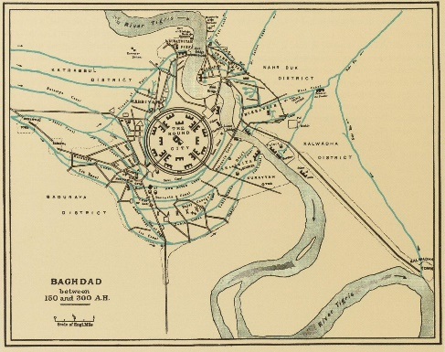
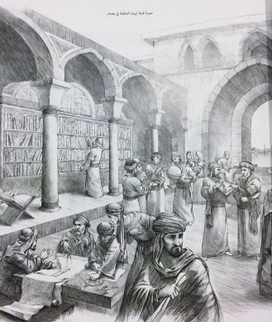
Year 6 – Summer Term History Unit: Islamic civilization, c900 & study of Baghdad.

Key vocabulary: Islamic civilisation, Baghdad, Golden Age, scholar, House of Wisdom, innovation, translation
Level 4
Why is the Islamic Golden Age important today?
How did Baghdad influence modern science or maths?
Why was knowledge valued in this society?
How does this period contrast with Britain at the same time?
What would the world be like without these innovations?
Why is it important to study non-European history?
Level 3
Why was Baghdad a centre of learning?
Why were translations important?
How did new ideas spread from Baghdad?
Why was this called a Golden Age?
How might life in Baghdad be different from Britain at the same time?
Why were scholars important?
Level 2
What are the people doing?
What is this place used for?
What are they learning about?
What do you notice about the buildings or people?

Level 1
Show me the scholar
Point to the book
Where is the city?
Show me the House of Wisdom
Point to someone who is learning
Find something used for writing

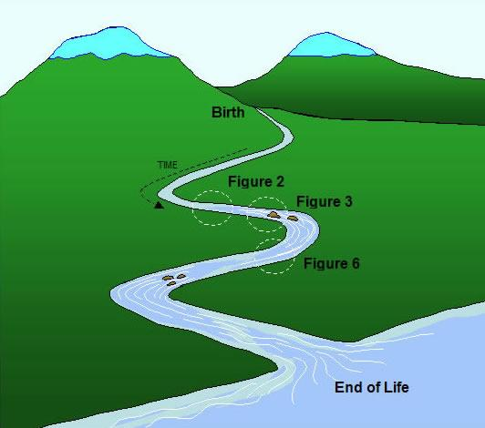
Year 6 – Summer Term RE Unit: Humanism: River of Life
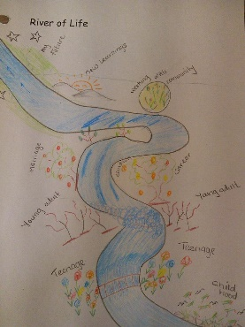
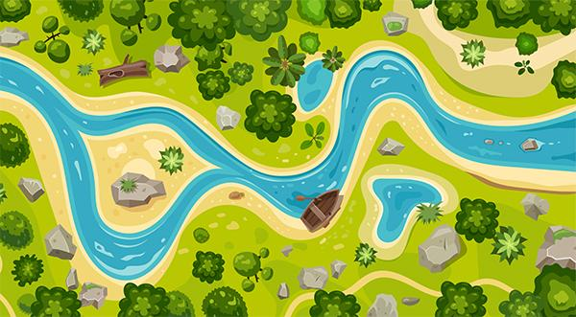

Key vocabulary: River, journey, life, change, choice, event, future, past, Humanist, metaphor, influence, legacy
Level 3
How is a river like a human life?
What could the start of the river represent?
What might a difficult part of the river represent?
What might a calm part represent?
What important events might appear on your river?
Level 4
Why might Humanists use the idea of a River of Life?
Why is it important to think about your life journey?
What do Humanists believe happens after life?
How can your actions continue after you die?
Do you think the River of Life is a useful idea? Why?
Level 2
What is happening in the river?
How does the river change as it moves?
What do you notice about the different parts?
Where is the river fast? Where is it slow?
What might the different parts of the river represent?
Level 1
What is this?
Where does the river start?
Where does the river end?
Point to a calm part of the river
Point to a fast part of the river
Show me a bend in the river

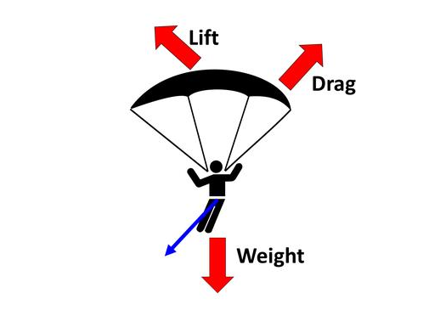
Year 6 – Summer Term Science Unit: Forces that oppose motion
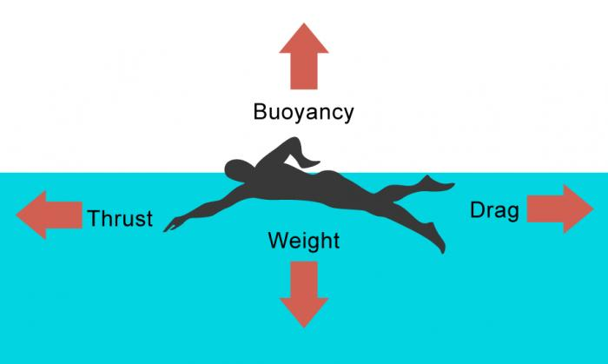
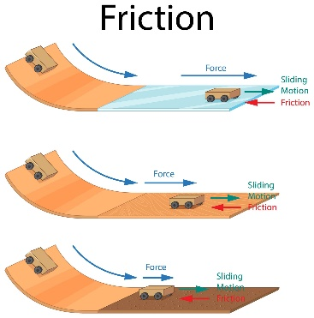

Key vocabulary: Water resistance, air resistance, friction, undulations, interlock, gears, pulley, lever
Level 3
Why is water resistance stronger than air resistance?
Why do rough surfaces create more friction?
What happens when surfaces interlock?
Why do objects slow down when moving through air or water?
How do levers, pulleys or gears make movement easier?
Level 4
Why is friction sometimes useful?
How could you reduce resistance?
How could you increase friction?
Why do pulleys and levers reduce the force needed?
Which force is most important in this situation? Why?
Level 2
What is happening to the object?
What is slowing it down?
What happens when something moves through air?
What happens when something moves through water?
What happens when surfaces rub together?
How do the bumps (undulations) affect movement?
Level 1
What force is this? (air resistance / water resistance / friction)
What is moving?
What is pushing back?
What is touching? (friction)
Point to the drag
Show me the weight

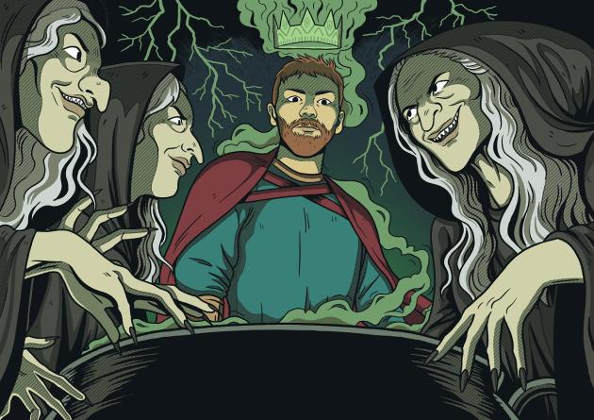
Year 6 – Summer Term Writing Unit: Macbeth
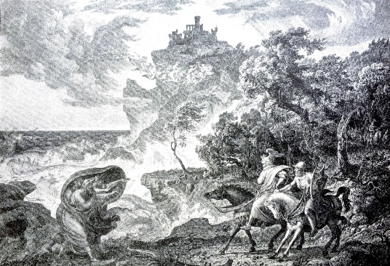
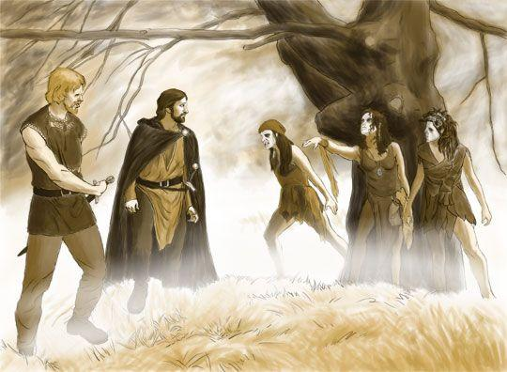

Key vocabulary: witches, prophecy, prediction, Thane, king, battle, loyalty, ambition, power, fate, choice, trust, betrayal, fear, guilt, supernatural, appearance, reality, consequence, influence, Macbeth, Banquo
Level 1
What can you see?
Who is in the scene?
What is the setting like?
What are they wearing?
Point to the most unusual character
Point to the castle in the picture
Level 2
What is happening?
What is the atmosphere like?
How are the men reacting?
What can the characters hear or feel?
Why is the crown green?
Level 3
How does the setting make the scene feel?
Why is the weather important?
How do Macbeth and Banquo feel?
What might they be thinking?
What might the witches be saying to Macbeth?
What might happen next?
Level 4
Why might these figures be important to the story?
Do you think they are helping or tricking the men? Why?
Why does this moment feel important?
What kind of story do you think this is? Why?
What clues suggest something bad might happen later?

