Task to term be completed over this half | Home Apps  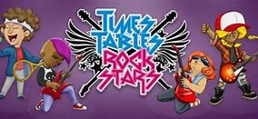  Timetable Rockstars  Even in Y6, timetables are vital to support in many areas. |  | SATS help on Wednesdays  Mrs Jones and Mr Masson invite you to join your child after school on a Wednesday from 3:15-3:45 to complete some revision activities together. This will commence from the 18th March and finish on 6th May. |  | Creative family project: Volcanoes  Submission date: 18.5.26  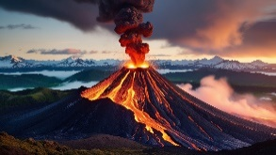  In Geography, we are looking at the formation and location of Volcanoes. Can you create your own project about volcanoes. Consider the following questions:  - How are volcanoes formed?  - Where are they found in the world?  - Are they always active?  - Have there been any significant eruptions in your lifetime?  You can present your learning in your own creative way: a model, posters, research, food creation or booklets. The choice is yours!
Task to term be completed over this half | Oxford Reading Buddy  Login to read books matches to your child’s level and complete online comprehensions.  Oxford Reading Buddy - Log in  At least four times a week. Can year six be the year group that have completed the most quizzes? |  | This half term we will be exploring the class text:  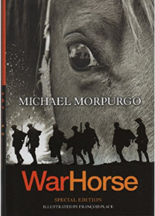
Spellings to learn at home | Week 1 Spellings (tested 24.04)  parliament  persuade  physical  prejudice  privilege  profession  programme  pronunciation | Week 2 Spellings (Test 1.05)  queue  recognise  recommend  relevant  restaurant  rhyme  rhythm  receive |  | Week 3 Spellings (Test 8.05)  sacrifice  secretary  shoulder  signature  sincere  sincerely  soldier  stomach |  | Week 4 Spellings (Test 22.05)  sufficient  suggest  symbol  system  temperature  thorough  twelfth  thoughtful

In Geography, we are learning about:  - Indonesia: Volcanoes  This is likely to moved to Summer 2 due to SATS. | In Science, we are continuing with our learning about:  - Controlling electrical circuits | Curriculum Overview  Summer 1  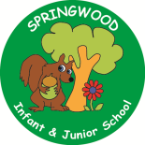  Year 6 | In PSHE, we are learning about:  Media literacy and digital resilience by considering:  - The benefits of safe internet use.  - Why images can be manipulated and how to recognise them.  - Social media and its risks and restrictions.  - Rules about sharing things online, what is appropriate to share, the dangers and how to report inappropriate content.  Money and work  - Influences and attitudes towards money  - Money and financial risks including the impact of gambling
In RE, we will be learning about:  - Theme/Unit: Wesak  - Concept: Community | In Computing, we are learning about:  - Intro into Python  - Big data 2  This is likely to moved to Summer 2 due to SATS.
In PE, we are learning:

- Tennis
Rounders

In English, we are using War Horse as our stimulus and will be writing:  - A set of diaries from different points of view  - Two narratives from different points of view and parts of the story  - Revising our grammatical terms for SATS  In Reading we will be following a revision plan using a variety of fiction and non-fiction texts. |  |  | In Maths, we will continue to develop our Arithmetic skills.  We will also develop our skills and knowledge in:  - Shape  - Co-ordinates  - Ratio  - Revising our arithmetic and reasoning problems

