Task to be completed over this half term | Early Reading / Phonics  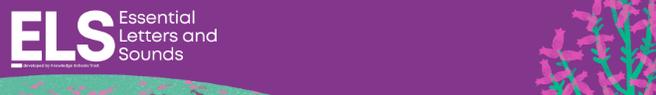  Help your child to login to their Essential Letters and Sounds E Library Account using the password you have been provided with separately.  To best support us in teaching your child how to read we ask that you read the online decodable text shared by the school 4 times across the week.  Spending 10 minutes a day reading with your child will hugely support them in their journey to becoming an independent reader  If you do not have access to a computer, tablet or smart phone, please contact the school. |  | Early Mathematics  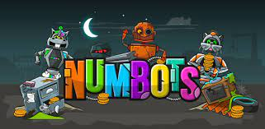  Help your child to login to their Numbots account using the password you have been provided with separately.  Numbers to 10  *Can you find numbers around your home  *Can you count the number of stairs in your house?  *How many toys you have? *What are the door numbers on your road? |  |  | Reading for Pleasure  Share a mix of story books and an information book this half term.  Your teacher recommends this author and will be reading some of their books with you:  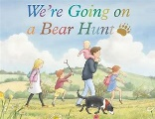  We’re going on a bear hunt – Michael Rosen  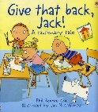  Give that back Jack - Phil Roxby  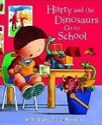  Harry and the dinosaurs go to school - Ian Whybrow |  | Creative Family project:  Please bring in your creative projects week beginning 19th October ready for sharing these on our school website.  Understanding the world  Past and Present  Talk about the lives of the people around them and their roles in society.  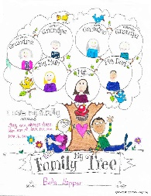  Pick one challenge from the list below:  *Make a family tree  *Draw and label picture of your family  *Find out about your family traditions  *Investigate what jobs people in your family have  *Make a timeline of your family’s birthdays
Suggested timetable | Week 1  Phonics / Reading – read we ask that you read the online decodable text shared by the school 4 times across the week.  *What part of the book did you like?  Numbers – Count to 5 | Week 2  Phonics / Reading – read we ask that you read the online decodable text shared by the school 4 times across the week.  *What did you not like about the book?  Numbers – Count to 5 |  | Week 3  Phonics / Reading – read we ask that you read the online decodable text shared by the school 4 times across the week.  *Who did you like in the book?  Numbers – Count to 10 |  | Week 4  Phonics / Reading – read we ask that you read the online decodable text shared by the school 4 times across the week.  *Where did the story happen?  Numbers – Count to 10 | Week 5  Phonics / Reading – read we ask that you read the online decodable text shared by the school 4 times across the week.  *What else could have happened in the end?  Numbers – Count to 10 |  | Week 6  Phonics / Reading – read we ask that you read the online decodable text shared by the school 4 times across the week.  *Who else would enjoy this book?  Numbers – Count to 10 forwards and backwards
EYFS Autumn 1 Curriculum
Children’s areas of interest (from home / nursery visits) |  |  |  |  | All about Us
Suggested Shared Reading Texts linked to children’s interests |  |  |  |  | Give that back Jack  Harry and The Dinosaursgo to School
Speaking and Listening  Poetry Focus |  |  |  |  | Early Learning Goal – Communication and Language - Speaking  *Little Bo Beep has lost her sheep  *5 Little ducks
Reading Themes |  |  |  |  | Lost and Found / Courage
Shared Suggested Quality Text |  |  |  |  | A Bit Lost  Oscar’s Starry Night
English-Reading |  |  |  |  | - Essential Letters and Sounds
English - Writing |  |  |  |  | - Essential Letters and Sounds  - Funky fingers  - Fine Motor Skills  - Gross Motor Skills  - Name writing
Maths |  |  |  |  | Early mathematical experiences Pattern and early number
Understanding of the World  (Science) |  |  |  |  | - Understand some important processes and changes in the natural world
Understanding of the World  (RE) |  |  |  |  | - Know some similarities and differences between different religious and cultural  communities in this country, drawing on their experiences and what has been  read in class  ‘All about me’  - (Belonging)
Understanding of the World  (Geography) |  |  |  |  | Describe their immediate environment using knowledge from observation,  discussion, stories, non-fiction texts, and maps;  - Know some similarities and differences between different religious and cultural  communities in this country, drawing on their experiences and what has been  read in class  -non-fiction texts and –when appropriate – maps.

