Task to be completed over this half term | Early Reading / Phonics    Help your child to login to their Essential Letters and Sounds E Library Account using the password you have been provided with separately.  You can access Oxford Owl through this link:  https://www.oxfordowl.co.uk/login  To best support your child learning how to read we ask that you read the online decodable text shared by the school 3+ times across the week. Your child will be praised and rewarded in school for their reading practise.  If you cannot access Oxford Owl or misplace your login details, please speak to a member of the Year 1 team. |  |  | Maths  *Can you read all the door numbers in your road?  *Can you use blocks/ toys to build the numbers 1-20?  *Can you use the kitchen utensils to create doubles at home?  *Practise writing your numbers from 1-20, making sure they are round the right way and formed the correct way. |  | Reading for Pleasure  Challenge yourself to read a mix of story books and an information book this half term.  Your teacher recommends these authors and will be reading some of their books with you:  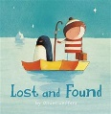  Lost and Found – Oliver Jeffers  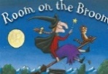  Room on the Broom – Julia Donaldson  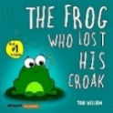  The Frog who lost his croak – Toni William. |  | Creative family project:  Submission date: week beginning 19th October 2026  Can you create a toy from the past or the present based on our History learning? It could be a drawing, or made from recycled materials at home!  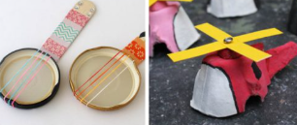  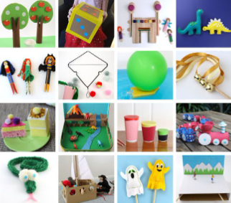
Task to be completed over this half term | Spelling  We will also have a short spelling quiz each Friday. These will include Harder to Read and Spell Words and words containing sounds we have been learning in school. You can find these below to practise at home, along with our focus sounds from the previous week. We will also include a mystery word from a previous quiz to help us revisit our learning!  Please remember, these quizzes are completely pressure-free. We do not expect children to get every word correct and there is no need to worry about scores. All words will have been taught in school, and the quizzes are simply another opportunity to practise and celebrate progress.  We will keep them positive and enjoyable, praising effort and achievement. Little and often is plenty, home practice should be short and enjoyable!
Spelling Quiz words | Week 1 (Testing on 11.09)  Focus sounds: ay, ou, ie, ea  I the put no  play cloud pie sea | Week 2 (Testing on 18.09)  Focus sounds: oy, ir, ue, aw  of is to go  boy bird blue dawn | Week 3 (Testing on 25.10)  Focus: Review Week  we me be push  proud quirk fawn glue |  | Week 4 (Testing on 02.10)  Focus sounds: wh, ph, ew, oe  into pull as his  whip dolphin chew toe |  | Week 5 (Testing on 09.10)  Focus sounds: au, ey, a-e, e-e  he she buses we  corn key came theme |  | Week 6 (Testing on 16.10)  Focus: Review Week  buses he put pull  horn tame dolphin these

In History, we are learning about:  - The history of toys. | In Science, we are learning about:  - Describing materials, sorting them and exploring what objects are made of. | Curriculum Overview  Autumn 1  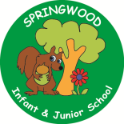  Year 1 | In PSHE, we are learning about making friends, playing and learning together.  Our topics are:  - Ground rules  - Learning and playing  - together  - Friendship and bullying  - Consent  - Asking for permission | In RE, we will be learning about:  - Harvest through the concept of being thankful.
In PE, we are learning about:  - Locomotion, practising the skill of running.  - Gymnastics shapes (wide, narrow and curled) | In Computing, we are learning:  - How to use a mouse on a laptop. |  | In Music, we are learning about:  - Discovering dimensions  Through singing and by playing percussion instruments | In DT, we are:  - Planning  - Making  - Evaluating  How to make a free-standing penguin enclosure .
In English, we are writing using Room on the Broom – Julia Donaldson and The Frog Who Lost his Croak – Toni Williams to write labels and captions, and as an introduction to sentence building.  Once upon a Jungle – Laura Knowles will be used as a basis for a diary entry, whilst Little Lost Dragon – Wayne Anderson, will be used to annotate a map. Dogger – Shirley Hughes will introduce your children to questions and predictions.  In Reading we are focusing on the skills of reading, but we will be reading stories related to the above books during our daily story time, and discussing our thoughts, feelings and opinions. |  |  | In Maths, we will continue to develop our skills and knowledge in:  - Numbers within 10  - Adding and Subtracting Numbers within 10  - Shape and Patterns  - Numbers to 20

