Task to be completed over this half term |   Timetable Rockstars  https://play.ttrockstars.com/ | Spelling  Practise spelling daily using words from the Year 5/6 spelling list. |  | Reading  Challenge yourself to read a fiction and non-fiction book this half term  Your teacher recommends and will be reading with you:  The Arrival by Shaun Tan  The boy at the back of the class.  We will be looking at Fossils in Science.  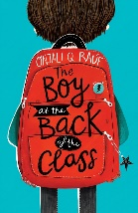  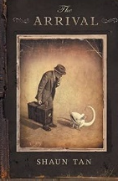 |  | Creative Family project (Submission date: 20.10.25)  Be a geographer!  Using your research skills and creative ideas, find out more about our focus country Australia. Be as creative as you can by making an artwork, presenting a powerpoint, constructing a model, designing a travel document, to inform others about Australia’s geography, history, culture or art. Some other ideas:  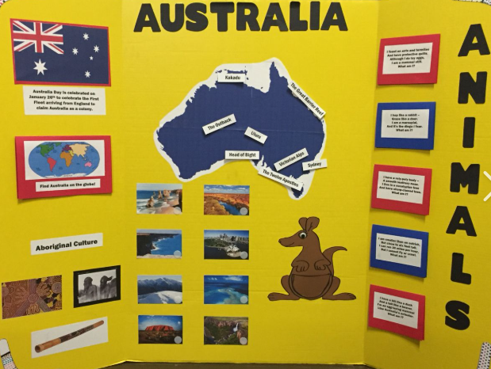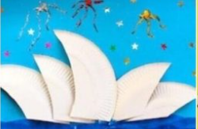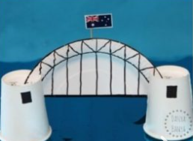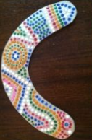  Art & Design – Australia Model  Choose a landmark such as the Sydney Opera House, Uluru or the Great Barrier Reef and make a model using cardboard, paper, clay or recycled materials.  History & Culture – First Nations Australia  Learn about Aboriginal and Torres Strait Islander peoples as the First Peoples of Australia.  Geography – Discover Australia  Find Australia on a world map and create your own colourful map. Label the capital city Canberra, major cities such as Sydney, Melbourne, Brisbane and Perth, and features such as the Great Barrier Reef and Uluru. Add the surrounding Indian and Pacific Oceans.
Task to be completed over this half term | Oxford Reading Buddy  Login to read books matches to your child’s level and complete online comprehensions.
Task to be completed over this half term | Letter-Join: Handwriting
Spelling to learn at home. | Week 1 Spellings  accidentally actually  address answer  appear arrive  believe bicycle  breath breathe | Week 2 Spellings  calendar caught  century exercise  certain experience  complete consider  favourite February | Week 3 Spellings  ancient achieve  average attached  available bargain  bruise category  cemetery community |  | Week 4 Spellings  competition  curiosity  definite  desperate  determined  develop  dictionary  environment  equipment  equipped |  | Week 5 Spellings  especially  excellent  explanation  familiar  immediate  forty  frequently  government  identity  individual | Week 6 Spellings  language  leisure  lightning  marvellous  muscle  neighbour  nuisance  occupy  occur  opportunity | Week 7 Spellings  physical  prejudice  profession  programme  queue  recognise  relevant  rhyme  shoulder  stomach

In Geography, we are learning about:  - Australia and their natural resources. | In Science, we are learning about:  - Fossils, geological time and classification. | Curriculum Overview  Autumn 1  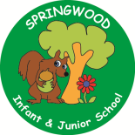  Year 5 | In PSHE, we are learning about friendships, stereotypes and bullying.  Our topics are:  - Including others  - Positive and respectful friendships  - Bullying and its impact  - Belonging and community  - Challenging stereotypes  - Addressing extremism | In RE, we will be learning about:  - Theme/Unit: Shahada and salat.  - Concept: Belonging.
In PE, we are learning:  - the skills needed to play dodgeball.  - Orienteering. | In Computing, we are learning about:  - Programming: Music. |  | In Music, we are:  - Australia - Read, Write and Remember to Twinkle. | In Art, we are:  - creating Indigenous Australian Art.
In English, we are using The Arrival as our stimulus and will be writing:  - a detailed narrative building suspense and tension.  In Reading we will be Reading complimentary texts including:  - The boy in the back of the class – Onjali Q Rauf. |  | In MFL, we are developing our French skills through:  - La phonetique (Phonics and Pronunciation)  - La date (The date) | In Maths, we will continue to develop our Arithmetic skills.  We will also develop our skills and knowledge in:  - Number, Place Value and reasoning with whole numbers  - Problem solving with addition and subtraction  - Statistics (Line graphs and time tables)  - Measurement (area and perimeter)  - Multiplication and Division

