Task to be completed over this half term | Suggested Timetable: |  | Maths:  In Year 2, we secured our understanding of place value of two-digit numbers, recognising their tens and ones.  In Year 3, we are going to be exploring and understanding the place value of three-digit numbers up to 1000.  We need to be able to recognise how many hundreds, tens and ones a number has.  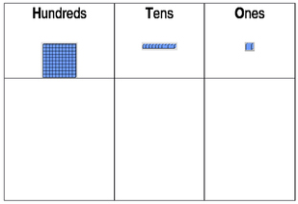    1 3 2  You can also use TTR to rehearse the timetables that you are learning. |  | Reading  Continue to read at least 3 times a week. This can be on Oxford Reading Buddy and/or a library book.  Challenge yourself to read a narrative and a non-fiction book this half term.  Your teacher recommends and will be reading with you:  - The Promise – Nicola Davies  - Cinnamon – Neil Gaiman  - Can you catch a mermaid? – Jane Ray  - The Child of Dreams – Irena Brignull  - The Dark – Lemony Snicket  Use non-fiction books to learn about:  - The Stone Age, Bronze Age, Iron Age |  | A creative family project:  Submission date: 20.10.25  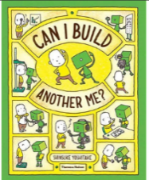  Can you build another you?  Inspired by one of our Writing texts this half term, can you build another you?  You can be creative and build yourself out of recycling materials and materials you can find around the house.  What would you get your ‘you’ to do?  How would they help you?  What facts would you tell you robot about yourself?
  Week 1 | Spellings  Oxford Reading Buddy  Maths focus – Place Value
  Week 2 | Spellings  Oxford Reading Buddy  Maths focus – TTRS
  Week 3 | Spellings  Oxford Reading Buddy  Maths focus – Place Value
  Week 4 | Spellings  Oxford Reading Buddy  Maths focus – TTRS
  Week 5 | Spellings  Oxford Reading Buddy  Maths focus – Money
Spelling words to practise | Week 1 (Testing on 19.09) | Week 2 (Testing on 26.09) |  | Week 3 (Testing on 03.10) | Week 4 (Testing on 10.10) | Week 5 (Testing on 17.10) |  | Week 6 (Testing on 24.10)
Spelling words to practise | could  every  when  with  would  people  was  some  come  money | jumped  jumping  jumps  remove  removed  movement  moves  unmoving  removes  moving |  | actually  happily  slowly  usually  dramatically  basically  actually  gently  possibly  strangely | busier  busiest  busily  business  businesses  afterward  awkward  backward  forward  toward | towards  awkwardly  afterwards  dispossess  possessed  possessing  possessive  dogs  horses  pencils |  | possesses  possession  possessions  tables  classes  potatoes  babies  flies  tomatoes  parties

In History, we are learning about:  - Stone, Bronze, and Iron ages. | In Science, we are learning about:  - Magnets | Curriculum Overview  Autumn 1  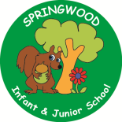  Year 3 | In PSHE, we are learning about:  - Families and friendships  - Respecting ourselves and others  - Safe relationships | In RE, we will be learning about:  - Theme/Unit: Trees  - Concept: symbol
In PE, we are learning:  - OAA Orienteering  - Ultimate Frisbee | In Computing, we are learning about:  - Computing systems and networks |  | In Music, we are learning:  - Stone Age  - Ivory Coast | In Art, we are looking at:  - Stone Age jewellery using natural dyes.
In English, we are using the following text drivers:  - ‘Can I build another me?’ by Shinsuke Yoshitake (an autobiography/fact file)  - The Misadventures of Frederick by Ben Manley (a letter)  - Black Dog by Levi Pinfold (a contrasting character description)  In Reading, we will be looking at a variety of different texts linked to the themes visited within the Writing quality text drivers. These themes focus on Lost and Found/Courage. |  | In MFL, we are beginning to learn French through the topics of:  - Phonics  - ‘I am learning French’ | In Maths, we will continue to develop our Arithmetic skills.  We will also develop our skills and knowledge in:  - Number sense and exploring calculation  - Place Value  - Graphs

