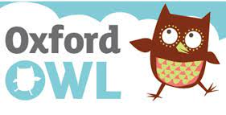
How to access Oxford Owl
Follow these instructions to be able to access the online texts for your children.
- Type in Oxford Owl into Google and select the first search that comes up.
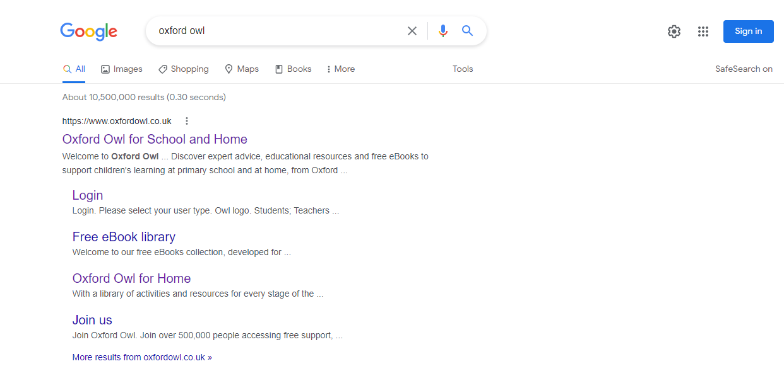
It should say www.oxfordowl.co.uk

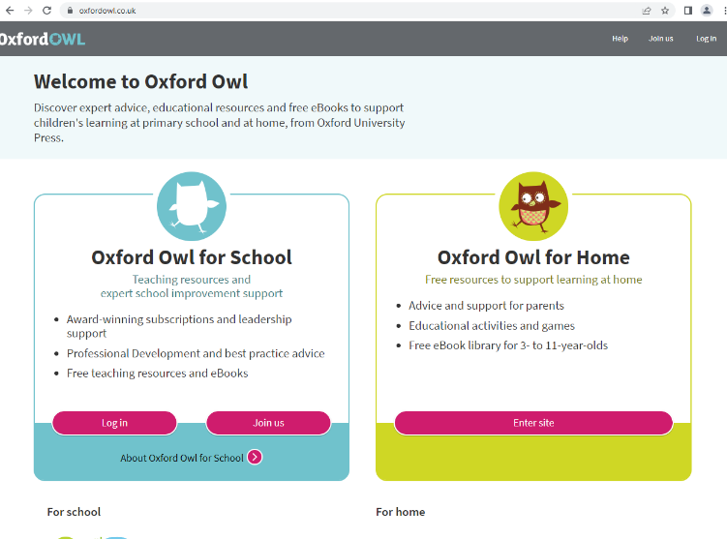
- It should take you to this page where you need to select the Oxford for School option and login.

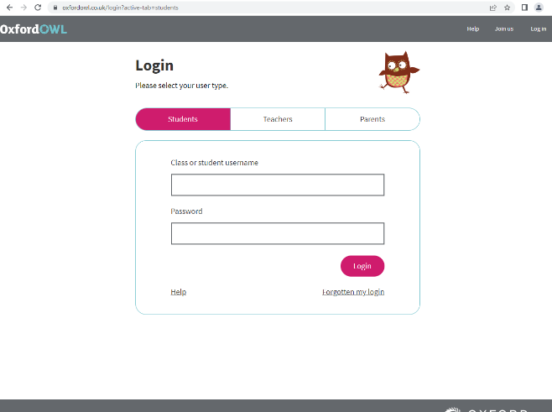
- On the login page you need to ensure that you have selected ‘Student’ up the top to be able to access your child’s reading texts.
You will be able to find the login details in your childs home learning book.
You need to enter your username and password then it will ask you for the school code.

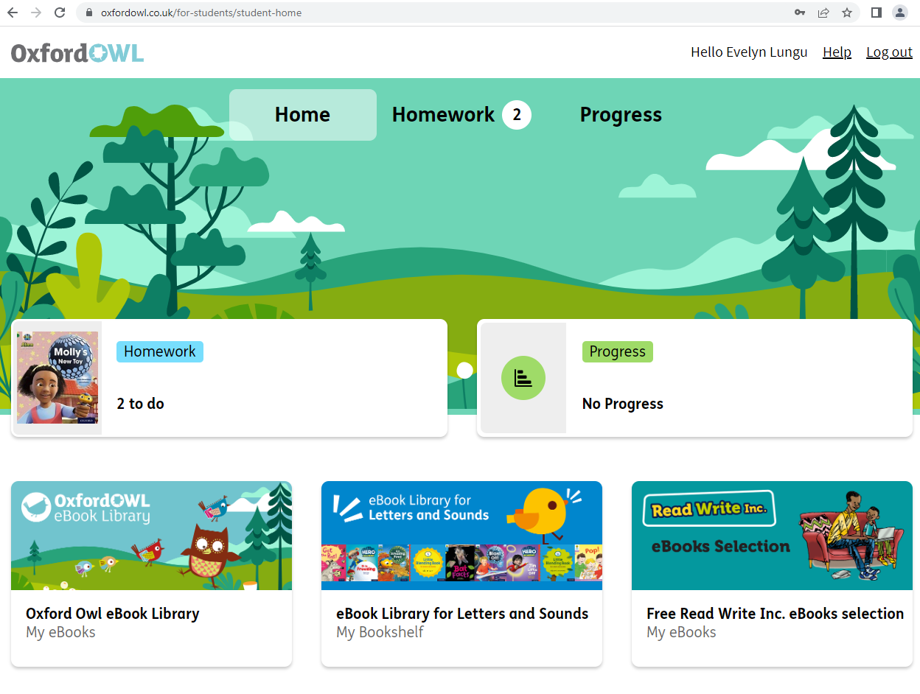
- Once you have entered the login details it will send you to a page that looks like this where you can access the texts.

If there are any questions then please don’t hesitate to get in touch

