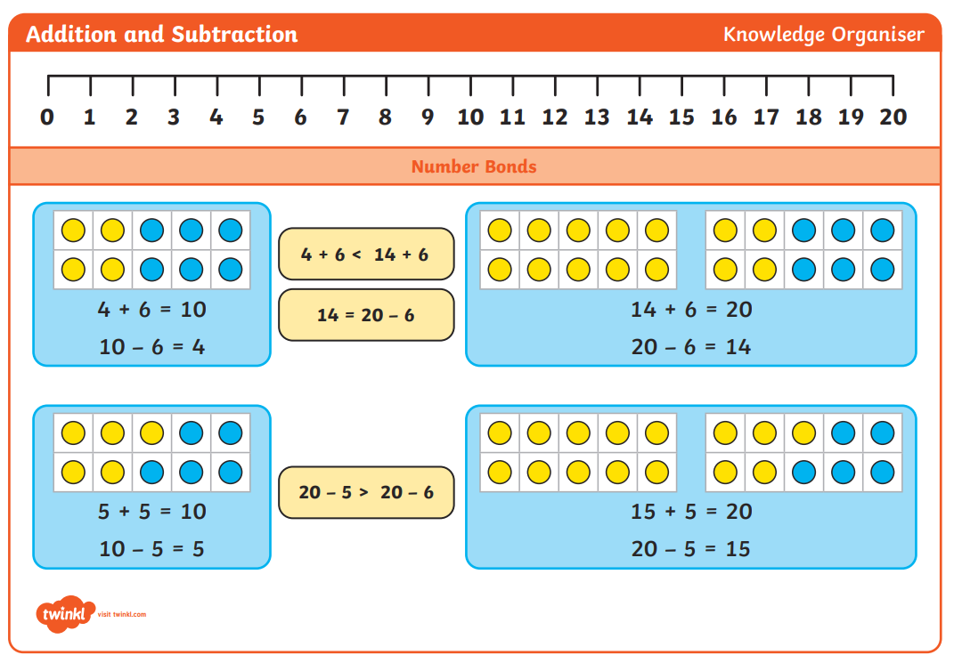
Pre-teach poster
Year 2
Autumn 2

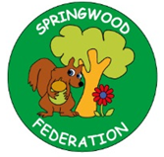

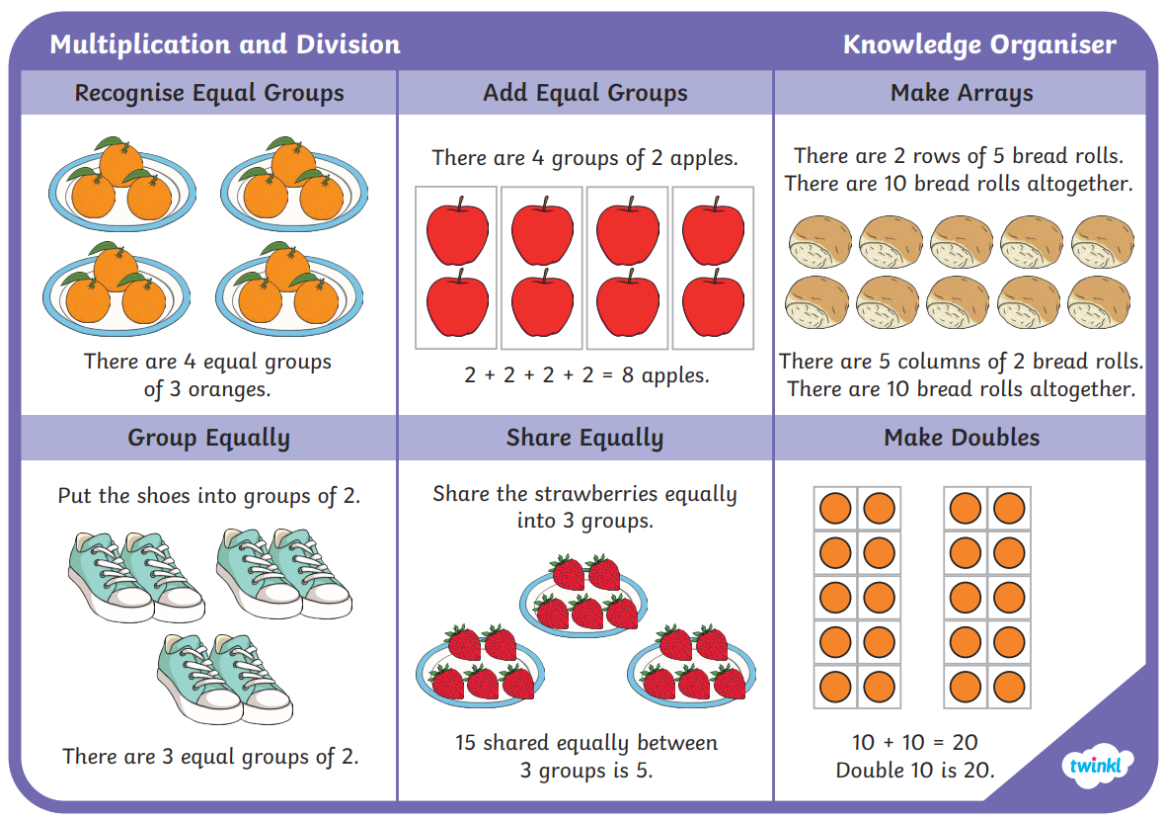
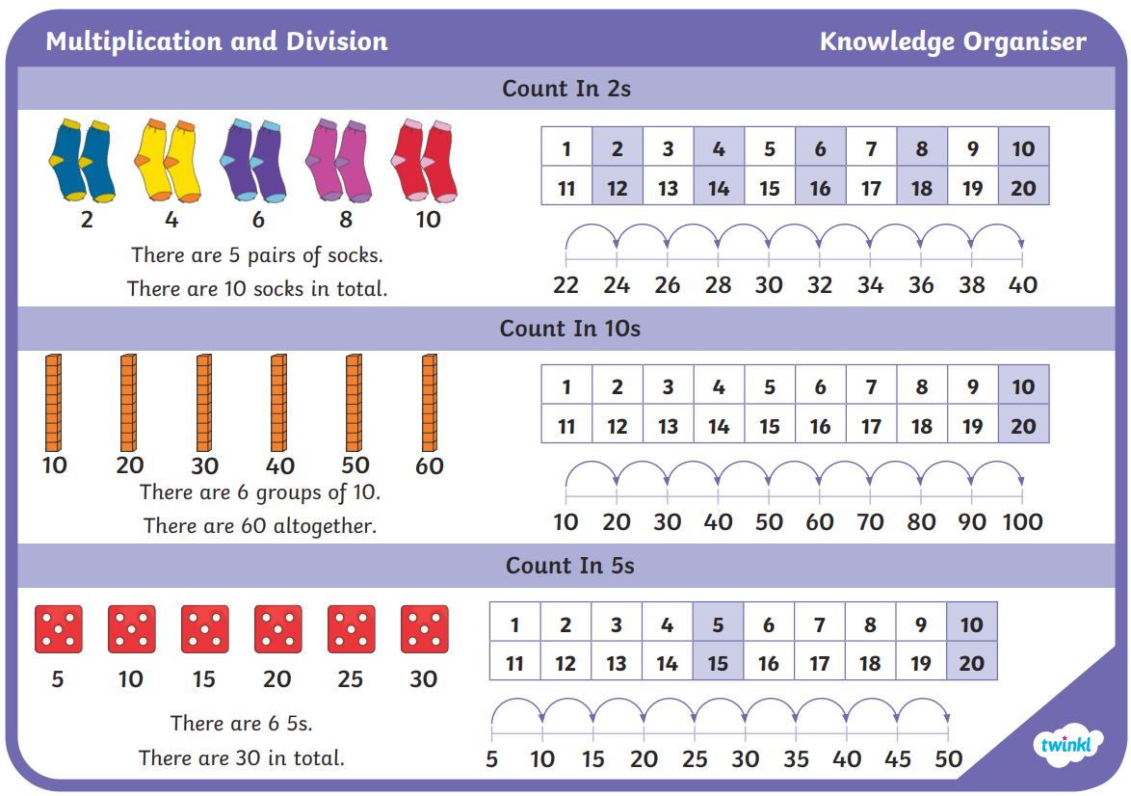
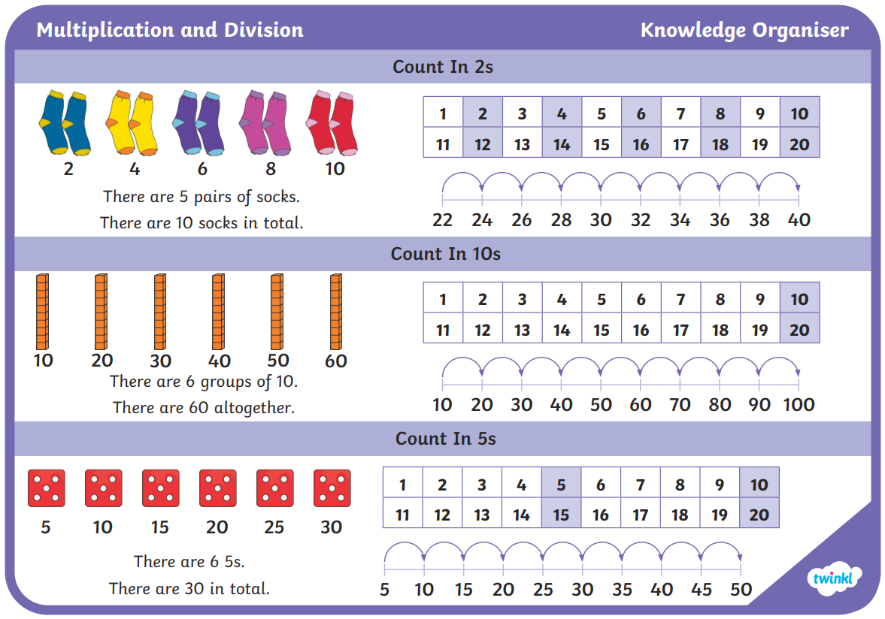

Upcoming English Texts:
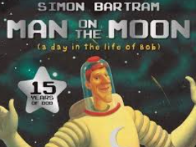 | Text: Man On The Moon  Key vocabulary: astronaut, launch, rocket, responsible, entertain, tourists  Skill: To recall events and write a diary entry.
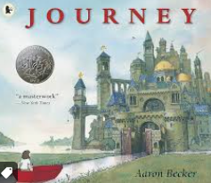 | Text: Journey  Key vocabulary: journey, unknown, explore, enchanted, imagination, castle  Skill: To write a setting description.
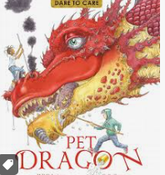 | Text: Pet Dragon  Key vocabulary: dragon, teeth, claws, scales, mighty, fire-breathing, nostrils, swooped, soared, collided  Skill: To design a dragon and write information about it.

