Task to term be completed over this half | Home Apps  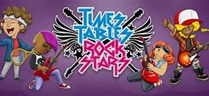  Timetable Rockstars  Even in Y6, timetables are vital to support in many areas. | Spelling  Practise daily spelling using the word sums that we will be focusing on in class.  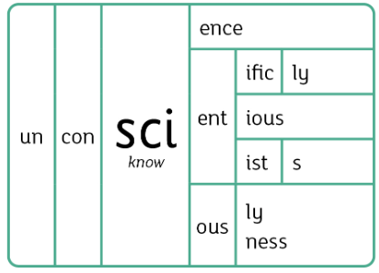  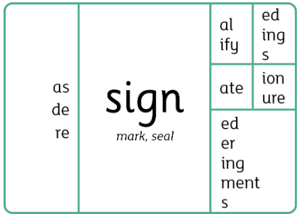  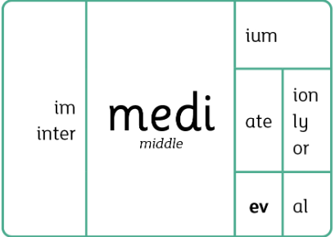 |  | Reading  Continue to read at least 4 times a week using the Oxford Reading Buddy.  Challenge yourself to read a narrative and a non-fiction book this half term.  Your teacher recommends and will be reading with you The Errand by Leo LaFleur  Can you remember any other books set in a dark magicial wood?  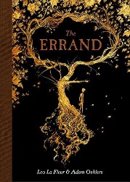 |  | Creative Family project:  Submission date: Week of 12th of December  Open classroom event –Sharing of children’s Books in Classrooms 3:15-3:30pm. It is an opportunity for your child to share their learning with you.  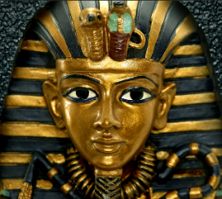  In History, we are looking at the Egyptians Can you answer following questions:  *Who were the Egyptians?  *Why are the Egyptians remembered today?  *What legacy have the Egyptians left behind?  Research using the sites below:  BBC - History: Egyptians  History, primary, Year 6 - Lesson listing | Oak National Academy  You can present your learning in your own creative way: a model, hieroglyphics, posters, research, food creation or booklets. The choice is yours!
Task to term be completed over this half | Oxford Reading Buddy  Login to read books matches to your child’s level and complete online comprehensions.  Oxford Reading Buddy - Log in  At least four times a week.  Can year six be the year group that have completed the most quizzes?
Spellings to learn at home | Week 1 Spellings (Test 14.11.25)  action  auction  eruption  fiction  station  nation  fraction  friction |  | Week 2 Spellings (Test 21.11.25)  portion  option  motion  section  caption  lotion  attention  sensation |  | Week 3 Spellings (Test 28.11.25)  abrasion  admission  aggression  commission  compassion  confession  depression  discussion |  | Week 4 Spellings (Test 12.12.25)  erosion  passion  tension  division  decision  revision  expression  collision
In History, we are learning about:  - Egyptians | In Science, we are learning about:  - Continuing our unit on Making new substances  - Classification and evolution | Curriculum Overview  Autumn 2  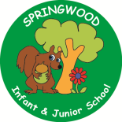  Year 6 |  | In PSHE, we are learning about:  Safe relationships  - Recognising and managing pressure, consent in different situations  Respecting ourselves and others  - Expressing opinions and respecting other points of view, including discussing topical issues | In RE, we will be learning about:  - Theme/Unit: An extraordinary baby  - Concept: Incarnation
In Art, we are:  - Canopic Jar Sculpture with a coiled pot base | In MFL, we are developing our French skills through:  - Clothes  - Habitats
In PE, we are learning:  - Invasion: Football  - Gymnastics: Mirroring and matching | In Computing, we are learning about:  - Bletchley Park and the history of computers  - Exploring AI
In English, we are using The Errand by Leo LaFleur and The Land of Neverbelieve by Norman Messenger and stimulus for writing:  - A instructional narrative  - A non-fiction information page  - A third person narrative to include dialogue  In Reading, we will be reading complimentary texts about other worlds  and fantastical tales, that contain poetic language and beautiful illustrations. |  |  | In Maths, we will continue to develop our Arithmetic skills.  We will also develop our skills and knowledge in:  - Multiplication and division  - Calculation problems  - Fractions and decimals

