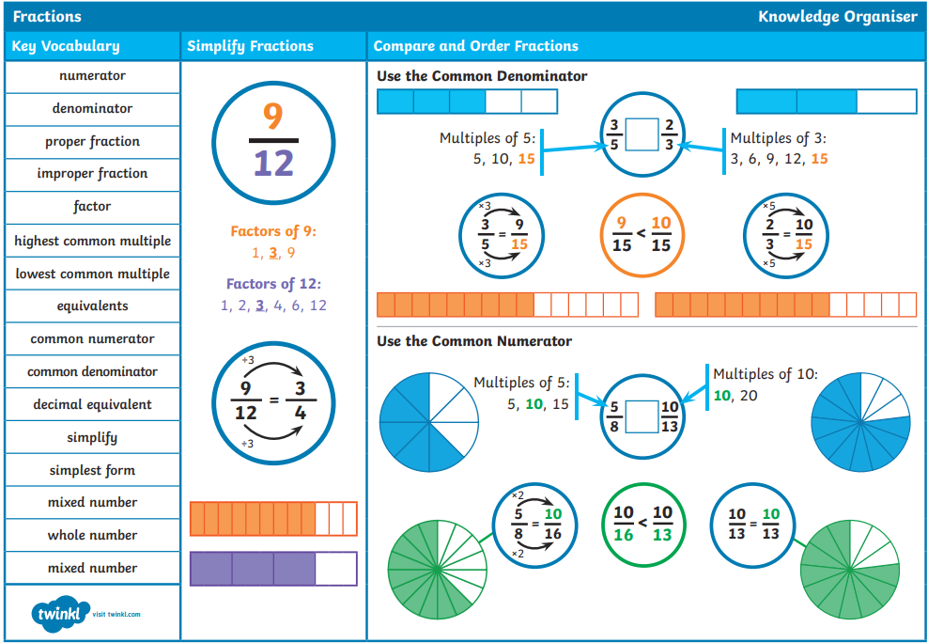
Pre-teach poster
Year 6
Autumn 2

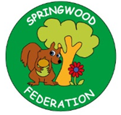

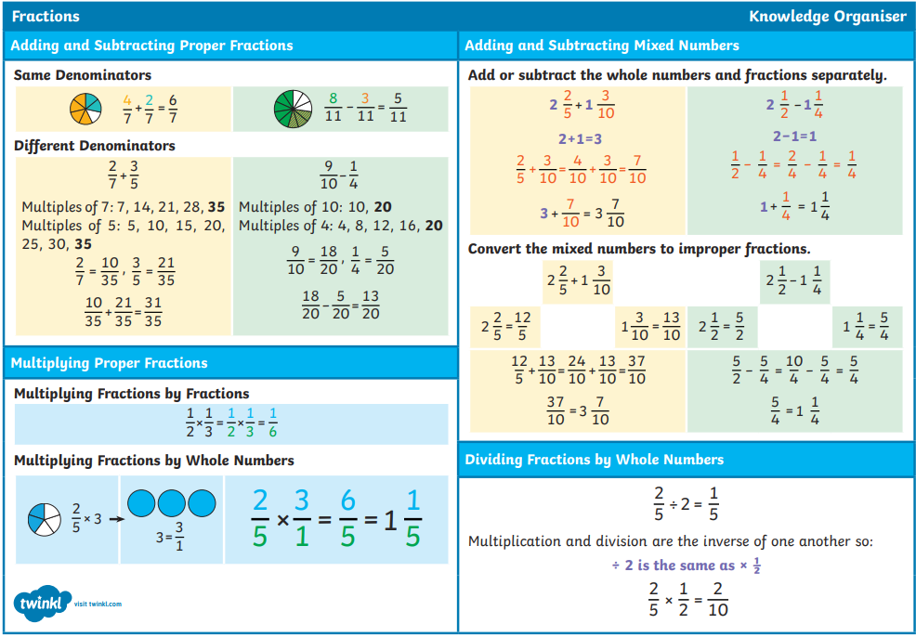

Reading and  Writing  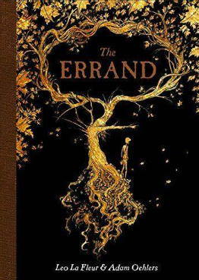 |   The Errand:  errand, enchantment, witch, warlock, awry, tardiness, uncleanliness, dense, mystical, entangle, inhuman, leering, Naiad (Goddess of the River), unholy, simmering, broil, miniature, awakes, unmistakable, courage, roaming, aglimmer, mansion  Skill: Writing a narrative

