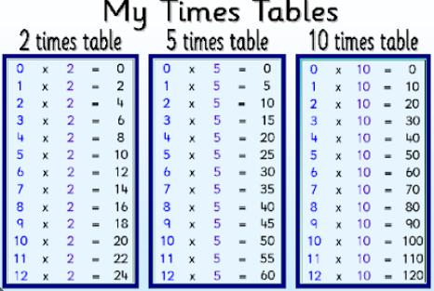
Pre-teach poster
Year 2
Spring 1
Read the times: securing o’clock and half past.
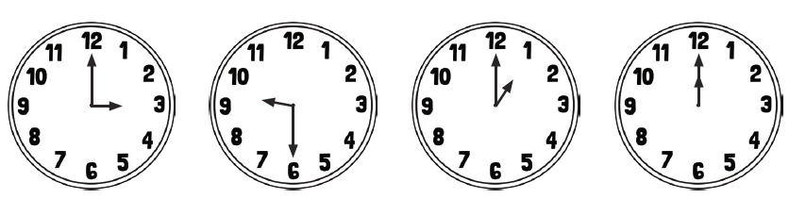
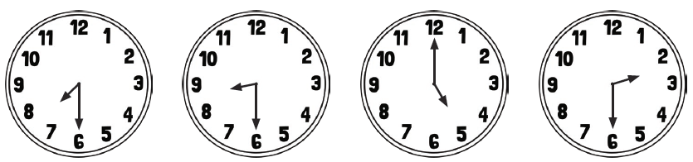
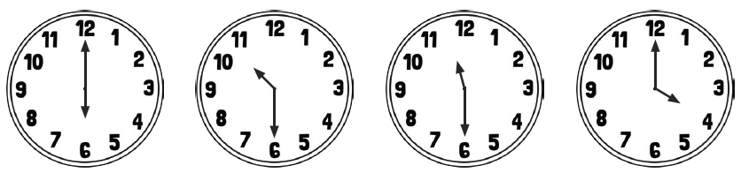
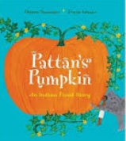  Writing |   Text: Pattan’s Pumpkin  Key vocabulary: flood, village, animals, valley, pumpkin,  thunder, storm, rain, climb,  Skill: To adapt a story to create our own narrative.
Reading | In reading we are looking at a variety of traditional tales.  Here are a few examples:  - Hansel and Gretel  - Jack and the beanstalk  - The Three Little Pigs  - Three Billy Goats Gruff  - Sleeping Beauty  - Princess and the Pea  Key vocabulary: character, setting, plot, goblin, prince charming, tiara, curse, carriage, wicked, character, ogre, adventure, beanstalk, hero, weak, forest, tower, enemy, fairy, axe, bear, Step-mother, enchantment, crown, tower, fairy godmother, wand, glass slippers

