Task to be completed over this half term | Maths  Can you draw arrays to compute these calculations?  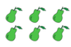  2 x 3 = 3 x 2 =  4 x 5 =  5 x 4 =  5 x 3 =  3 x 5 =  Times tables rock stars is also available to rehearse the timetables that you are learning at school: 2s, 10s, 5s, 3s  https://www.timestables.co.uk/   |  | Reading  *Continue to read at least 4 times a week.    Your child will be set books to read online on:  Oxford Reading Buddy.  *Focus on your fluency – how many words can you read without having to sound them out? Can you explain what you have read? Can you answer questions and retrieve information from the text?  Your teacher recommends and will be reading a range of traditional tales with you.  E.g. Little Red Riding Hood, The Gingerbread Man, The Three Little Pigs and Jack and the Beanstalk.  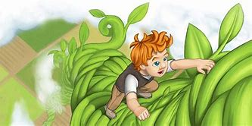  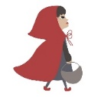  Which is your favourite? Why? |  |  | Creative Family project  Submission date: 9th February.  This term, we will be comparing our local area to Miami!    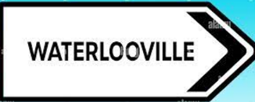  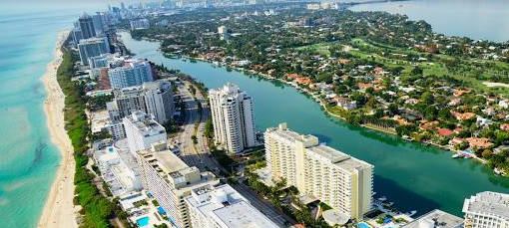  Pick one challenge from the list below:  -Create a tourist brochure or poster for either your local area or Miami, USA – what is there to see and do?  - Make a map of your route to school. Can you add symbols and a key?
Weekly spelling test words | Week 1 (Test on 16.1)  Spellings (ly suffix)  proudly  badly  quickly  lightly  slowly  gracefully | Week 2 (Test on 23.1)  Spellings: (less suffix)  useless  careless  thoughtless  hopeless  fearless  colourless |  | Week 3 (Test on 30.1)  Spellings: (ful suffix)  useful  careful  thoughtful  mindful  fearful  helpful | Week 4 (Test on 6.2)  Spellings: (ment suffix)  refreshment  enjoyment  payment  treatment  agreement |  | Week 5 (Test on 13.2)  Spellings: (ness suffix)  brightness  sadness  lateness  illness  blackness  politeness

In Geography, we are learning:  A contrasting place study:  - To explore the area around Kota Kinabalu to see how the area is similar/different to their local area | In Science, we are learning about:  - How materials change and why we choose different materials for different things.  - Forces – Push and Pull. | Curriculum Overview  Spring 1  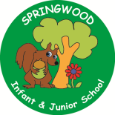  Year 2 | In PSHE, we are learning about:  - Our bodies and feelings  - Our local environment  - Types of behaviour (including teasing and bullying)  - Our rights | In RE, we will be learning about:  - ‘Remembering’ through the festival of Holi
In PE, we are learning about:  - Ball skills using our hands and feet  - Dance – theme of water | In Computing, we are learning:  - Exploring word-processing software by using keyboard shortcuts, importing images and applying simple editing tools such as bold, italics, underlining and font colour. |  | In Music, we are learning:  - Ukelele | In Art, we are learning about:  - Wax resist to create a collaborative piece of Holi artwork
In English, we will be using the texts:  Pattan’s Pumpkin, The Gigantic Turnip, Rapunzel and The Gingerbread Man. We will be writing:  - A Narrative  - A set on instructions  - A character description  In Reading we will be Reading complimentary texts including examples of Traditional tales, mixed up fairy tales and twisted tales. |  |  | In Maths, we will continue to develop our Arithmetic skills.  We will also develop our skills and knowledge further in:  - Multiplication  - Division  - Time

