Task to be completed over this half term | Maths  Time – use the clock to tell the time to o’clock and half past.  https://www.topmarks.co.uk/time/teaching-clock  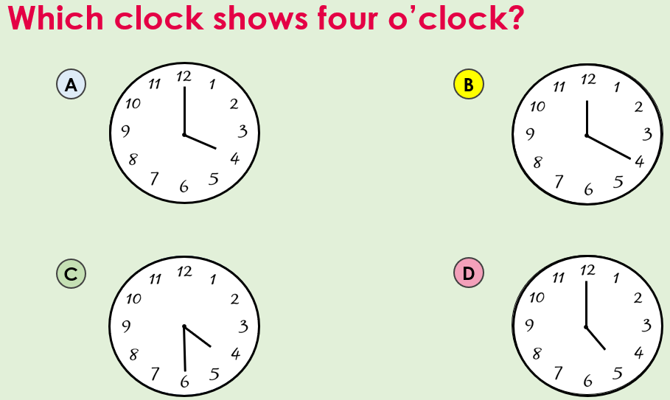  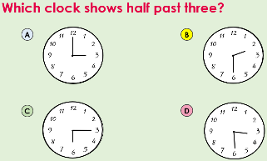  Times tables rock stars to rehearse the timetables that you are learning at school: 2s, 10s, 5s  https://www.timestables.co.uk/  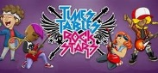  Use your Numbots login to access this site! |  | Reading  *Continue to read at least 3 times a week.    Your child will be set books to read online on:  Oxford Reading Buddy.  *Focus on your fluency – how many words can you read without having to sound them out? Can you explain what you have read? Can you answer questions and retrieve information from the text?  Your teacher recommends and will be reading a range of traditional tales with you.  E.g. Little Red Riding Hood, The Gingerbread Man, The Three Little Pigs and Jack and the Beanstalk.  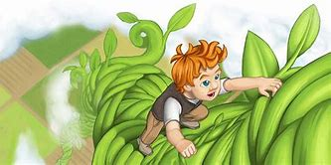  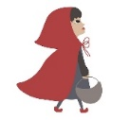  Which is your favourite? Why? |  |  | Creative Family project  Submission date: 9th February.  This term, we will be comparing our local area to Miami!    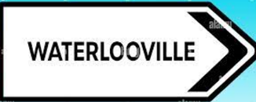    Pick one challenge from the list below:  -Create a tourist brochure or poster for either your local area or Miami, USA – what is there to see and do?  - Make a map of your route to school. Can you add symbols and a key?
Weekly spelling test words | Week 1 (Test on 16.1)  Spellings  my  they  all  was | Week 2 (Test on 23.1)  Spellings:  the  he  me  she  we |  | Week 3 (Test on 30.1)  Spellings:  some  come  of  so | Week 4 (Test on 6.2)  Spellings:  his  her  has  any |  | Week 5 (Test on 13.2)  Spellings:  there  where  love  come

In Geography, we are learning:  A contrasting place study:  - To explore the area around Miami to see how the area is similar/different to their local area | In Science, we are learning about:  - Forces – Push and Pull. | Curriculum Overview  Spring 1  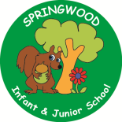  Year 2 | In PSHE, we are learning about:  - Community  - Film categories  - Finances | In RE, we will be learning about:  - ‘Remembering’ through the festival of Holi
In PE, we are learning about:  - Ball skills using our feet  - Dance | In Computing, we are learning:  - Exploring word-processing software by using keyboard shortcuts, importing images and applying simple editing tools such as bold, italics, underlining and font colour. |  | In Music, we are learning:  - Ukelele | In Art, we are learning about:  - Wax resist to create a collaborative piece of Holi artwork
In English, we will be using the texts:  Pattan’s Pumpkin and The Gigantic Turnip, we will be writing:  - A Narrative  - A set on instructions  - A character description  In Reading we will be Reading complimentary texts including examples of Traditional tales, mixed up fairy tales and twisted tales. |  |  | In Maths, we will continue to develop our Arithmetic skills.  We will also develop our skills and knowledge further in:  - Time  - Calculation (addition and subtraction  - Number and place value – Numbers to 50

